CRITERION IV : Infrastructure and Learning Resources:
4.1.1: Physical Facilities:
4.1.1 Institution plan and availability of physical infrastructure
>Class rooms as per INC/NTRHS
>Laboratories
>Seminar hall
> Computer Lab
>Library
>ICT-enabled class rooms
4.1.2: College resources for student learning:
4.1.3: College campus facilities for students survival:
4.1.4: College expenditure:
4.2.: Clinical, Equipment and Laboratory Learning Resources :
> Teaching hospital
>Clinical teaching learning & Lab with equipments
4.2.2: Data regarding teaching hospital:
(Total number of IP/OP Numbers)
4.2.3: NA
4.2.4: Infrastructure for community based training:
4.3: Library with Digital facility:
4.3.2: Total number of books & journals
4.3.3: e- library with membertship
4.3.4: Annual expenditure for college books
4.3.5: In-person and remote access in library:
NA(Not available)
4.3.6: E- content resources used by teachers:
4.4: WI-FI- enabled ICT facilities:
4.5: Maintenance of Campus Infrastructure:
> Budget and auditory certificates
4.5.2: Policy Details for used college facilities:

4.1.1: Physical Facilities:
4.1.1 Institution plan and availability of physical infrastructure
  - Sri Venkateswara College of Nursing is located in the campus of Tirupathi Main road, RVS Nagar, Chittoor. The institution is endowed with the physical infrastructural facilities that support and facilitate teaching learning process.
  - The academic, administrative, research, examination and other curricular and extracurricular activities are housed and carried out in aesthetically designed building.
  - The college has established their own separate and self-contained buildings with the laboratories, classroom, seminar halls, office room, student amenities, library, faculty room and hostel facilities for students and faculty to facilitate and conduct various academic, research and training and extension activities associated with the teaching and learning processes.
  - All the laboratories are equipped with modular and functional workspaces integrating the student needs like water, electricity and gas. The laboratories are designed with the safety features imbibed in the infrastructure resulting in an excellent ambience and atmosphere for academic and research work.
  - The class rooms are equipped to meet the audiovisual needs as well as conventional teaching tools and furnished comfortably to meet the student requirements for learning.
  - Building is also supported by 24x7 power backup so as to facilitate uninterrupted in the academic environment.
  - The water needs for the hostels, laboratories, landscape and consumption are met through the effective use of ground water resources within the campus, rain water harvest for gardening and other similar purposes. The water supply is ensured through the strategically located overhead tanks.

As per the Indian Nursing Council, New Delhi requirements, building and infrastructure facility is exclusively utilized by faculty as well as students of the institution as follows:
    - Infrastructure is optimally utilized by B.Sc., (N) students and B.Sc., (N) & M.Sc., (N). staff members for their research work.
    - They utilize infrastructure facilities on Sundays and official holidays also. Students also avail the computer facility for internet-surfing without disturbing the routine time table.
    - Infrastructure is also optimally utilized for organizing scientific seminars, conferences and extracurricular program and social activities like blood donation camp, medical checkup for diabetes and hypertension, etc.
    - Library referencing facilities are also utilized for students of other institutions and faculty members.
    - Research facility in terms of equipment and instrument is availed by other staff and research students. Infrastructure and instrumental facility is utilized for various other student projects also.

COLLEGE FRONT VIEW HOSTEL BLOCK

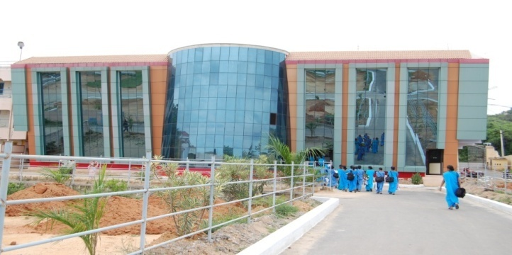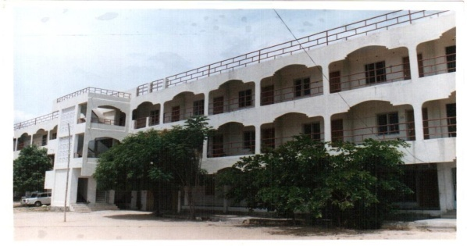

Class rooms for the programme
- College is having adequacy of rooms for lectures,seminars etc..
- College has sufficient class rooms for conducting lectures ,tutorials for B.Sc Nursing program
- Classrooms are provided with Good ventilation,LCD, podium and uninterrupted power supply.
- College has seminar hall of 150 capacities to conduct seminars ,guest lectures and workshops.
- Total No of class=12
- All class rooms are equipped with facilities like blackboard,fans,tubelights, benches,chairs and podium.
- All classrooms are fixed with LCD projectors for presentations sessions.
Quality of acoustics
- All classrooms are around 90 sq.mt in which adequate number of benches shairs are provided to accommodate good number of students.

.Each and every class room is built with good ventilation
. All class rooms are equipped with facilities like black board , fans, tube lights , benches chairs & podium with good ambience.

Faculty Rooms:
.Adequate number of staff rooms with a size of 30sq.m each is available to accommodate every faculty number.
. Cabins are provided with each faculty members.
.All HoD’S are provided with computer with internet facility.
. All the staff rooms are available with WiFi facility.

Facilities for Laboratories:
Institution has well developed & fully equipped laboratories for B.Sc. Nursing students . The institution has 7 laboratories namely
- Anatomy & Physiology Laboratory
- Fundamental of Nursing Laboratory
- Medical surgical nursing Laboratory
- Maternal & Child health Laboratory
- Community health nursing Laboratory
- Nutritional Laboratory
- Audio Visual Laboratory

SRI VENKATESWARA COLLEGE OF NURSING
RVS NAGAR, CHITTOOR
NURSING FOUNDATIONS LAB INVENTORY LIST

SL.NO | NAME OF THE ARTICLES | STOCK
1 | Cot | 5
2 | Matters | 5
3 | Pillows | 4
4 | Dummy Male | 3
5 | Dummy Female | 2
6 | Bed side lockers | 6
7 | Steel trolley | 1
8 | Revolving stool` | 4
9 | Wheel chair | 1
10 | Back rest | 4
11 | I.V Stand | 7
12 | Basin stand | 2
13 | Commode | 1
14 | Foot Stool | 3
15 | Oxygen cylinder with stand | 1
16 | Weighing machine | 2
17 | Crutches | 1 pair
18 | Canes | 1
19 | Walkers | 2
20 | Big tables | 2
21 | Examination table | 1
22 | Bed side screen | 1
23 | Cardiac tables | 3
BANDAGES
1 | Triangular bandage | 14
2 | T. Binder | 10
3 | Abdominal bandage | 6
4 | Crape bandage | 2
5 | Roller Bandage | 25
6 | Stockings | 8
7 | POP Bandage | 13
LINEN
1 | Gowns | 6
2 | Plastic aprons | 3
3 | Cloth aprons | 3
4 | Pillow covers | 13
5 | Towel big | 2
6 | Bath towels | 8
7 | Sponge towels | 10
8 | Blanket | 1
9 | Draw sheet | 18
10 | White sheet | 22
11 | OT caps | 2
12 | Ice cap covers | 3
13 | Hot water bags covers | 6
14 | Sponge bags | 16
15 | Split towels | 8
16 | Tray wrappers | 7
17 | Dusters | 20
18 | Face mask | 2
RUBBER GOODS
1 | Hot water bags | 14
2 | Ice caps | 11
3 | Mackintosh | 21
4 | Aircushions | 15
5 | Kelley’s pad | 6
6 | Pessary rings | 2
7 | Catheters single lumen | 1
8 | Catheters 2 way | 10
9 | Catheters 3 way | 10
10 | Rectal tube | 4
ALUMINIUM ITEMS
1 | Aluminium Jars | 1
 | Aluminium feeding cups | 4
3 | Aluminium Bowls | 4
4 | Aluminium Kidney tray Big | 1
5 | Aluminium Kidney tray Small | 3
6 | Aluminium bowl medium | 1
7 | Pingani Feeding cups | 2
8 | Aluminium big bowl with one lid | 2
9 | Aluminium Bed pan with lid | 1
10 | Aluminium Enema can | 1
11 | Aluminium bowls | 2
12 | Aluminium tray without lid | 3
13 | Aluminium Basins | 3
14 | Injection box | 2
COSTLY ITEMS
1 | Stethoscope | 16
2 | B.P Apparatus | 6
3 | Adhesive tape | 4
4 | Glass syringe | 6
5 | Motor with Piston | 2
6 | Hemometer | 1
7 | Filter paper box | 1
8 | Uri sticks | 1box
9 | Ampoule cutter | 18
10 | Glass slides | 1
11 | Thermometer | 15
12 | Litmus paper | 1 box
13 | Urinometer | 2
14 | Heater | 1
15 | Oxygen flow meter | 1
16 | Nelson inhaler | 3
17 | Glucose strips | 1
18 | Suction apparatus | 1
STEEL INSTRUMENTS
1 | Steel basins | 5
2 | Steel enema canes | 4
3 | Steel kidney tray- very big | 3
4 | Steel kidney tray- big | 11
5 | Steel kidney tray- medium | 6
6 | Steel kidney tray- small | 7
7 | Steel jar with lid | 2
8 | Steel jar without lid | 1
9 | Steel fetoscope | 9
10 | Steel feeding cups | 5
11 | Steel bowls big | 2
12 | Steel bowls medium | 5
13 | Steel bowls small | 15
14 | Steel big glasses | 2
15 | Steel small glasses | 4
16 | Steel container with lid big | 1
17 | Steel container with lid small | 5
18 | Steel pint measure | 1
19 | Kettle | 1
20 | Sterile bins | 5
21 | Spoons | 5
22 | Steel tray with lid | 27
23 | Steel tray without lid | 7
24 | Steel injection trays | 9
25 | Steel tray lids | 7
PLASTIC ITEMS
1 | Cannulas | 29
2 | Needles | 293
3 | 3 way adaptor | 6
4 | Scalp vein set | 3
5 | Syringe 50ml | 5
6 | Syringe 20ml | 18
7 | Syringe 10ml | 6
8 | Syringe 5ml | 5
9 | Syringe 3ml | 5
10 | Syringe 2ml | 5
11 | Insulin syringe | 6
12 | Corrugated drainage set | 3
13 | Blood pack | -
14 | Blood transfusion set | 5
15 | Suction catheter plain | 5
16 | NG tube | 4
17 | Enema tubings | 2
18 | Urobags | 10
19 | Oxygen mask | 1
20 | Paedia drip | 2
21 | Twin born nasal oxygen set | 1
22 | Adult oxygen mask | 1
23 | Asepto syringe | 1
24 | Enema canes | 12
25 | Sputum cups | 7
26 | Ounce glass | 3
27 | Measuring jars | 3
28 | Plastic containers | 34
29 | Specimen bottles | 3
30 | Plastic bowels | 3
31 | Test tube stands | 9
32 | Plastic fetoscope | 2
33 | Funnel big | 7
34 | Funnel medium | 1
35 | Funnel small | 4
36 | Feeding cup plastic | 3
37 | Plastic tray very big | 1
38 | Plastic tray big | 42
39 | Plastic tray medium | 25
40 | Plastic tray small | 24
41 | Plastic basin medium | 3
42 | Plastic bed pan with lid | 1
43 | Plastic bed pan without lid | 4
44 | Plastic mugs | 5
45 | Bucket medium | 4
46 | Bucket small | 2
47 | Urinals | 13
48 | Plastic kidney tray | 10
49 | Emesis basin | 5
50 | Venturi mask | 2
51 | Drain set | 2
52 | ET tubes | 6
53 | Nasal prongs | 3
54 | Nebulizer mask | 1
55 | Oxygen reserve mask | 1
56 | Airways | 2
57 | Oxygen hood | 1
58 | Dust bins | 4
59 | Plastic scissor | 1
60 | IV sets | 13
61 | Plastic basin small | 9
62 | Droppers | 10
63 | Knee hammer plastic | 2
INSTRUMENTS
1 | Straight artery forceps | 19
2 | Curved artery forceps | 10
3 | Thumb forceps toothed | 17
4 | Thumb forceps noon toothed | 15
5 | Ovum forceps | 2
6 | Towel clip | 1
7 | Proctoscope | 1
8 | Tongue depressor | 13
9 | Spatulas | 2
10 | Vaginal speculum | 3
11 | Cuscus speculum | 1
12 | Tuning fork | 2
13 | Knee hammer metal | 2
14 | Chettle forceps | 9
15 | Allis tissue forceps | 4
16 | Scissors | 9
17 | Abdominal retractor | 2
18 | Suture removal scissors | 3
19 | Nasal clip | 1
20 | Needle holders | 7
21 | Surgical blades | 5
OTHER ITEMS
1 | Inch tape | 12
2 | Comb | 5
3 | Test tube holder | 10
4 | Test tubes | 28
5 | First Aid Boxes | 5
6 | Tourniquet | 7
7 | Soap box | 6
8 | Nail cutter | 5
9 | Nail brush | 5
10 | Spirit lamps | 9
11 | Spirit lamp threads | 5
USABLE ITEMS AND SOLUTIONS
1 | Gauze | 1 packet
2 | Cotton roll big | 3
3 | Cotton roll small | 1
4 | Disposable Glove box | 2
5 | Surgical gloves | 10 pairs
6 | Disposable face mask | 1 box
7 | Head caps | 1 box
8 | Vaseline | 4
9 | Face powder | 5
10 | Coconut oil | 5
11 | Spirit | 100ml-1
12 | Dettol | 500ml-4
13 | Povidine Iodine | 500ml-3
14 | Benedict solution | 500ml-3
15 | Tincture benzoine | 100ml-4
16 | Hydrogen peroxide 100ml | 4
17 | Acetic acid | 100ml-4
18 | Lignocaine gelly | 3
19 | NS-500ML | 500ml-5
20 | RL-500ML | 500ml-2
21 | Savlon 100ml | 5
22 | Soaps | 5
23 | Micropore | 5
24 | Salt | 1
25 | Pen torch | 1

SRI VENKATESWARA COLLEGE OF NURSING
RVS Nagar, TIRUPATHI ROAD, CHITTOOR -517127
Medical Surgical Nursing
LAB Inventory LISTs
S.No | Name of the Articles | Stock
FURNITURES
1 | Iron Cot | 10
2 | Mattress | 5
3 | Pillows | 6
4 | Dummy Male | 4
5 | Dummy Female | 2
6 | Bedside Lockers | 12
7 | Steel trolley | 2
8 | Revolving Stools | 8
9 | Wheel Chairs | 2
10 | Back Rest | 10
11 | IV Stand | 16
12 | Suction Apparatus | 2
13 | Basin Stand | 2
14 | Foot Stool | 4
15 | Weighing Machine | 4
16 | Crutches | 2
17 | Canes | 2
18 | Walkers | 4
19 | Bedside Screens | 2
20 | Cardiac Tables | 4
21 | Big Wooden Tables | 4
22 | Examination Tables | 3
23 | Chairs | 5
24 | Stretcher/ Trolley | 2
25 | Stools | 14

S.No | Name of the Articles | Stock
PLASTIC ITEMS
1 | Cannulas | 22
2 | Needles | 40
3 | 3 Way Adaptor | 6
4 | Scalp Vein Set | 8
5 | Syringe 50 ml | 6
6 | Syringe 20ml | 50
7 | Syringe 10 ml | 18
8 | Syringe 5 ml | 12
9 | Syringe 2 ml | 12
10 | Insulin Syringe | 9
11 | Blood pack | 2
12 | Suction Catheter Plain | 6
13 | NG tubes | 10
14 | ET tubes | 20
15 | Urobags | 5
16 | Medi Drain | 6
17 | Nebulizer Mask | 5
18 | Oropharyngeal Airway | 12
19 | Eye Wear | 2
20 | Tracheostomy Tube Plain | 2
21 | Tracheostomy Tube Cuffed | 5
22 | Asepto Syringe | 2
23 | Douch Set | 60
24 | Sputum Cups | 10
25 | Ounce Glass | 15
26 | Measuring Jars | 6
27 | Plastic Specimen Bottle | 6
28 | Plastic Bowl | 2
29 | Plastic Feeding Cups | 6
30 | Urometer | 12
31 | Dropper | 5
32 | Plastic Tray- Big | 2
33 | Plastic Tray- Medium | 34
34 | Plastic Tray- Small | 35
35 | Plastic Basin – Big | 2
36 | Plastic Basin-Medium | 5
37 | Plastic Jugs | 12
38 | Plastic Bucket- Medium | 10
39 | Plastic Bucket- Small | 2
40 | Test Tube Holder | 22
41 | First Aid Boxes | 6
42 | Traction Bags | 5
43 | Glucometer Strips | 2 Box
44 | Test tube Stands | 12
45 | Nail Brush | 6
46 | Micropore | 6
47 | Ampule Cutter | 4
48 | IV sets | 20
49 | Dust Bins (Red, Blue, Green, Yellow) | 8
50 | Disposable Gloves | 2 Box
51 | Plastic Containers | 50
52 | Romo Drains | 6
53 | Nasal Prongs | 4
54 | Oxygen Mask | 2
55 | Disposable OT Caps | 6
56 | Plastic Kidney Trays | `4
57 | Slides | 2 Packet
58 | Burrette | 2

S.No | Name of the Articles | Stock
RUBBER GOODS
1 | Mackintosh | 30
2 | Air Cushion | 1(damged)
3 | Pessary Rings | 4
4 | Catheter 2 Way | 14
5 | Catheter 3 Way | 8
6 | Mucus Sucker | 6
7 | Blood Administration Set | 10
8 | Hot Water Bags | 6

S.No | Name of the Articles | Stock
LINENS
1 | Gowns | 30
2 | Plastic Aprons | 22
3 | Cloth Aprons | 4
4 | Pillow Covers | 10
5 | Bath Towels | 14
6 | Draw Sheets | 12
7 | White Sheets | 40
8 | Sponge Bags | 10
9 | Split Towels | 16
10 | Tray Wrappers | 20
11 | Dusters | 12
12 | Crepe Bandages | 2
13 | Splints | 4
14 | Towels – Big | 4
15 | Towels – Small | 6
16 | Cloth Mask | 4
17 | Green Cloth –Big | 4
18 | Head Caps | 6
19 | Disposable Caps | 2 Box
20 | Screens –Old | 14
21 | Screens – New | 12

S.No | Name of the Articles | Stock
STEEL ITEMS
1 | Steel Basins | 12
2 | Steel Kidney Trays- Big & Medium | 20
3 | Steel Kidney Tray – Small | 18
4 | Steel Jug with Lid | 2
5 | Steel Jug without Lid | 2
6 | Steel Feeding Cups | 10
7 | Steel Bowl – Big | 4
8 | Steel Bowl – Medium | 10
9 | Steel Bowl – Small | 30
10 | Steel Glasses | 10
11 | Steel Pint Measure | 2
12 | Injection Box | 6
13 | Spoon | 2
14 | Steel Tray without Lid | 12
15 | Steel Tray with Lid | 6
16 | Steel Injection Box | 16
17 | Sterile Bins | 8
18 | Sterile Big Trays | 4
19 | Sterile Trays -10x8 (Big) | 16
20 | Sterile Trays -9x6 (Medium) | 22
21 | Sterile Trays -8x6 (Small) | 20
22 | Spirit Lamps | 8
23 | Sternal Puncture Needle | 2
24 | Torch | 2

S.No | Name of the Articles | Stock
INSTRUMENTS
1 | Curved Artery Forceps | 85
2 | Straight Artery Forceps | 30
3 | Thumb Forceps Toothed | 25
4 | Thumb Forceps Non -toothed | 20
5 | Tongue Depressor | 22
6 | B P Handle | 14
7 | Spatulas | 22
8 | Screws | 4
9 | Allis Tissue Forceps | 30
10 | Babcock Forceps | 12
11 | Needle Holder | 20
12 | Suture Removal Scissors | 4
13 | Kocher Forceps Toothed | 8
14 | Kocher Forceps Narrowed | 8
15 | Vulsellum | 16
16 | Green Armytage Forceps | 4
17 | Curette | 4
18 | Single Hook | 8
19 | Double Hook | 2
20 | Holders | 6
21 | Forceps Connection | 16
22 | X-Shaped Retractors | 6
23 | Proctoscope | 8
24 | Dilators | 4
25 | Suction Catheters | 6
26 | Vaginal Speculum | 2
27 | Cuscus Speculum | 6
28 | Tuning Fork | 2
29 | Knee Hammer – Plastic | 4
30 | Knee Hammer – Metal | 10
31 | Cheatle Forceps | 10
32 | Sponge Holding Forceps | 40
33 | Abdominal Retractors | 6
34 | Ovum Forceps | 2
35 | Bone Cutter | 2
36 | Towel Clips | 40
37 | Nasal Clips | 22
38 | Spanner | 2
39 | Metal Saw | 2
40 | Scissors | 16
41 | Surgical Blades | 85
42 | Metal Catheters | 8
43 | Metal Needles | 4 Boxes
44 | LP Needles | 16
45 | Spinal Needles | 6
46 | Uterine Sound | 4
47 | Inch Tape | 2

S.No | Name of the Articles | Stock
SUTURE MATERIALS
1 | Round Body Needle | 10
2 | Cotton Threads | 4
3 | Nylon Thread | 2
4 | Normal Thread | 2
5 | Catgut 3.0 | 16
6 | Silk | 2

S.No | Name of the Articles | Stock
COSTLY ITEMS
1 | Stethoscope | 6
2 | BP Apparatus | 6
3 | Colostomy Kits | 4
4 | Neck Belt | 2
5 | Abdominal Belt | 6
6 | Orthopedic Heat Belt | 4
7 | Skin Traction | 8
8 | Incentive Spirometry | 8
9 | Laryngoscopes | 4
10 | Otoscope | 2
11 | Glucometer | 4
12 | Oristick | 2 Box
13 | Nelson Inhaler | 2
14 | Urinometer | 4
15 | Nebulizer Machine | 2
16 | Heater | 2
17 | Biopsy Gun | 2
18 | Head Mirror | 2
19 | Spring Balance | 2
20 | Ambu Bag Sets | 4
21 | Venturi Mask | 4
22 | CVP Manometer | 2
23 | Oxygen Hood | 2
24 | Syringe Pump | 2
25 | Test Tubes | 22
26 | Surgical pads | 4
27 | Coconut Oil | 2
28 | Powder | 4
29 | Arm Sling | 4

S.No | Name of the Articles | Stock
SOLUTIONS
1 | Formaline | 4
2 | Normal Saline-500ml | 4
3 | Normal Saline-100ml | 4
4 | Ringer Lactate(RL)- 500ml | 2
5 | Tincture Benzoin | 2
6 | Provident Iodine | 4
7 | Asthaline Respules | 4
8 | Lifebouy Soap | 4
9 | Spirit -400ml | 4
10 | Spirit -100ml | 4
11 | Benedicts Solution – 500ml | 2
12 | Lidociane Gel | 4
13 | Savlon -100ml | 4
14 | Dettol -500ml | 2
15 | Dettol -100ml | 4
16 | Hydrogen Peroxide- 400ml | 2
17 | Hydrogen Peroxide- 100ml | 6
18 | Swab Stick | 4
19 | Eye/Ear Drops | 2
20 | Nasal Drops | 2
21 | Glass Jar | 10
22 | Absorbent Cotton Roll | 6
23 | Thermometer | 6
24 | Lancets | 2 Box
25 | Epsoin Salts | 2
26 | Surgical Gloves | 20
27 | Roller Bandages | 30
28 | Gauze Packs | 2
29 | Glycerine | 2

SRI VENKATESWARA COLLEGE OF NURSING,R.V.S.NAGAR, CHITTOOR
 |  | ANATOMY LAB INVENTORY LIST
S.NO | NAME OF THE ITEM |  |  |  |  | STOCK
I | BONES
1 | SKULL BONES-REAL |  |  |  |  | 5
 |  | ARTIFICIAL |  |  |  | 3
2 | JAW BONES-REAL |  |  |  |  | 5
 |  | ARTIFICIAL |  |  |  | 4
3 | CLAVICAL BONE |  |  |  |  | 6
4 | SCAPULA-REAL |  |  |  |  | 6
 |  | ARTEFICIAL |  |  |  | 10
5 | HUMERUS BONE-REAL |  |  |  |  | 4
 |  | ARTEFICIAL |  |  |  | 14
6 | RADIUS |  |  |  |  | 3
7 | ULNA |  |  |  |  | 5
8 | HAND SET-REAL |  |  |  |  | 3
9 | INNOMINATE BONE-REAL |  |  |  |  | 3
 |  | ARTIFICIAL |  |  |  | 8
10 | FEMUR BONE –REAL |  |  |  |  | 8
 |  | ARTIFICIAL |  |  |  | 8
11 | FIBULA AND TIBIA SET |  |  |  |  | 7
12 | FOOT SET |  |  |  |  | 3
13 | SKELETON –REAL |  |  |  |  | 3
 |  | ARTEFICIAL |  |  |  | 4
 |  | WITH PAPER |  |  |  | 3
 |  | WITH BOX |  |  |  | 3
14 | VERTEBRAL COLOUMN |  |  |  |  | 3
15 | SACRUM ARTIFICIAL |  |  |  |  | 6
16 | RIBS-REAL |  |  |  |  | 4
17 | TIBIA-REAL |  |  |  |  | 6
 |  | ARTIFICIAL |  |  |  | 7
18 | FIBULA-REAL |  |  |  |  | 6
19 | FETAL SKULL ARTIFICIAL |  |  |  |  | 5
II | TRANSPARENCIES
20 | REPRODECTIVE SYSTEM FEMALE AND MALE |  |  |  |  | 4
21 | URINARY SYSTEM |  |  |  |  | 3
22 | SPINAL CORD STRUCTURE |  |  |  |  | 3
23 | HUMAN BRAIN AND CRANIAL NERVES |  |  |  |  | 2
24 | OPTIC NERVE |  |  |  |  | 4
25 | HUMAN TEETH |  |  |  |  | 4
26 | STRUCTURE POF | OF EAR |  |  |  | 4
27 | TYPES OF TEETH |  |  |  |  | 4
28 | HOW TO REMOVE MOSSEL GONE WRONG WAY |  |  |  |  | 2
29 | MEMBRANEOUS COCHLEA |  |  |  |  | 4
30 | LACRIMAL GLANDS |  |  |  |  | 4
31 | HUMAN EYE DEFECTS I &II |  |  |  |  | 1+2
32 | SOUND PATHWAY |  |  |  |  | 4
33 | STRUCTURE OF RETINA |  |  |  |  | 4
34 | HUMAN MOUTH STRUCTURE |  |  |  |  | 4
35 | EYE ASSOCIATED MUSCLES |  |  |  |  | 4
36 | HUMAN EYE |  |  |  |  | 6
37 | STRUCTURE OF HUMAN SKIN |  |  |  |  | 4
38 | STRUCTURE OF EYE BALL |  |  |  |  | 4
39 | REFRACTION THROUGH CONVEX LENS |  |  |  |  | 6
40 | BONY LABRINTH |  |  |  |  | 4
41 | EAR AUDITORY OSSICLES |  |  |  |  | 4
42 | SPERM STRUCTURE |  |  |  |  | 4
43 | TYPES OF TOURNIQUET |  |  |  |  | 2
44 | THOMAS SPLINT |  |  |  |  | 2
45 | MUSCULAR SYSTEM |  |  |  |  | 4
46 | HUMAN SKELETON |  |  |  |  | 4
47 | HUMAN HEART |  |  |  |  | 2
48 | HUMAN ENDOCRINE SYSTEM |  |  |  |  | 4
49 | LYMPHATIC SYSTEM |  |  |  |  | 4
50 | PRESSURE POINT OF NECK |  |  |  |  | 2
51 | HUMAN DIGESTIVE SYSTEM |  |  |  |  | 4
52 | HUMAN RESPIRATORY SYSTEM |  |  |  |  | 2
53 | HUMAN CIRCULATORY SYSTEM |  |  |  |  | 2
54 | HUMAN NOSE |  |  |  |  | 4
55 | STRUCTURE OF HUMAN RETINA |  |  |  |  | 4
56 | MICROSCOPES |  |  |  |  | 4
III | CHARTS
57 | CIRCULATORY SYSTEM |  |  |  |  | 3
58 | DIGESTIVE SYSTEM |  |  |  |  | 6
59 | ENDOCRINE SYSTEM |  |  |  |  | 6
60 | MUSCULAR SYSTEM |  |  |  |  | 8
61 | NERVOUS SYSTEM |  |  |  |  | 4
62 | RESPIRATORY SYSTEM |  |  |  |  | 4
63 | SKELETAL SYSTEM |  |  |  |  | 4
64 | REPRODECTIVE SYSTEM FEMALE AND MALE |  |  |  |  | 1+2
65 | EXCRETORY SYSTEM |  |  |  |  | 4
66 | GENITO URINARY SYSTEM |  |  |  |  | 3
67 | LYMPHATIC SYSTEM |  |  |  |  | 3
68 | CIRCULATION OF BLOOD |  |  |  |  | 4
69 | HUMAN SKELETAL ND CVS |  |  |  |  | 6
70 | BURNS AND SCALDS |  |  |  |  | 2
71 | HUMAN NOSE |  |  |  |  | 4
72 | DIFFERENT KINDS OF BONES |  |  |  |  | 2
73 | HEART |  |  |  |  | 2
74 | EYE ASSOCIATED MUSCLES |  |  |  |  | 4
75 | EART |  |  |  |  | 3
76 | HUMAN PHYSIOLOGY |  |  |  |  | 8
IV | WOODEN BOARDS
77 | HUMAN SKELETON(BIG &SMALL) |  |  |  |  | 1+1
78 | RESPIRATORY SYSTEM(BIG & SMALL) |  |  |  |  | 2+1
79 | HUMAN STOMACH(SMALL) |  |  |  |  | 4
80 | LIVER (SMALL) |  |  |  |  | 4
81 | DIGESTIVE SYSTEM (BIG+SMALL) |  |  |  |  | 2+1
82 | LUNG WITH HEART(SMALL) |  |  |  |  | 6
83 | NOSE |  |  |  |  | 4
84 | ENDOCRINE GLAND(MEDIUM) |  |  |  |  | 8
85 | SKULL WITH JAW |  |  |  |  | 4
86 | SPINAL CORD |  |  |  |  | 2
87 | MUSCULAR SYSTEM |  |  |  |  | 4
88 | NERVOUS SYSTEM |  |  |  |  | 2+1
89 | REPRODECTIVE SYSTEM FEMALE AND MALE |  |  |  |  | 1+1
90 | KIDNEY WITH BLADDER(SMALL) |  |  |  |  | 4
91 | CIRCULATORY SYSTEM |  |  |  |  | 4
92 | MALE AND FEMALE PELVIS |  |  |  |  | 1+1
93 | FEMALE REPRODECTIVE SYSTEM(SMALL) |  |  |  |  | 4
94 | SKIN MEDIUM |  |  |  |  | 6
V | MODELS
95 | SKULL WITH BRAIN |  |  |  |  | 6
96 | BRAIN |  |  |  |  | 11
97 | HUMAN KIDNEY (BIG & SMALL) |  |  |  |  | 2+2
98 | HEAD WITH NECK |  |  |  |  | 4
99 | SKIN |  |  |  |  | 2
100 | HEART |  |  |  |  | 9
101 | LARYNX |  |  |  |  | 2
102 | HAND SET-REAL |  |  |  |  | 2
103 | PELVIS |  |  |  |  | 6
104 | SHOULDER JOINT |  |  |  |  | 4
105 | ELBOW JOINT |  |  |  |  | 2
106 | THIGH JOINT |  |  |  |  | 2
107 | ALVEOLI |  |  |  |  | 2
108 | SPLEEN |  |  |  |  | 2
109 | TEETH |  |  |  |  | 8
110 | EAR |  |  |  |  | 4
111 | LIVER SMALL AND BIG |  |  |  |  | 1+4
112 | EYE AND EYE LIDS |  |  |  |  | 3+2
VI | TORSO
113 | HUMAN MALE BIG AND SMALL |  |  |  |  | 3+1
114 | HUMAN FEMALE BIG AND SMALL |  |  |  |  | 3+1
VII | LAMINATED CHARTS
115 | HUMAN SKIN |  |  |  |  | 4
116 | HUMAN EYE |  |  |  |  | 2
117 | SEXUALLY TRASMITTED DISEASE |  |  |  |  | 2
118 | HUMAN TONGUE |  |  |  |  | 4
119 | NERVOUS SYSTEM |  |  |  |  | 2
120 | STRUCTURE OF BRAIN |  |  |  |  | 2
121 | HUMAN SPINAL CORD |  |  |  |  | 2
122 | EXCRETORY SYSTEM |  |  |  |  | 2
123 | BLOOD AND BLOOD GROUP |  |  |  |  | 4
124 | RESPIRATORY SYSTEM |  |  |  |  | 2
125 | ENDOCRINE SYSTEM |  |  |  |  | 4
126 | FEMALE AND MALE REPRODECTIVE SYSTEM |  |  |  |  | 1+1
127 | DNA STRUCTURE |  |  |  |  | 2
128 | HUMAN SKELETON |  |  |  |  | 2
129 | HUMAN CIRCULATORY SYSTEM |  |  |  |  | 4
130 | SKELETON JOINTS |  |  |  |  | 4
131 | ORIGIN AND DEVELOPMENT &STRUCTURE OF BLOOD CELLS |  |  |  |  | 2
132 | PROSTRATE |  |  |  |  | 4
133 | HEART |  |  |  |  | 4
134 | FEMALE REPRODECTIVE ANATOMY AND PATHOLOGY |  |  |  |  | 6
135 | REPRODECTIVE SYSTEM FEMALE AND MALE |  |  |  |  | 3
136 | TEETH AND SKIN CHART |  |  |  |  | 3
137 | HUMAN EYE AND EAR CHART |  |  |  |  | 3
138 | IMMUNE SYSTEM CHART |  |  |  |  | 4
139 | FRACTURES CHART |  |  |  |  | 2
140 | HEALTH ILLNESS AND RULES CHART |  |  |  |  | 2
141 | EFFECTS OF ALCOHOL CHART |  |  |  |  | 2
142 | HEAMOMETER |  |  |  |  | 2
143 | EYE MODEL |  |  |  |  | 8
VIII | OTHERS
144 | MICROSCOPIC SLIDES |  |  |  |  | 4 BOXES
145 | ABNORMAL FETUS SPECIMEN |  |  |  |  | 3
146 | NORMAL FETUS SPECIMEN |  |  |  |  | 3
147 | HUMAN TORSO SMALL |  |  |  |  | 3

SRI VENKTESWARA COLLEGE OF NURSING RVS NAGAR, TIRUPATI ROAD, CHITTOOR.
LIST FOR CHN LAB (ORIGINAL)
S.No | Name of the Articles | Stock
1 | Ampule cutter | 29
2 | Apron | 58
3 | Artery forceps straight(big) | 74
4 | Artery forceps curved | 56
5 | Bottle brush | 43
6 | Bowels | 82
7 | Bucket | 1
8 | B.P Apparatus | 9
9 | Cloth bags | 62
10 | Community bags | 34
11 | Dropper small | 63
12 | Droppers big | 40
13 | Fetoscope | 70
14 | Hand towels | 34
15 | Inch tapes | 40
16 | Kidney tray plastic | 55
17 | Kidney tray steel | 20
18 | Nail brush | 55
19 | Nutritional cup sets | 37
20 | Needle box | 18
21 | Needles metal | 47
22 | Ounce glass | 51
23 | Plastic basin | 4
24 | Plastic tray | 17
25 | Puppets | 29
26 | Soap boxes | 43
27 | Scissors big | 26
28 | Scissors small | 21
29 | Syringe glass | 41
30 | Thermometer(oral)  (rectal) | 34  10
31 | Test tubes(big)  (small) | 47  87
32 | Test tube holder | 78
33 | Test tube stand | 48
34 | Trolley | 1
35 | Infantometer | 1
36 | Weighing scale | 6
37 | Stethoscope | 17
38 | Chart stand | 2
39 | Solution container big | 182
40 | Solution container small | 64
41 | Specimen container | 125
42 | Thumb forceps toothed | 47
43 | Thumb forceps non toothed | 62
44 | Spirit lamp | 45
45 | Glucometer | 4
46 | Glucometer strips | 12
47 | Knee hammer | 1
 | Furnitures
1 | Cupboard | 2
2 | Rack | 2
3 | Small table | 1
4 | Big table | 2
5 | Wooden benches | 4
6 | Big table steel | 2
7 | Examiners tables big | 2
8 | Round stools | 2
9 | Plastic chairs | 2
10 | Student sitting benches | 12
11 | Dust bins BMW
 | -green. | 1
 | -red | 1
 | -blue | 1
 | -yellow | 1
 | -classroom dustbin | 1
 | Rubber gloves | 4boxes
 | Gauze | 6packs
 | Spirit lamp threads | 20
 | Spatulas | 5
 | Charts
1 | Effects of environmental pollution | 1
2 | Pollution and health | 1
3 | Hemorrhage | 1
4 | Snakes and their bites | 1
5 | Electric shock and their first aid | 2
6 | Dysentery ort | 1
7 | Emergency resuscitation | 2
8 | Care of eye and teeth | 1
9 | Jaundice | 1
10 | Smallpox | 2
11 | Unconsciousness | 2
12 | Good habits | 2
13 | Personal cleanliness | 1
14 | Health rules | 1
15 | Plague | 3
16 | Leprosy | 1
17 | Influenza | 3
18 | Tuberculosis | 2
19 | Clean water | 1
20 | Unplanned family | 1
21 | Care of mother during pregnancy | 2
22 | Roller bandages | 2
23 | Viral diseases | 1
24 | Typhoid | 1
25 | Cholera | 2
26 | Mother craft | 1
27 | Malaria | 1
28 | Small family and Happy family | 1
29 | Ready for confinement | 1
30 | Prevention of disease | 2
31 | Welfare of mother | 1
32 | AIDS | 1
33 | Effects of alcohol | 2
34 | Fracture | 1
35 | Babies diet | 1
36 | Rules of social hygiene | 1
37 | Babies habit | 2
38 | Temporary methods of family planning | 1
39 | Cancer | 1

SIGNATURE OF THE LAB INCHARGE SIGNATURE OF THE PRINCIPAL

SRI VENKATESWARA COLLEGE OF NURSING
RVS Nagar, TIRUPATHI ROAD, CHITTOOR -517127
AV AIDS ROOM INVENTORY
S.No | Name of the Articles | Stock
1 | Big table | 1
2 | Benches | 3
3 | Small Table | 4
4 | White Sheet | 6
5 | Green Sheet | 8
6 | Chair Plastic | 5
7 | OHP | 2
8 | Chart Stand | 3
9 | Tape Recorder | 2
10 | Old speakers | 2
11 | Mike set old with mike | 1
12 | OHP transparencies anatomy First aid | 10
13 | Suturing material Tray | 2
14 | Funnel board | 1
15 | Charge wire | 2
16 | Computer Table | 1
17 | Speakers | 2
18 | Curtons | 4
NAME OF THE CHARTS
1 | Cause of Disease | 1
2 | Spacing years of child birth | 2
3 | Preparation for confinement | 1
4 | welfare of mother | 1
5 | Baby development | 1
6 | Electric shock and and it's first aid | 2
7 | Small Pox | 1
8 | Heart | 3
9 | Nervous System | 1
10 | Human physiology structure of the Ear | 1
11 | Snakes | 1
12 | Respiratory System | 1
13 | Cholera | 1
14 | Virus Disease | 1
15 | Care of Eyes and Teeth | 1
16 | Tobacco and other habit forming drugs | 1
17 | Our food | 4
18 | Nutrition | 1
19 | AIDS | 1
NAME OF THE MODELS
1 | Human Heart | 1
2 | Human Ear | 1
3 | Human Eye | 1
4 | Human Brain | 1
5 | Endocrine gland | 1
6 | Human Skeleton | 1
LAMINATION CHARTS
1 | Human Spinal Cord | 1
2 | Origin development and structure of blood cells | 1
3 | Human Ear | 1
4 | Human Blood groups | 1
5 | The important of weight control | 1
6 | Human Brain | 1
7 | The Prostate | 1
8 | Understanding HIV/AIDS | 1
9 | Sexually Transmitted Diseases | 1
10 | Understanding Menopause | 1
11 | The Male Reproductive System | 1
12 | Pregnancy and Birth | 1
13 | Female Reproductive System | 1
OTHERS
1 | One New Big table glass | 1
2 | New chairs red colour | 4
3 | Rack | 1
4 | White Board | 1
5 | Stand Black | 2
6 | Dinning Table with Chairs | 1
 | Signature of the Lab-Incharge | Signature of the Principal

SRI VENKATESWARA COLLEGE OF NURSING
RVS NAGAR,CHITTOOR
MCH LAB INVENTORY LIST
S.NO | NAME OF THE ARTICLES | NO.OF ITEMS
1 | Vaginal speculum | 19
2 | Cuscos speculum | 09
3 | Allis tissue forceps | 13
4 | Ambler dilator | 12
5 | Das dilator | 22
6 | Hegar’s dilator | 24
7 | Kocher’s forceps | 02
8 | Green armytage forceps | 06
9 | Episiotomy scissors Big  Small | 01  12
10 | Ovum forceps | 13
11 | Uterine sound | 07
12 | Female metal catheter | 10
13 | Long curved obstetric forceps | 02
14 | Wrigley forceps | 08
15 | Kielland’s forceps | 04
16 | Male metal catheter | 10
17 | Forceps lock | 05
18 | Uterine curette | 11
19 | Anterior vaginal wall retractor | 07
20 | Flushing curette | 06
21 | Needle holder Small  Big | 07  02
22 | Auvards Speculum | 02
23 | Vulsellum | 01
24 | Sponge holding forceps | 15
25 | Scissors Straight  Curved | 05  01
26 | Uterine manipulator | 01
27 | Uterine clamp | 05
28 | Chittel forceps Big  Small | 06  01
29 | Artery forceps Curved  Straight | 13  19
30 | Thumb forceps Toothed  Ton toothed | 06  20
31 | BP handle | 96
32 | Fetoscope | 28
33 | Proctoscope | 03
34 | Suture removal scissors | 04
35 | Retractors | 07
36 | Towel clips | 12
37 | Pelvimetry | 01
38 | Anurysm needle Single  Double hook | 03  04
39 | Steel Bin Big  Small | 06  03
40 | BP apparatus | 03
41 | Mucus sucker | 62
42 | Ambu bag | 01
43 | Big Bowl | 06
44 | Small bowl | 43
45 | Steel cotton ball container Small  Big | 10  06
46 | Ounce glass | 12
47 | Steel Jug with lid | 01
48 | Steel Jug without lid | 01
49 | Plastic kidney trays | 17
50 | Plastic trays | 22
51 | Steel kidney trays Big  Small | 05  23
52 | Infrared lamp | 01
53 | Steel tray with lid Big  Medium  Small | 05  15  12
54 | Basin stands | 02
55 | Oxygen Hood | 01
56 | Plastic basins | 03
57 | Plastic bedpans | 05
58 | Adult weighing machine | 03
59 | Mugs | 05
60 | Dust bins | 04
61 | IV stands | 02
62 | Bedside lockers | 05
63 | Buckets | 05
64 | Cots | 02
65 | Examination tables | 04
66 | Practical Examination table | 02
67 | Chairs | 03
68 | Wooden cupboard | 01
69 | Trolley | 02
70 | Drain set | 01
71 | Oxygen mask | 02
72 | Pregnancy kit | 03
73 | Knee hammer | 01
74 | Tuning fork | 01
75 | Enema cans | 02
76 | Delivery table | 01
77 | Wheelchair | 01
78 | Footstool | 05
79 | BP handle | 96
80 | Bedside screen | 01
81 | Stethoscope | 02
82 | Clinical thermometer | 01
83 | Digital thermometer | 02
84 | Rectal thermometer | 01
85 | Foley’s catheter | 05
86 | Plastic scissors | 04
87 | Tongue depressor | 04
88 | Steel bed pan | 02
89 | Spatulas | 10
90 | Nelson’s inhaler | 01
91 | Examination spotlight | 01
CHN ARTICLES
92 | Paediatric resusitation kit | 01
93 | Tumbler with spoon | 01
94 | Droppler | 02
95 | Specimen bottles | 05
96 | Fonnel | 01
97 | Test tube holder | 09
98 | Test tube stands | 03
99 | Test tubes | 17
100 | Paediatric weighing scale | 04
101 | Infantometer | 05
102 | Plastic baby bath tub | 03
103 | Feeding bottle | 02
104 | 50 ml syringe | 01
105 | Sputum cup | 03
106 | Nebulization kit | 01
107 | Paediatric splints | 02
108 | Cradles | 04
109 | IV cannula | 06
110 | Douch set | 06
111 | Bedside lockers | 04
112 | IV set | 02
113 | Gloves | 01
114 | Sterile gloves | 06
115 | Spirit lamps | 03
116 | Soap dish | 02
117 | Feeding pumps | 06
118 | Iron stool | 02
119 | Iron bench | 03
120 | Iron stands | 01
121 | Iron cupboard | 03
PLAY ARTICLES
122 | Bat and ball set | 06
123 | Bat05 | 04
124 | Big ba04lls | 05
125 | Small balls | 04
126 | Bowling pins set | 02
127 | Cars | 04
128 | Raffles | 10
129 | Round Rifles | 04
130 | Crayons set | 01
131 | Number slate | 01
132 | Creative blocks | 01
133 | ABCD puzzle | 01
134 | Prones | 02
135 | ABCD and 123 puzzles | 01
136 | Rings set | 01
137 | Baby doll | 02
138 | Rabbits with drum | 02
139 | Drums | 02
140 | Building blocks | 01
141 | Bats | 03
142 | Kitchen set | 02
143 | Fruits | 02
144 | Police man | 01
145 | Build ozars | 01
146 | Water gun | 01
147 | BP apparatus | 01
LINEN
148 | Mattress | 05
149 | White sheets | 35
150 | Draw sheets | 08
151 | Curtains | 09
152 | Big towel | 08
153 | Table cloth | 04
154 | Big baby bath towel | 01
155 | Small towels | 12
156 | Dummy nighties | 02
157 | Pillow with covers | 08
158 | Mittens | 41
159 | OT aprons green | 07
160 | Green cloth big | 02
161 | Plastic apron | 25
162 | Green clothes | 25
163 | Central hole towel | 03
164 | Small green sponge cloth | 03
LAMINATED CHARTS
165 | Male reproductive system | 01
166 | Female reproductive system | 01
167 | Breast disease | 01
168 | Menstrual cycle | 01
169 | Conditions of C.S | 01
170 | Menopause chart | 01
171 | Pregnancy with birth | 01
172 | Infertility | 01
173 | Brow presentation | 01
174 | Twin pregnancy | 01
175 | Annencephaly | 01
176 | Hydrocephalus | 01
177 | Cleft lip and cleft palate | 01
178 | Spinal bifida | 01
179 | Capet succedaneum | 01
180 | Breech presentation | 01
181 | Incomplete breach | 01
182 | Foot presentation | 01
183 | Shoulder presentation | 01
184 | Face presentation | 01
185 | Breast changes | 01
186 | First Stage of labour | 01
187 | Second Stage of labour | 01
188 | Third stage of labour | 01
189 | Uterine changes in pregnancy | 01
190 | Congenital changes | 01
191 | Human reproductive system | 01
192 | Prostate | 01
193 | Placenta previa | 01
CHARTS
194 | Human embryology | 01
195 | Female genital organs | 01
196 | Mother craft | 02
197 | Baby habits | 01
198 | Family planning methods | 01
199 | Reddy confinement | 01
200 | Small family happy family | 01
201 | Baby diet | 01
202 | Unplanned family | 01
203 | Baby weight | 02
MODELS
204 | Copper t | 01
205 | Loop | 02
206 | Diaphragm | 02
207 | Development of embryo | 02
208 | Pelvis with baby | 02
209 | Fetal development | 16
210 | Laparoscopy | 02
211 | Placenta | 01
212 | Cord wth placenta | 04
213 | Fetal skull | 02
214 | Natural pelvis | 03
215 | Dummy pelvis | 01
216 | Baby with placenta | 06
217 | Tubectomy | 01
218 | Uterus with fallopian tube | 01
219 | Simulator | 01
220 | Cervical dilation | 06
221 | Episiotomy models | 03
222 | Plastic aprons | 26
223 | Brain with Skull | 01
224 | Mother dummies | 02
225 | Steel basins | 09
226 | Baby dress | 02
227 | Plastic cup | 01

SIGNATURE OF LAB INCHARGE SIGNATURE OF HOD

1 | Incentive Spirometry | 5
2 | A1mbu Bag | 2
3 | Half Body Manikins | 3
4 | Syringe Pump | 2
5 | Infusion Pump | 2
6 | Eye Goggles | 2
7 | Blood Packets | 4
8 | Throat Swabs | 4
9 | Nelson’s Inhaler | 6
10 | Steel Bowls –Small | 20
11 | Plastic Tins- Small | 20
12 | Catheters – 2 way | 10
13 | NG tubes | 10
14 | Suction Tubes | 10
15 | Blood Transfusion sets | 10
16 | Big Buckets | 8
17 | Small Buckets | 8
18 | Ounce Glass | 12
19 | Pint Measures- Plastic | 12
20 | Steel Basins | 8
21 | Steel Bowls –Big | 8
MEDICAL SURGICAL NURSING LAB
1 | Ophthalmoscope | 2
2 | Small Ambu Bag | 2
3 | Half Body Manikins | 2
4 | Infusion Pump | 2
5 | Pulmonary Artery Catheter | 2
6 | Blood Packets | 4
7 | Nelson’s Inhaler | 6
8 | Plastic Tins- Small | 20
9 | Steel Bowls –Small | 20
10 | Catheters – 2 way | 10
11 | NG tubes | 10
12 | Suction Tubes | 10
13 | Blood Transfusion sets | 10
14 | Ounce Glass | 8
15 | Small Buckets | 8
16 | Suture Removal Scissors | 10
17 | Artery Forceps –Non toothed | 10
 | Signature of the Lab-Incharge | Signature of the Principal

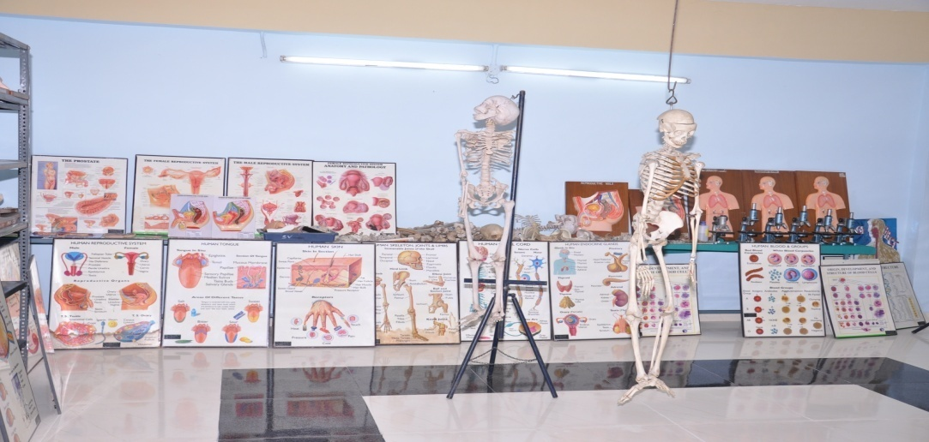 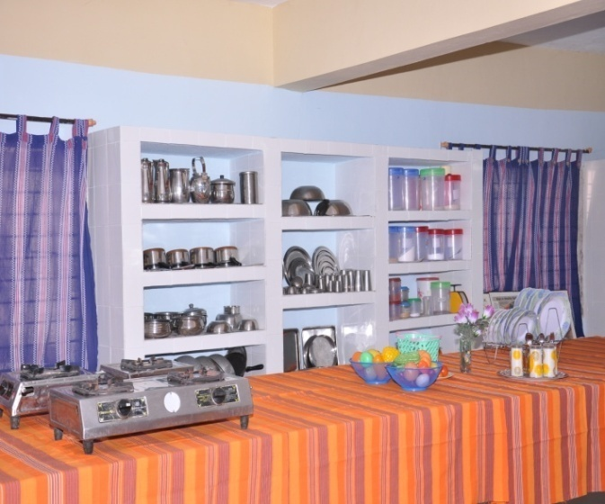 ANATOMY LAB NUTRITION LAB MEDICAL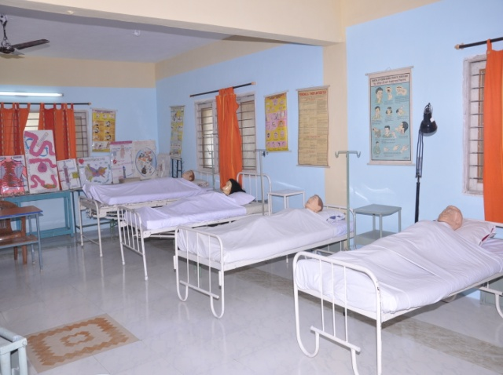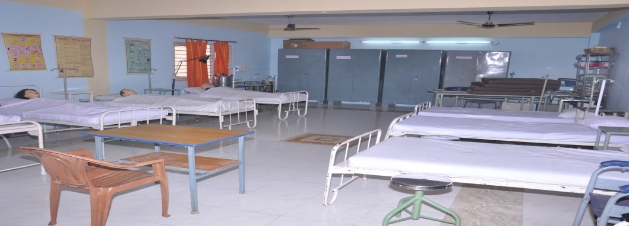

FU

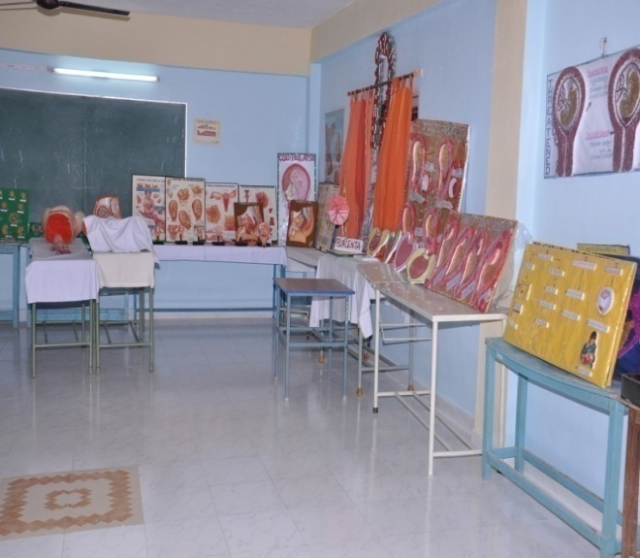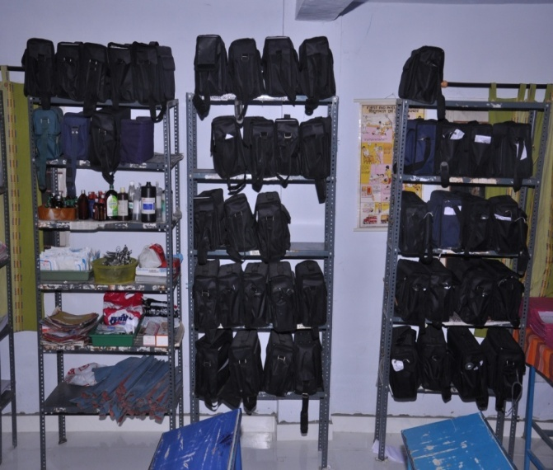
MCH LAB COMMUNITY LAB

LIBRARY AND JOURNALS
COMPUTER LAB

SEMINAR HALL

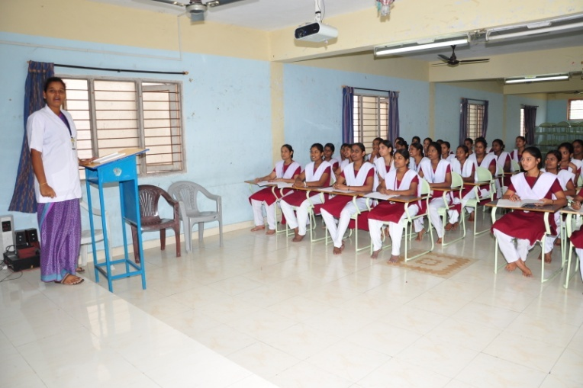

CLASS ROOMS
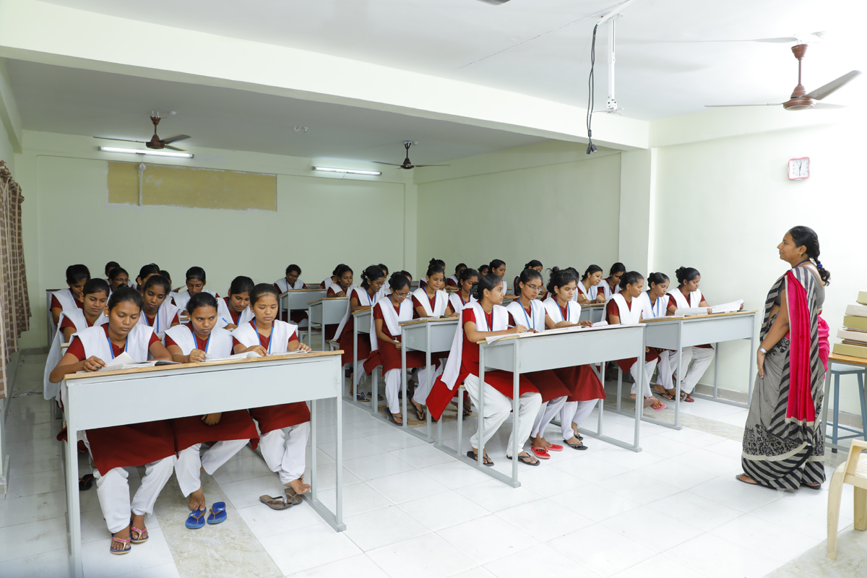

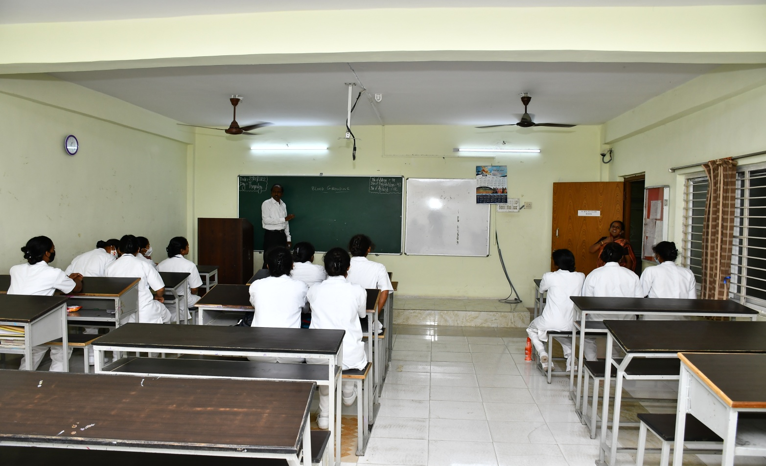

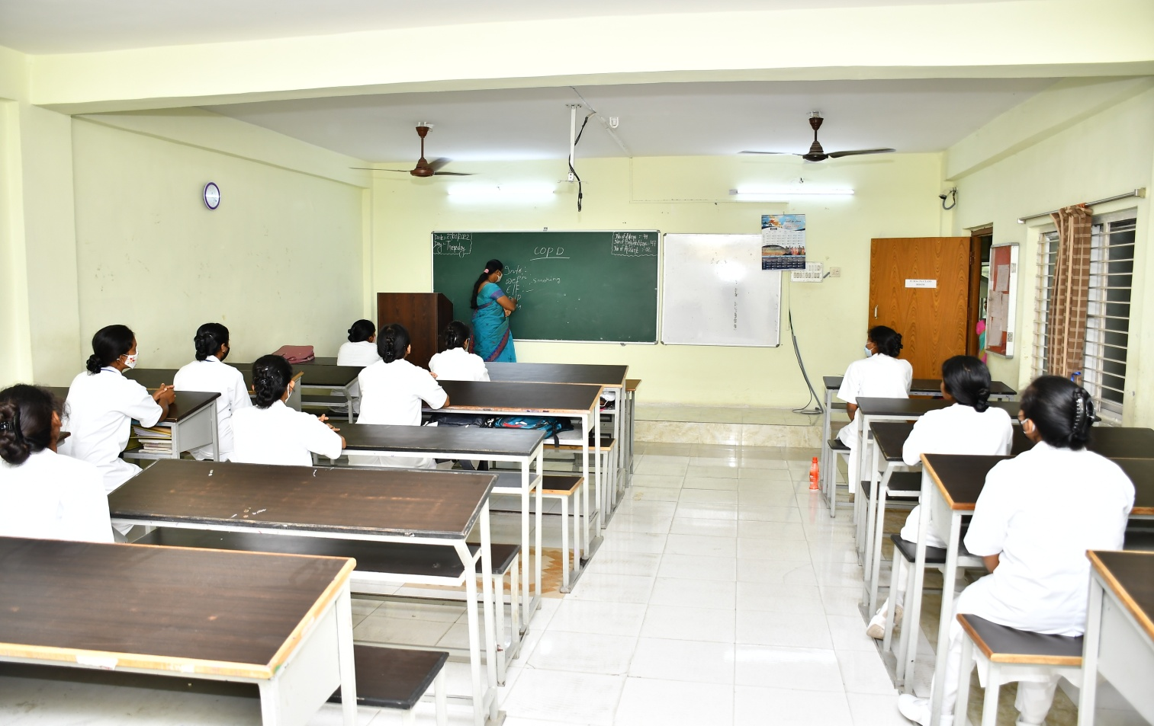

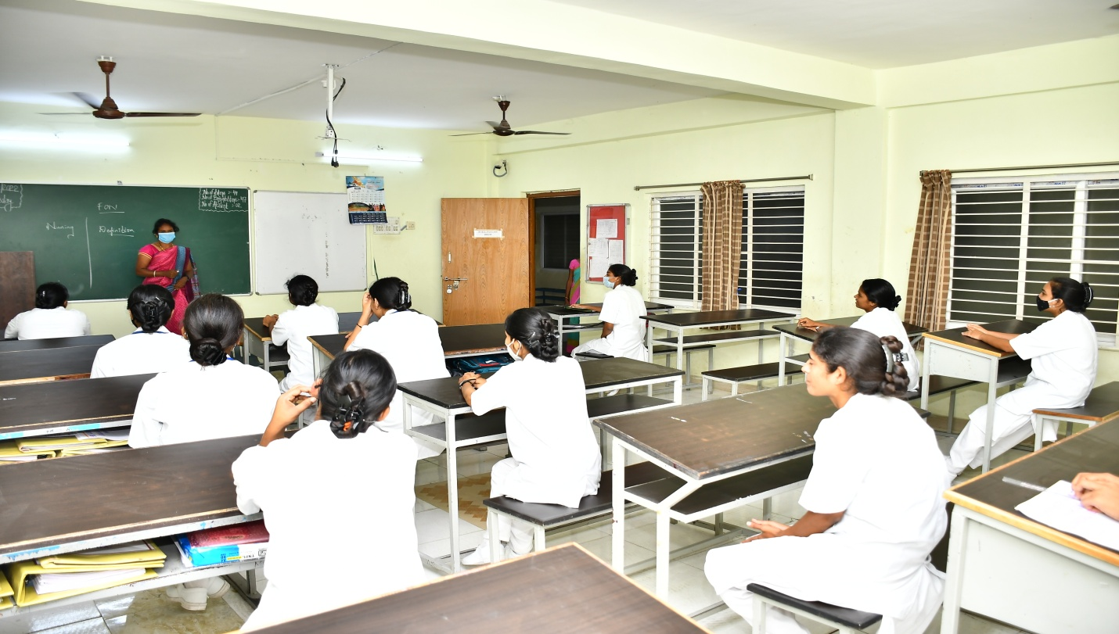

4.1.2 Additional facilities for sports and extracurricular activities
Our institution has separate committee for sports. sports committee members arrange these sports meet annually during fresher’s party and farewell party students are allowed in conduct the games for the respective batches.
Hostel campus is having gymnasium on the students are allowed to do workout in the gym during their leisure time.
We have seminar hall in the college which can accommodate all BSc nursing students at once and all the celebrations are celebrated their by the students .all the formal meeting for the students also conducted in the seminar hall.
4.1.3: Measures to ensure your campus safety and security for students faculty staff and visitors
- The institution is highly committed to providing and promoting a safe environment for our students faculty staff and visitors
- The office of safety and security maintain a visible presence throughout our campusand is readily available to serve and assist while ensuring that our campus remains secure for 24 × 7
- Educating our students in security issues personal safety measures and protective strategies are all part of services that we provide during practical proper performance in the laboratory
- Provision of first aid kit is made in each laboratory with demarcations
- To ensure the safety of both people and property students are required to wear their ideas when inside the campus it is priority to ensure the safety of our institution by having All students and safety readily identified.
- Grievance redressal unit and an anti ragging squad under the guidance of principal have been formed to up dress the student grievance and a separate space is provided for the same.
- The college has 24 by 7 multispeciality Hospital with adequate physicians full-fledged nursing with within the campus and a speciality is also available for Transport during medical emergencies from any way to hospital medical checkup for both students and staff is conducted regularly.
. We have a Cafeteria functioning with from morning till evening providing hygienic food and beverages that drinking water units provide safe drinking water and periodically analysed for contamination.

Health services for students teaching and non teaching staff
Our students have free medical services in our parents Hospital (RVS Hospital) periodical health check up will be done by the class coordinator monthly.
hepatitis vaccination and basic blood investigation for the BSc nursing first year students will be done by the institution with concession.
Provision of first aid kit is made in each laboratory with demarcation of place .
An ambulance facility is also available for transport during medical emergencies from anywhere to hospital.
for the teaching and non teaching staff of the college, 50% concession will be given by our parents hospital.

.

LIST OF LABORATORY WITH PROVIDE FACILITIES:

Name of the laboratory | Facility provided | Subject | As a learning resources
Anatomy and physiology laboratory | Rome cycle provider water supply lightning and all the models of our body system | Anatomy and Physiology | - Able to identify various parts of the body with its names  - Identify different types of bones and its functions  - Usage of stereo models  - Able to perform demonstration and Viva regarding anatomy and physiology of human body
2. Fundamentals of nursing lab | Rooms equipped with the solutions water supply lightning and the articles needed for basic procedures | Nursing foundations | - Able to identify various types of equipment  - able to prepare various types of tray setups  - able to know the various names of equipments  - able to know the various types of sheets for bed making  - able to handle the equipments during the procedure  - able to maintain body Mechanics by the students during the procedure  - able to safeguard the equipment after handling  - able to know the process of sterilizing the equipments  - .able to handle the rubber materials
 | First aid equipments | First aid | - Able to identify various kinds of first aid material  - able to identify different names of bandages  - able to apply different types of bandages to provide comprehensive nursing care  - able to know wound cleaning and dressing to patients
3. Medical surgical nursing lab | Rooms equipped with mannequins, solutions ,surgical instruments ,simulators water supply ,lighting and the articles needed for basic procedure | Medical surgical nursing I&II | - Able to identify the setup of the lab  - able to perform nursing procedures for providing comprehensive nursing care  - able to handle the equipment during nursing procedure  - able to handle the suturing material during wound care  - Able to know tray setup for different types of nursing procedures  - able to replace the equipment properly after the usage
4.maternal and child health nursing | Rooms equipped with the mannequin solutions instruments needed for labour process simulator water supply lighting and the articles needed for basic procedures | Obstetrics and gynaecology | - Understand the mechanism of delivery  - able to know the setup of the lab  - able to names of various equipments  - able to conduct delivery with sterile technique  - able to provide newborn care with sterile technique  - able to observe abnormal delivery process  - able to assist the doctors during difficult deliveries  - provide comprehensive nursing care to mother  - able to provide sitzs bath to postnatal mother  - able to provide antenatal assessment to mother  - able to perform postnatal assessment to mothers
 | Rooms equipped with the mannequins,solutions,surgical instruments, simulators,water supply, lighting and the articles needed for basic procedures | Child health nursing | - Able to know newborn assessment  - assess APGAR score to newborn  - Perform new born assessments and neonatal reflexes for newborn babies  - Provide baby bath  - Able to educate breast feeding technique to antenatal and postnatal mothers  - able to educate mother craft  - able to provide care to baby under phototherapy ,incubator, warmer  - able to handle the baby in an NICU  - able to provide comprehensive nursing care to baby by allowing rooming in
Community health nursing laboratory | Rooms equipped with the solutions, instruments, community bags ,water supply, lighting and the articles needed for community procedures | Community health nursing | - Able to draw map about community areas  - able to set community bag  - able to know the processes in community  - able to do dressings, baby bath, newborn reflexes  - able to do urine test and eye irrigation  - able to handle the babies while doing baby bath in community setting  - able to do antenatal and postnatal assessment in community  - able to sterilize the articles after the procedure  - able to perform bag techniques while doing the procedure  - able to collect the history from patient and family members  - able to replace the article in bag after the procedure  - able to provide comprehensive nursing care to community people
Nutrition laboratory | Rooms equipped with all the articles needed for cooking induction stove water supply lighting and the articles needed for cooking procedures | Community health nursing medical surgical optics and gynaecology child health nursing and mental health nursing | 1.Able to identify the physical setup of the lab  2. able to understand the nutritive values of various food items  3.able to prepare diet according to patients disease condition  4. able to prepare diet plan for various age groups like under five children malnourished children antenatal mothers personal mothers and old age people  5. able to prepare food aesthetically  6.able to prepare food by following cooking principles
Audio visual aids laboratory | Rooms equipped with all the audio visual materials, OHP,water supply and lighting | Medical surgical nursing, obstetrics and gynecology,child health nursing, mental health nursing and community health nursing | - able to know the different types of audio visual AIDS used for teaching  - able to choose the selection of AV AIDS during micro teaching  - able to handle preparation of different A.V aids like charts OHP ,LCDetc

4.2 Clinical Learning Resources
4.2.1 Teaching Hospital
- Year of establishment : June 2009

- Hospital institution distance : 100 meter

- Owned by the college or affiliated to any other institution : Own hospital

- The teaching hospitals and laboratories are accredited by NABH, NABL or any other national or international accrediting agency : No

- Number of beds : 350 beds

- Number of specialty services : 5 (Medicine, Surgery, Pediatrics, Gynecology and Obstetrics, Orthopedics).

- Number of super-specialty services : No

- Number of beds in ICU / ICCU / PICU / NICU, etc.
ICU – 6 beds
ICCU – 2 beds
PICU – 2 beds
NICU – 2 beds
Dialysis – 2 beds

- Number of operation theatres : 03

- Number of Diagnostic Service Departments: 02

- Clinical Laboratories : 05

- Service areas viz. laundry, kitchen, CSSD, Backup power supply, AC plant, Manifold Rooms, Nursing services : Yes

- Blood Bank services : Yes

- Ambulance services : Yes

- Hospital Nursing services : Yes

- Drug poison information service : Yes

- Pharmacovigilance : Yes

- Mortuary, cold storage facility : Yes

- Display the services provided free of cost : Yes

- Display charges levied for the paid services : Yes
- Names of the faculty and their field of specialization displayed prominently in the hospital : Yes
- Pictorial representation of the various areas of the hospital is displayed in a manner to be understood by illiterate patients : Yes
- There is a prominent display of ante-natal, mother and child health care facilities : Yes.
- Hospital ensures dissemination of factual information regarding rights, responsibilities and the health care costs to patient and the relatives/attendants : Hospital ensures that proper informed consent is obtained
- Hospital have well-defined policies for prevention of hospital-acquired infections : Yes.
- Hospital have good clinical practice guidelines and standard operating procedures : Yes.
- Hospital have effective systems for disposal of bio-hazardous waste : Yes.
- Hospital ensures the safety of the patients, students, doctors and other health care workers especially in emergency department, critical care unit and operation theatres : providing personal protective equipments to the staffs, doctors and staffs. Proper sign boards to direct the patients. Fire extinguisher present in all the floors and training was provided to all the staffs to operate in emergency.
- Safety measures are displayed in the relevant areas : Yes
- Casualty services/Accident and Emergency Services are organized and effectively managed : Yes
- Hospital provides patient friendly help-desks at various places : Yes.
- Hospital have medical insurance help desk : No
- Other measures are taken to make the hospital patient friendly : by providing empathetic care by the staff.
- Hospital achieves continuous quality improvement in patient care and safety?
By taking feedback forms the patient before discharge.
- What are the measures available for collecting feedback information from patients and for remedial actions based on such information?
Patients either can give the feedback forms directly to staff or to place them in the feedback box while leaving the hospital. Then the supervisors/HR will read them and take steps accordingly.
- How does the institution ensure uniformity in treatment administered by the therapists?
By the feedback forms
- Does the institution conduct any orientation training program for AYUSH-based Para-medical staff?
No

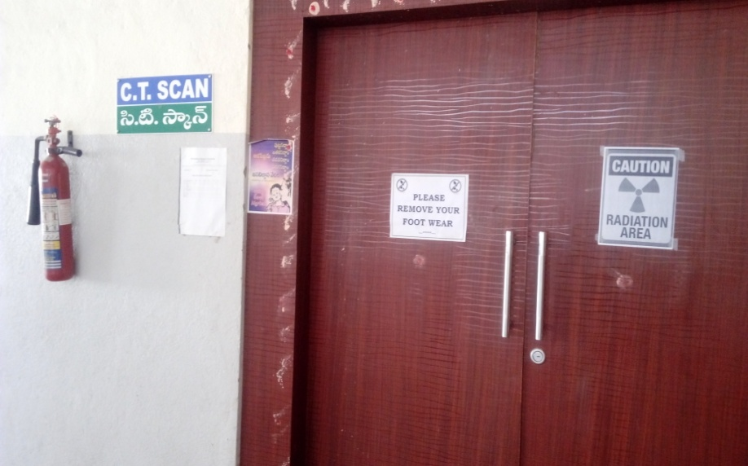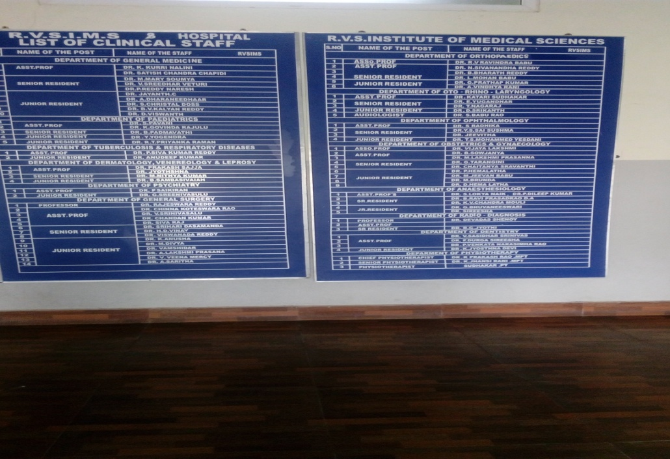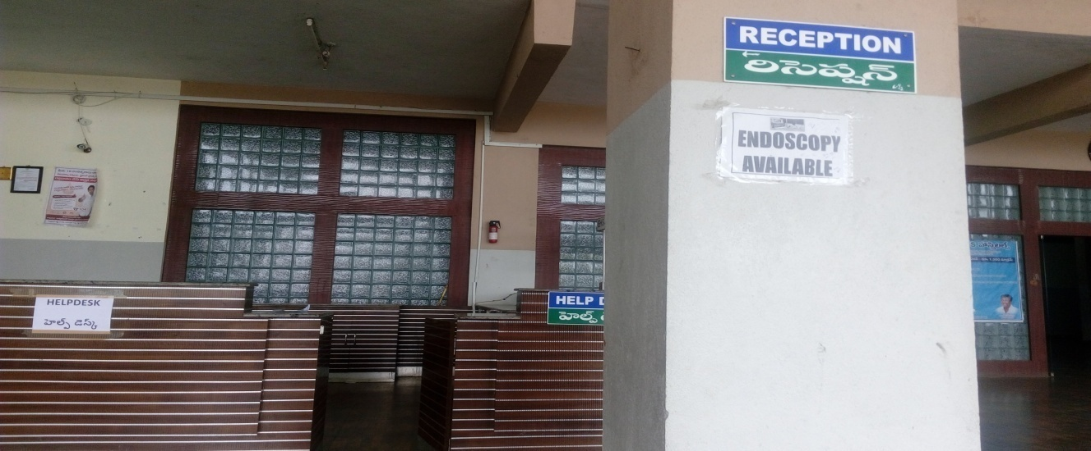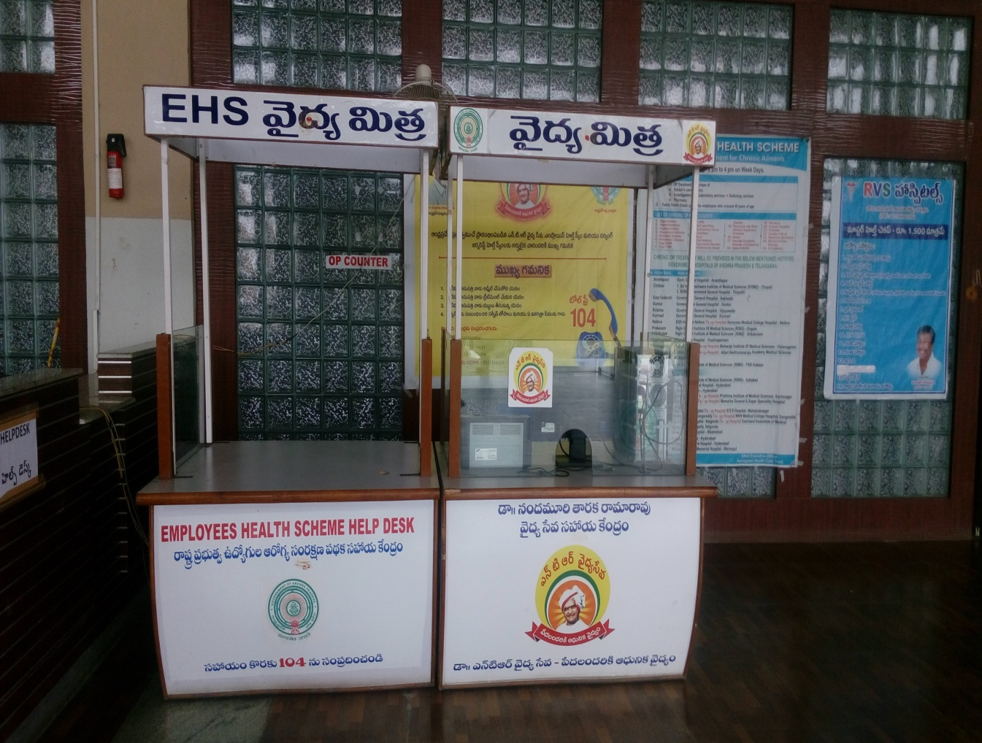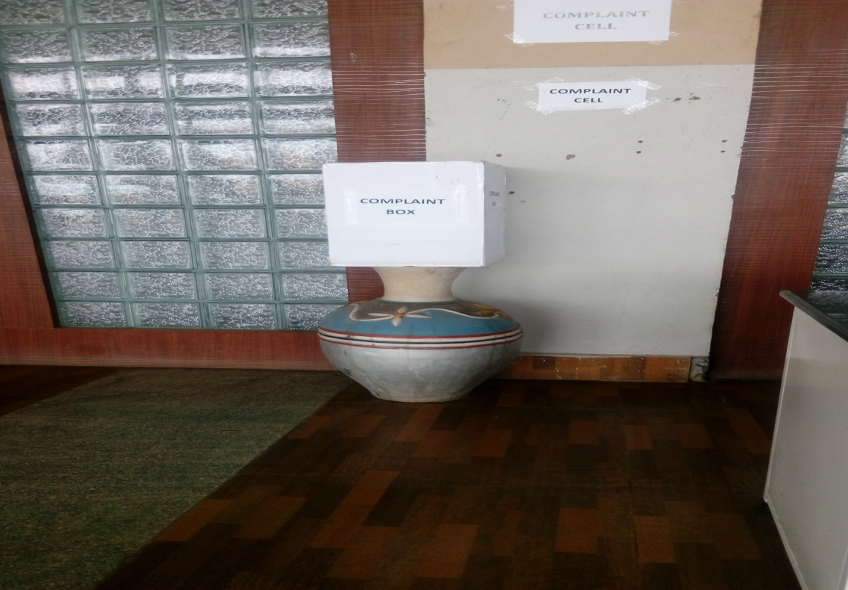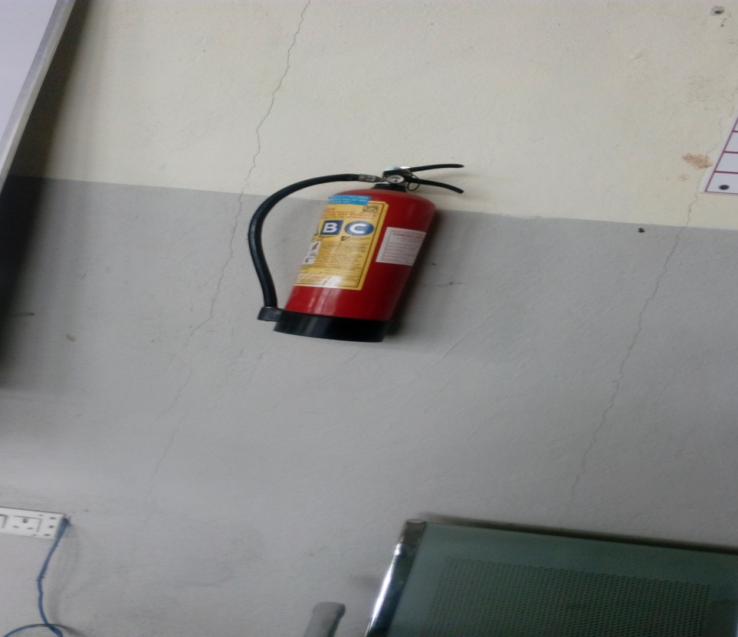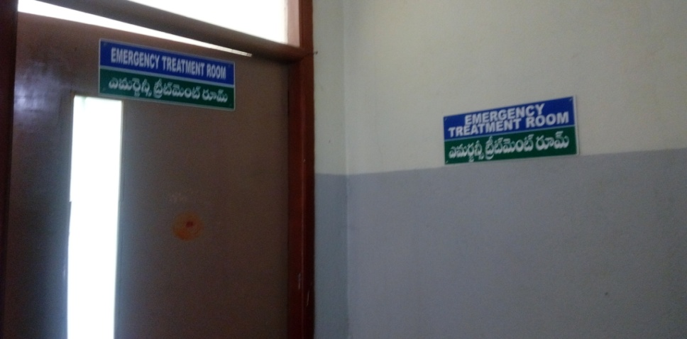

  - : LIBRARY RESOURCES IT IS IN MANJU MAIL)

LIBRARY PHYSICAL FACILITIES
NAME OF THE ITEMS | QUANTITY
CHAIR
TABLE
FANS
TUBELIGHTS
COMPUTERS
LAN FACILITY

TEXTBOOKS
JOURNALS
CD’S
QUESTION BANK

BOOK RACKS

CIRCULAR

All the library advisory committee members are requested to attend for meeting in seminar hall at
Library advisory committee
S.NO. | NAME | DESIGNATION | POST
1.

Newspapers available in the library

S.NO | Name of the Newspaper | Quantity
1 | Eanaadu(Teugu) | 1
2 | Hindu(Engligh) | 1

2021 PURCHASED JOURNALS
S.No | Name of The Journal | Period | No.Of Issues
1 | Indian Journal Of Public Health | 1 | 4
2 | International Journal Of Neurological Nursing | 1 | 2
3 | International Journal of Obstetrics and Gynecological Nursing | 1 | 2
4 | Pediatric Nursing | 1 | 6
5 | TNC Journal Of Medical Surgical Nursing | 1 | 2
6 | The Nursing Journal Of India | 1 | 6
7 | Inventi Impact: Advance Nursing | 1 | 4
8 | Inventi Impact: Neonatal Pediatric Nursing | 1 | 4
9 | International Journal Of Community Health Nursing | 1 | 2
10 | International Journal Of Nursing Education & Research | 1 | 2
11 | Journal Of Psychiatric Nursing | 1 | 3
12 | Indian Journal Of Continuing Nursing Education | 1 | 2
13 | Research & Reviews Journal Of Surgery | 1 | 3
14 | Research & Reviews Journal Of Medical Science & Technology | 1 | 3
15 | Nightingale Nursing Times | 1 | 12
16 | International Journal Of Nursing Education | 1 | 4

4.4: IT INFRASTRUCTURE

COMPUTER EDUCATION
B.Sc Nursing I Year students have one internal subject as computer.For that class,one expert will come and take the classes for the students in the computer lab. Students have the freedom to use the computers for the practice.computer lab has LAN facility with 100 mbps speed.
COMPUTER LAB:

Computing facility
The college has well equipped infrastructure in terms of hardware and software facilities to use ICT(information and communication technology) solutions in nursing. The details of IT infrastructure are given as under:
S.No | SPECIFICATION | NUMBER
1 | Desktop
2 | Laptop
3 | Projector
4 | Software
5 | Printers
6 | Scanners
7 | DVD&writers
8 | UPS&Stabilizers

DETAILS OF CPU SPECIFICATION
S.No. | TYPE | PROCESSOR | RAM | MOTHER BOARD
1 | HCL | Intel,Pentium(R),D,CPU2.60GHZ | 512MB | Intel graphic
2 | ACER | Intel,core I3,3240-3rd Generation | 4GB | Intel graphic
3 | LENOVA | Intel .Dual core 2,Duo,13 | 1GB,4GB | Intel graphic
4 | FONTECH | Intel Pentium (R),4 | 128MB | P4
Computer -student ratio:The computers are utilized by the student in 1:6 ratio
LAN facility
- Yes .20 computers LAN connected,100 mbps,BSNL broadband connection.
- Wi-Fi facility :yes.Reliance jio connection is available.
- Number of nodes/computers with internet facility :20
- Internet provider: BSNL,Division ,9512kbps/connection:20 connections)
Basic software
Window XP SP3+Windowa 7
Microsoft office 2007
360 security antivirus
Data processing software
Tally 9.0
Student software
Nursing software
SPSS software
Criterion -IV :INFRASTRUCTURE &LEARNING RESOURCES
Institutional plans and strategies for deploying and upgrading the IT infrastructure and associated facilities
Sequential up gradation plans are included every year
* The activities have been planned in such a way that,to make the college campus as Wi-Fi campus ,and up gradation of all the systems with latest software versions and to provide additional printers ,scanners with latest technology.
* Computer laboratory with internet facilities functioning from 09:00 to 17:30 during working days.the institution also has system administrator ,laboratory assistants and electricians to maintain the computers.
*It also hires the help of computer proffesionals whenever necessary.
* The equipment in the laboratory are serviced regularly .
* Annually college plans to upgrade the computer facility for the benefit of the students (as computer laboratory) and to each staff to advocate academic related affairs like laboratory manual preparation,course planner,MCQ in subjects,GPAT model question papers etc
* As per the suggestions of IQAC and departments,facilities are upgraded from time to time.

IT Facilities available to individual teachers for effective teaching and quality research
. Staff can use institutional Laptop connected with LCD projector while taking class with . Desktop with internet facility for faculty members.
power point presentation. Also, can avaio the facility of OHP.
Each faculty can save their important documents in to storage space on the server,
. Completed research projects/ activities are stored in CDs and DVDs for lifelong retrieval process.
. Staff can use e-data base for preparing their lecture notes, for research purpose, subscription of e- journals has been availed to the entire staff as well as research scholar.
. There is laboratory of data base of all the scientific journals cited in Science Direct, and Willey science, DEL, NET & Bentham,
. Provision of audio-visual recording of guest lectures has been made for the future use by the students as well as staff members.

4.5: Campus Facilities:
Maintenance of Campus Facilities
Designated officer for overseeing the maintenance of buildings, class-rooms and laboratories
At institutional level, the maintenance and repair is communicated to a person in charge, who in turn forwards the same to the campus coordinator, who seeks the service from various approved agencies and persons. These agencies are finalized after discussions based on their past experience, quality of services and quotations.
.For electrical maintenance:
.For civil work:
.For plumbing work:
. At institution level, any services related to administration are conveyed to
.For instrument/equipment servicing and maintenance, laboratory assistants are assigned the responsibility for maintenance after discussion of the problem with the HOD in department meetings. Job card for each equipment are maintained by the laboratory Assistant.

