Curriculum Enrichment
Curriculum Enrichment are the activities which colleges provide in order to extend students' education beyond their main course of study. The commitment to providing opportunities for broadening students' educational experience is widespread throughout the further education sector.
Curriculum Enrichment provides students with the chance to acquire mastery of standards at a deeper level than what is outlined in the required curriculum.

Importance of Curriculum Enrichment
- Enrichment promotes critical thinking and problem solving skills.
- It improve student's ability to concentrate.
- It makes learning more meaningful, valuable, and rewarding.
- Enrichment activities provides fun, which helps students to become more engaged in their learning and retain more information.
- It provide extended learning opportunities and challenges to students who have already mastered, or can quickly master, the basic curriculum.
- It gives the student more time to study concepts with greater depth, breadth, and complexity.

Curriculim Enrichment (2020-2021)
1.Poster presentation( 25 January 2021)
2.Research projects(10th February 2021)
3.School health program (18thMarch 2021)
4.Quiz competition on Nursing challenges-(15thApril 2021)
5.Model making(30thApril 2021)
6.Mass media program(31st August 2021)
7.Symphoism(6thSeptember 2021)

1.Poster presentation( 25 January 2021)
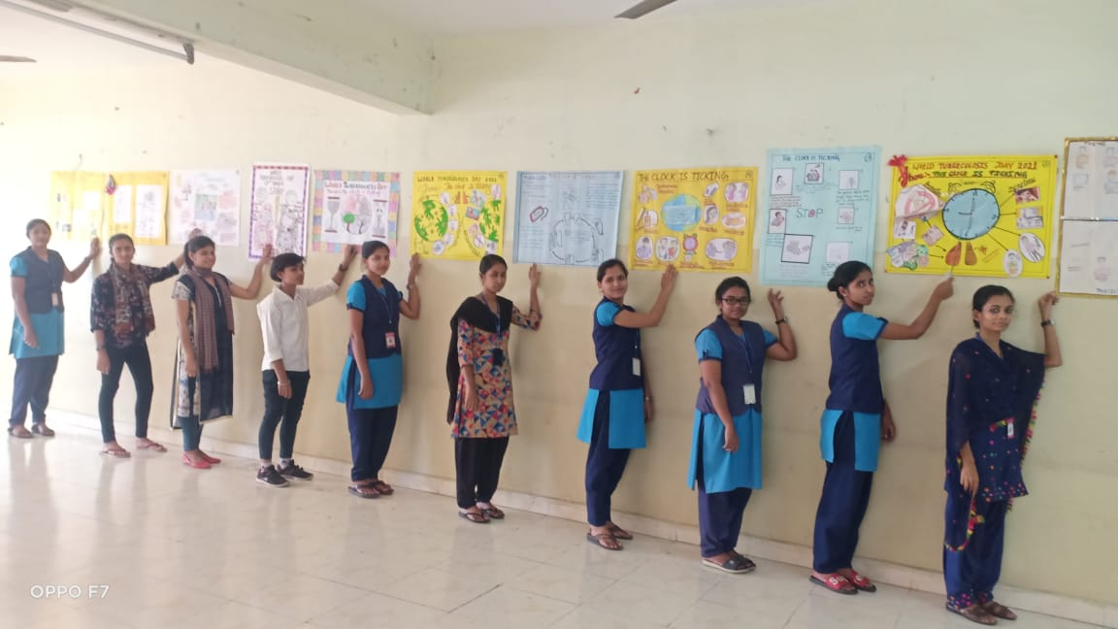

2.Research program(10th February 2021)
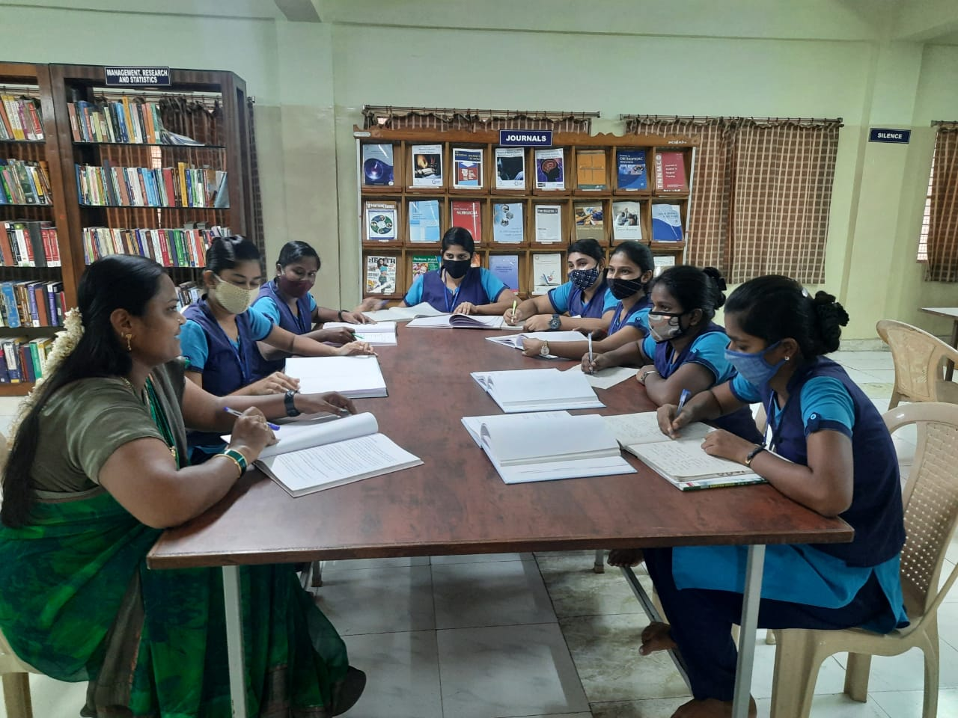

3.School health program (18th March 2021)
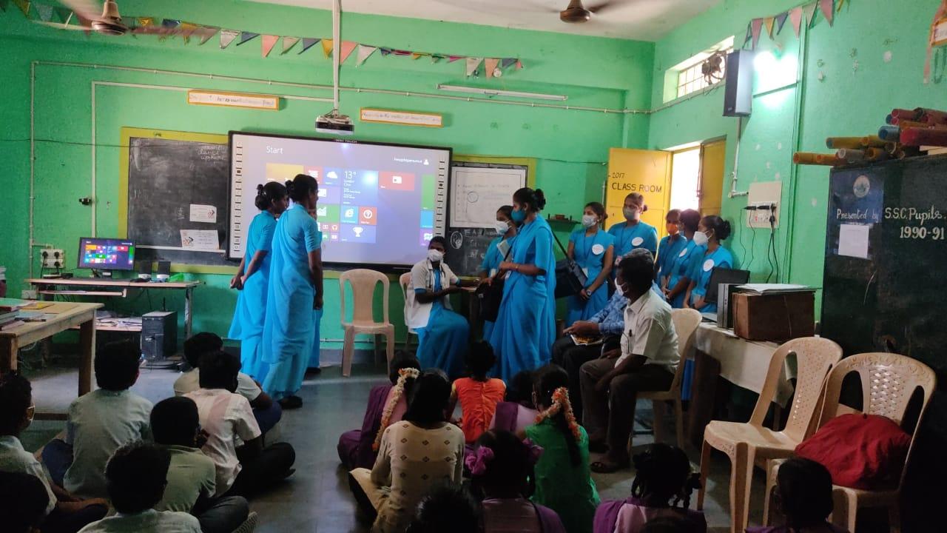
4.Quiz competition on Nursing challenges(15th April 2021)
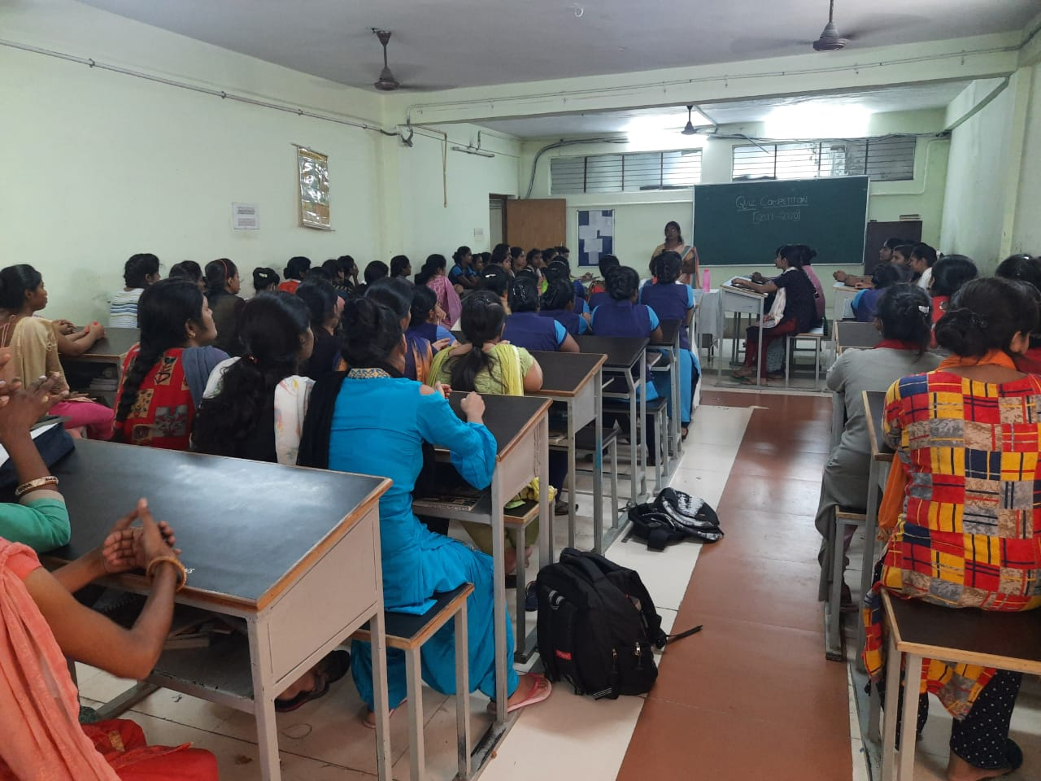

5.Model making(30th April 2021)
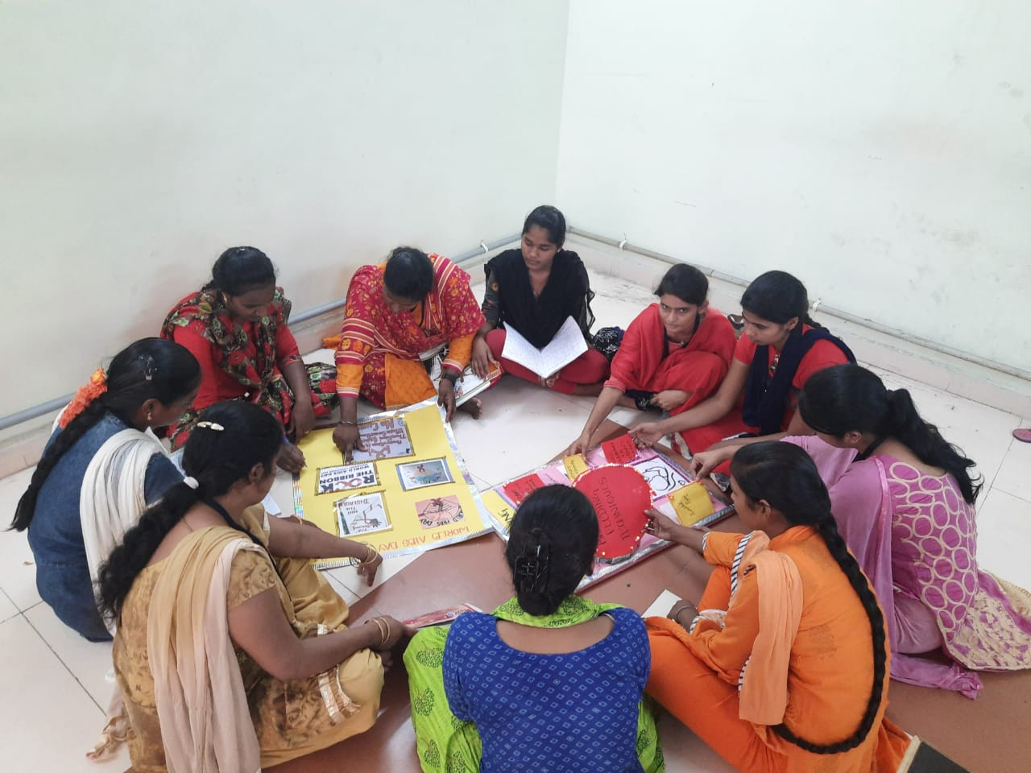
6.Mass media program ( 24th January 2020)
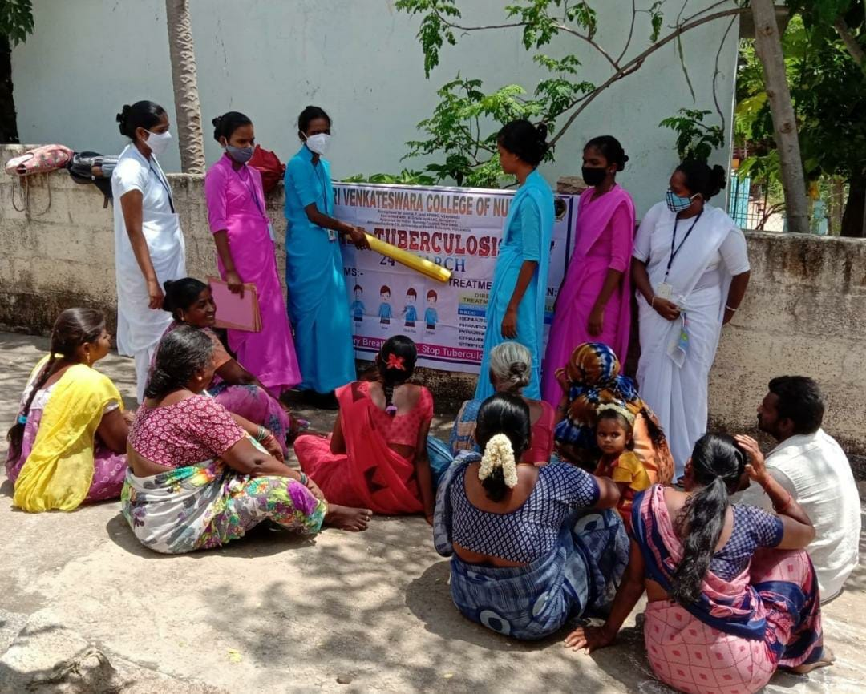

7.Symposium(6th September 2021)

S.No | Value Added course | Date of Introduction | Number of students Enrollment
1 | Poster presentation | 25 January 2021 | 20
2 | Research projects | 10th February 2021 | 49
3 | School health program | 18thMarch 2021 | 49
4 | Quiz competition on Nursing challenges | 15thApril 2021 | 20
5 | Model making | 30thApril 2021 | 30
6 | Mass media program | 31st August 2021 | 49
7 | Symphoism | 6thSeptember 2021 | 30

