SRI VENKATESWARA COLLEGE OF NURSING, CHITTOOR, ANDHRA PRADESH
The Red Ribbon Club at Sri Venkateswara College of Nursing motivates young nursing students to build their capacity as peer educators and change agents by developing their skills on leadership, negotiation and team building.
BASIC CONCEPTS OF RRC
* Red Ribbon was created in 1991 by the visual AIDS Artists Causus, New York City, America
* The color of red was then chosen as it symbolizes the color of the BLOOD, the idea of PASSION- not only ANGER but also by LOVE.
* The Red Ribbon is the international symbol of HIV/AIDS awareness.
* BY Wearing a Red Ribbon – Care & Concern for those living with HIV/AIDS
* Support to the organizations that care for the HIV/AIDS
RED RIBBON CLUB (RRC)
Red Ribbon Club (RRC) is a voluntary on campus intervention is being implemented in the higher educational Institutions, aiming at heightening their risk perception and preventing HIV as well as promoting voluntary blood donation among youth between 17-25 years of age with department of higher education, technical support from TANSANCS.
OBJECTIVES:
* To reduce new HIV infection among youth by raising their risk perception through awareness on sex, sexuality and HIV/AIDS.
* To induce the spirit among youth to help and support people living with HIV/AIDS (PLHIV) thereby reducing stigma and discrimination against PLHIVs.
* To motivate youth and build their capacity as peer educators and change agents by developing their skills on leadership, negotiation and team building
* To promote voluntary non- remunerated Blood donation among youth.

REPORT ON HIV/AIDS RALLY 1st December, 2021
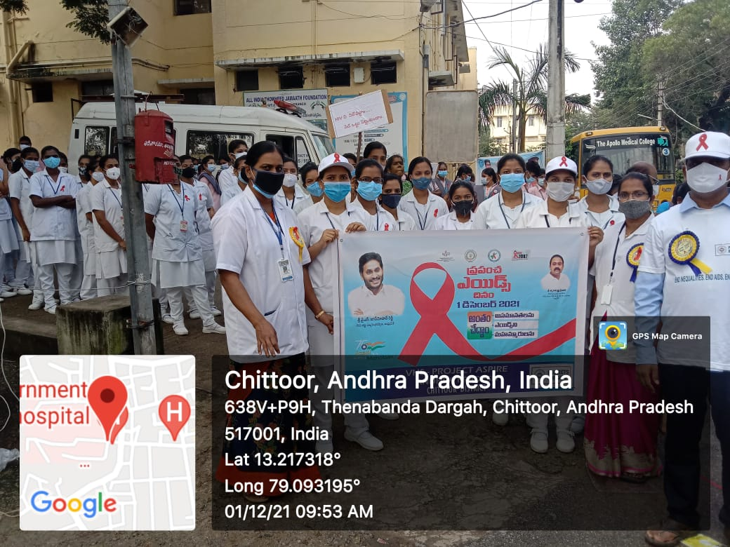
On 1st December, 2021 we celebrated as World HIV/AIDS Day. The theme of 2021 year is “End inequalities. End AIDS”. With a special focus on reaching people left behind, WHO and its partners are highlighting the growing inequalities in access to essential HIV services.
The rally started at 10:00am from Government Hospital, Chittoor to PCR Circle, Chittoor . 3rd year& 4th year B.Sc.Nursing students of SVCON College, Chittoor, along with ASHA workers, Volunteers organization, Scout members participated.

