SRI VENKATESWARA COLLEGE OF NURSING
Recognized by Govt. AP & APNMC, Vijayawada,
Accredited with ‘A’ Grade by NAAC, Bengaluru,
Approved by Indian Nursing Council, New Delhi,
Affiliated to Dr. NTR University of Health Sciences, Vijayawada,
RVS Nagar, Tirupati Road, Chittoor, Andhra Pradesh
CRITERION VI- GOVERNANCE AND LEADERSHIP AND MANAGEMENT
6.1. INSTITUTIONAL VISION AND LEADERSHIP
- vision and mission
- NSS and SNA activities, Medical Camps, Special Days
- Guest Lectures
- Student Seminar research projects
- E- Governance
- Organization and management
- Interaction with stakeholders (Alumni Meeting)
- Reinforcing culture of excellence
- Mentor-Mentee system
- Composition of Committee
- Culture of participative management
- Knowledge management strategy
- Values reflected in the functioning of the institution
- Projected budgetary provisions
6.2 STATERGY DEVELOPMENT AND DEPLOYMENT
- Policies and strategies
- Organizational Structure: Roles and Responsibilities
        - Governing Body
- Regular meetings
- Grievance redressed cell
- Student feedback form for the faculty

6.1. INSTITUTIONAL VISION AND LEADERSHIP
- vision and mission
- NSS and SNA activities, Medical Camps, Special Days
- Guest Lectures
- Student Seminar research projects
- E- Governance
- Organization and management
- Interaction with stakeholders (Alumni Meeting)
- Reinforcing culture of excellence
- Mentor-Mentee system
- Composition of Committee
- Culture of participative management
- Knowledge management strategy
- Values reflected in the functioning of the institution
- Projected budgetary provisions

SRI VENKATESWARA COLLEGE OF NURSING
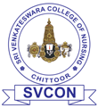
Recognized by Govt. AP & APNMC, Vijayawada,
Accredited with ‘A’ Grade by NAAC, Bengaluru,
Approved by Indian Nursing Council, New Delhi,
Affiliated to Dr. NTR University of Health Sciences, Vijayawada,
_RVS Nagar, Tirupati Road, Chittoor, Andhra Pradesh
VISION, MISSION @MOTTO

VISION
TO create leaders in Global Nursing and Health Care Services, who render optimal patient care with passion and compassion for upliftment of the society.

MISSION
To provide best nurses for enhancing health care by impairing quality and adopting best global practices in nursing education

PRINCIPAL

SRI VENKATESWARA COLLEGE OF NURSING
Recognized by Govt. AP & APNMC, Vijayawada,
Accredited with ‘A’ Grade by NAAC, Bengaluru,
Approved by Indian Nursing Council, New Delhi,
Affiliated to Dr. NTR University of Health Sciences, Vijayawada,
_RVS Nagar, Tirupati Road, Chittoor, Andhra Pradesh
NSS ACTIVITES FOR THE ACADEMIC YEAR 2017
S.No | NAME OF THE EVENT | DATE AND PLACE | ACTIVITIES CONDUCTED | NO OF VOLUNTEERS PARTICIPATED | EVENT CO-ORDINATOR
1.  2. | Pulse polio programmee  Blood donation camp | 29-1-2017 to  31-1-2017  03-4-2018,RVS Institute of medical science&Srivenkata  Sai charitable trust blood bank, Tirupathi. | immunization  Blood donation | 35  50 | MS.G.Anusha  MS.G.Anusha

PRINCIPAl

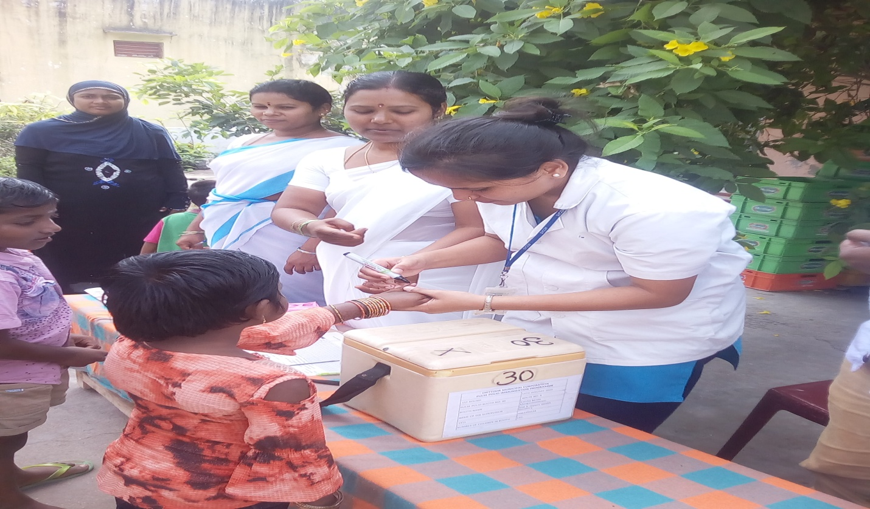
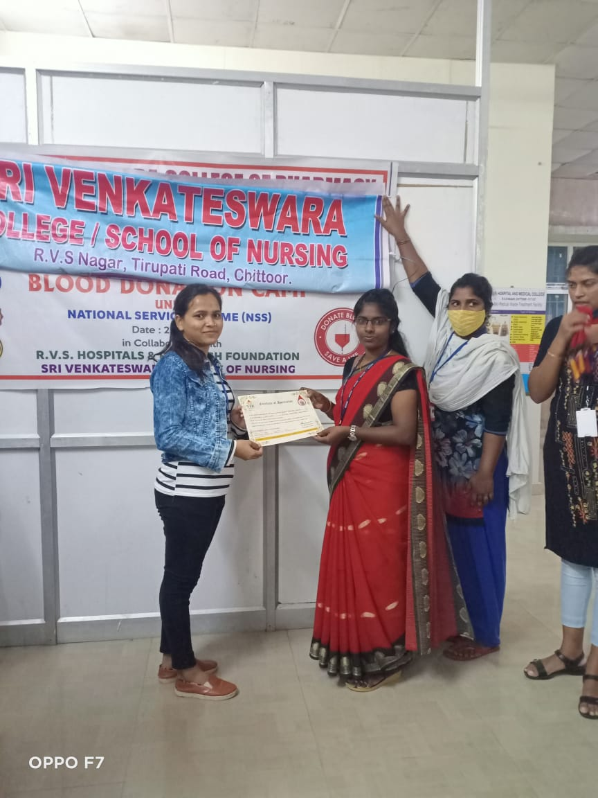
SRI VENKATESWARA COLLEGE OF NURSING
Recognized by Govt. AP & APNMC, Vijayawada,
Accredited with ‘A’ Grade by NAAC, Bengaluru,
Approved by Indian Nursing Council, New Delhi,
Affiliated to Dr. NTR University of Health Sciences, Vijayawada,
_RVS Nagar, Tirupati Road, Chittoor, Andhra Pradesh

NSS ACTIVITES FOR THE ACADEMIC YEAR 2017

PRINCIPAL

S.No | NAME OF THE EVENT | DATE AND PLACE | ACTIVITIES CONDUCTED | NO OF VOLUNTEERS PARTICIPATED | EVENT CO-ORDINATOR
1. | World health day | 7-4-2017 | Essay writing competition | 45 | MS.G. Anusha
2. | World Population day | 11-7-2017 | Essay competition rally for creating awareness on this year theme “ family planning-Empowering people, Developing Nations. | 50 | MS.G.Anusha
3. | World Breast feeding Week | 1-8-2017 to 7-8-2017 | Role play on breast feeding and work –Sustaining Breastfeeding Together. | 80 | MS.G. Anusha
4. | NSS Camp for 2 days | 20-12-2017 TO 21-12-2017 | Minor ailments for both adults& children. Awareness on controlling DM& HTN. Conducted medical camp for adults, old age, children, adolescents | 57 | MS.G. Anusha

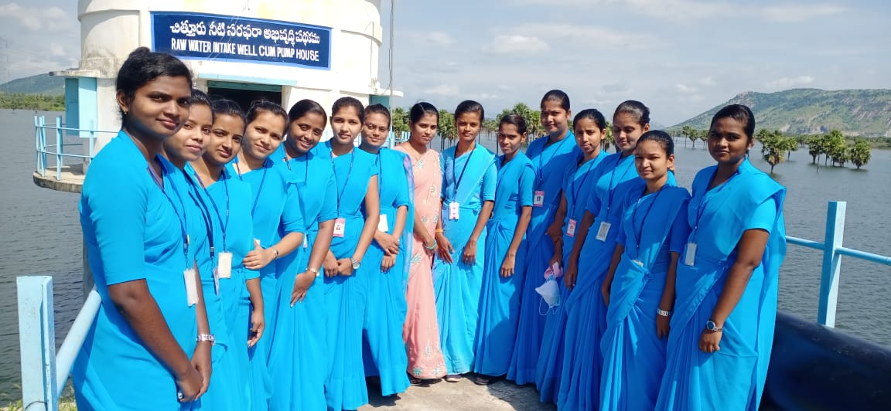

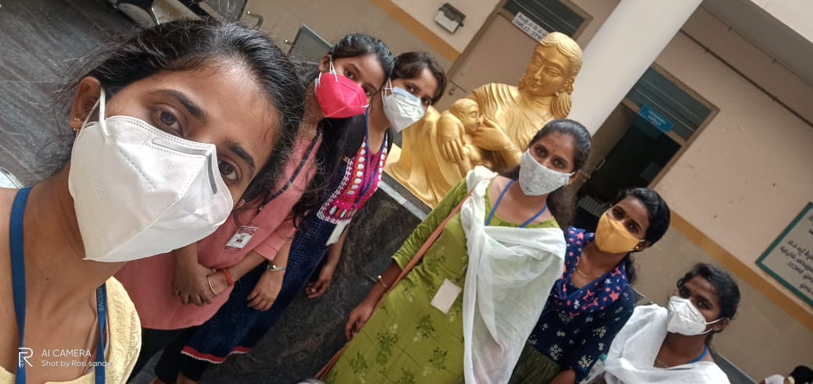

SRI VENKATESWARA COLLEGE OF NURSING
Recognized by Govt. AP & APNMC, Vijayawada,
Accredited with ‘A’ Grade by NAAC, Bengaluru,
Approved by Indian Nursing Council, New Delhi,
Affiliated to Dr. NTR University of Health Sciences, Vijayawada,
_RVS Nagar, Tirupati Road, Chittoor, Andhra Pradesh
NSS ACTIVITES FOR THE ACADEMIC YEAR 2018

S.No | NAME OF THE EVENT | DATE AND PLACE | ACTIVITIES CONDUCTED | NO OF VOLUNTEERS PARTICIPATED | EVENT CO-ORDINATOR
1. | NSS Camp for 3 days | 7-4-2018  9-7-2018 | Medical camp for adults, old age, children. Given Health Education, environmental sanitation. | 48 | Mrs. C. Radhiga
2.  3. | NSS Camp 7 days  NSS Camp for 2 days | 1-8-2018  1-8-2018  29-8-2018 to  30-8-2018 | Medical Camp for adults, adolescents children, old age  - Cooking demonstration  - Health education  (Skit, Myme, Puppet show)  - Cleaning the village& planting Tress.  - Games & entertainment  Medical camp for adults, for adults, old age, children. | 65  49 | Mrs. C. Radhiga  Mrs. C. Radhiga

PRINCIPAL

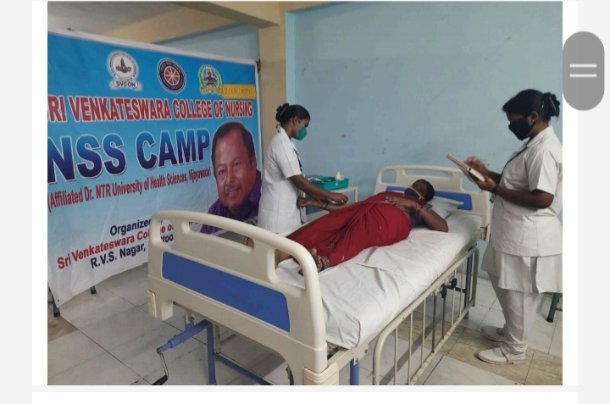
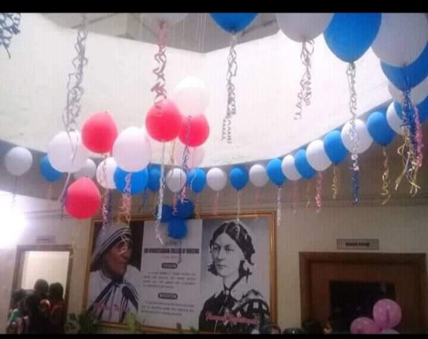

SRI VENKATESWARA COLLEGE OF NURSING
Recognized by Govt. AP & APNMC, Vijayawada,
Accredited with ‘A’ Grade by NAAC, Bengaluru,
Approved by Indian Nursing Council, New Delhi,
Affiliated to Dr. NTR University of Health Sciences, Vijayawada,
_RVS Nagar, Tirupati Road, Chittoor, Andhra Pradesh
- Health Check up Programme
- For Diabetes & Hypertension
- For Geriatric
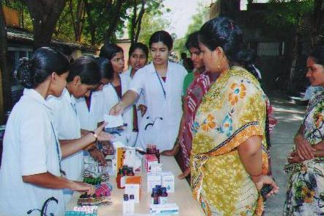
- For School children

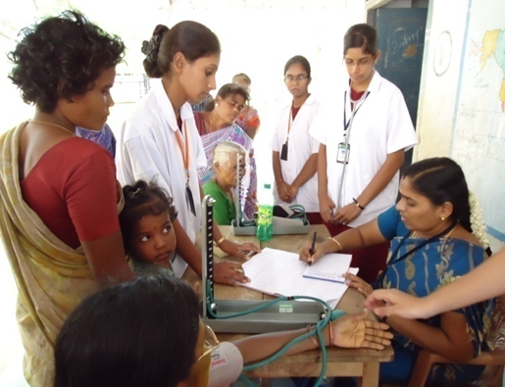

SRI VENKATESWARA COLLEGE OF NURSING
Recognized by Govt. AP & APNMC, Vijayawada,
Accredited with ‘A’ Grade by NAAC, Bengaluru,
Approved by Indian Nursing Council, New Delhi,
Affiliated to Dr. NTR University of Health Sciences, Vijayawada,
_RVS Nagar, Tirupati Road, Chittoor, Andhra Pradesh
NSS ACTIVITES FOR THE ACADEMIC YEAR - 2019

S.No | NAME OF THE EVENT | DATE AND PLACE | ACTIVITIES CONDUCTED | NO OF VOLUNTEERS PARTICIPATED | EVENT CO-ORDINATOR
1. | National pulse Polio Programme | 17-1-2019  19-1-2019 | Participated ralley on National Pulse Polio Programme,conducted pulse polio campaign | 150 | MS.G.Anusha
2.  .  3  4.  5.  6. | National pulse Polio Programme  World Tuberculosis Day  World Health Day  World Breast Feeding Week  World AIDS Day | 20-1-2019  To 23 -8-2019  7-3-2019  7-4-2019  1-8-2019 to  7-8-2019  19-12-2019 to 20-12-2019 | conducted pulse polio campaign  Quiz-Rally on unite to end TB  Awareness on the theme “Universal health coverage: everyone, everywhere”  Awareness Programme on key to sustainable development  Awareness on reducing the incidence of AIDS in the population | 150  80  40  55  50 | MS.G.Anusha  Ms G Anusha  MS.G.Anusha  MS.G.Anusha  MS. Vasantha kumari c

PRINCIPAL

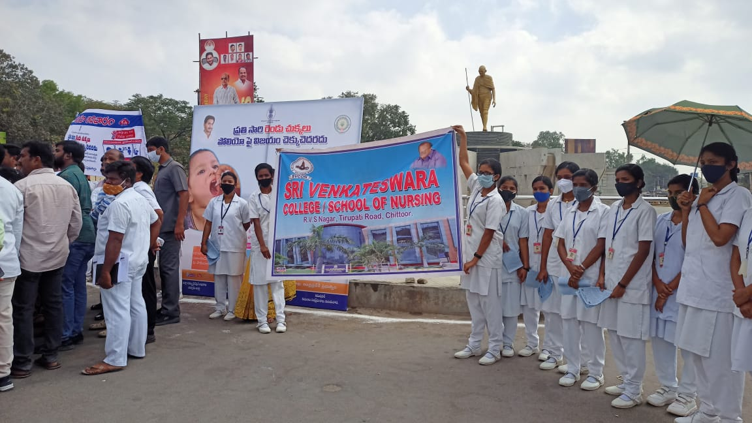
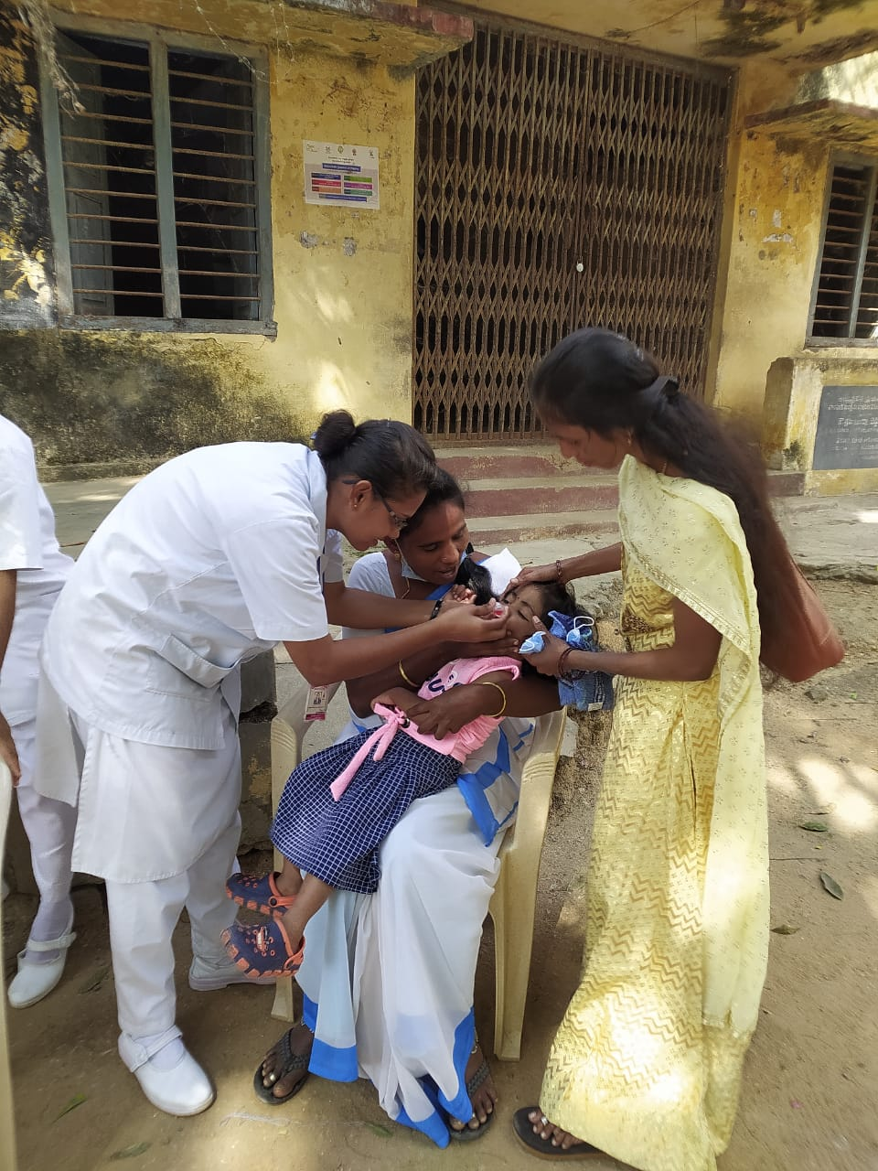
SRI VENKATESWARA COLLEGE OF NURSING
Recognized by Govt. AP & APNMC, Vijayawada,
Accredited with ‘A’ Grade by NAAC, Bengaluru,
Approved by Indian Nursing Council, New Delhi,
Affiliated to Dr. NTR University of Health Sciences, Vijayawada,
_RVS Nagar, Tirupati Road, Chittoor, Andhra Pradesh
NSS ACTIVITES FOR THE ACADEMIC YEAR - 2020
S.No | NAME OF THE EVENT | DATE AND PLACE | ACTIVITIES CONDUCTED | NO OF VOLUNTEERS PARTICIPATED | EVENT CO-ORDINATOR
1. | World Leprosy Eradication Programme | 30-1-2020 | Essay writing competition. Rally to create awareness on theme of Leprosy isn’t what you think | 50 | MS. Vasantha kumari
2 | World Cancer Day | 4-2-2020 | Essay writing competition. Mime on cancer, Awareness programme on theme of the cancer I AM and I WILL | 80 | MS. Vasantha kumari
3 | National Science Day | 28-2-2020 | Postal presentation,  Quiz. | 80 | MS. Vasantha kumari
4 | International Women’s Day | 8-3-2020 |  | 50 | MS. Vasantha kumari
5 | National Vaccination Day | 16-3-2020 | Awareness programme on immunization ,rally | 100 | MS. Vasantha kumari
6 | World Tuberculosis Day | 24-3-2020 | Quiz-Rally on Its Time to End TB | 50 | MS. Vasantha kumari

PRINCIPAL

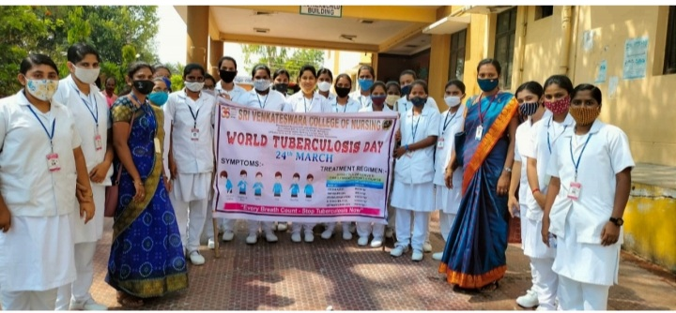
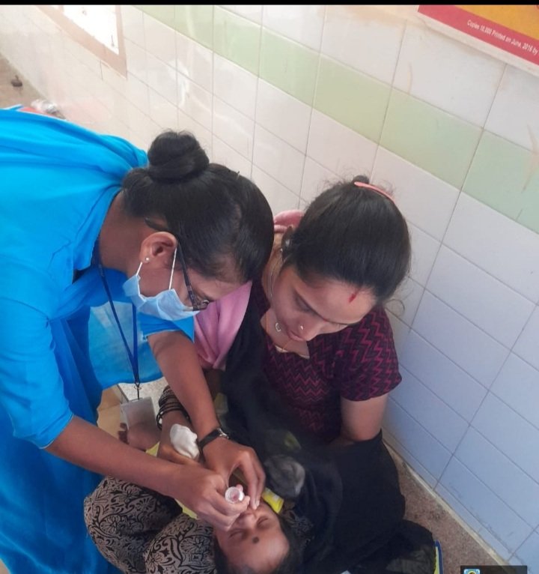
SRI VENKATESWARA COLLEGE OF NURSING
Recognized by Govt. AP & APNMC, Vijayawada,
Accredited with ‘A’ Grade by NAAC, Bengaluru,
Approved by Indian Nursing Council, New Delhi,
Affiliated to Dr. NTR University of Health Sciences, Vijayawada,
_RVS Nagar, Tirupati Road, Chittoor, Andhra Pradesh
NSS ACTIVITES FOR THE ACADEMIC YEAR – 2021

S.No | NAME OF THE EVENT | DATE AND PLACE | ACTIVITIES CONDUCTED | NO OF VOLUNTEERS PARTICIPATED | EVENT CO-ORDINATOR
1. | Mother Theresa’s birthday | 1-9-2021 | Distrubuted 150 note and pens to the needy | 100 | MS. Vasantha kumari
2 | International Day | 16-9-2021 | Awareness on importantance of Ozone | 80 | MS. Vasantha kumari
3 | Special camp | 28-9-2021TO 30-9-2021 | Awarness programme on COVID-19 | 80 | MS. Vasantha kumari
4 |  | 8-3-2020 |  | 50 | MS. Vasantha kumari
5 | Gandhi Jayanthi | 02-10-2021 | Distribution of sweets to the Children’s | 50 | MS. Vasantha kumari
6  7  8  9. | International day for Disaster Risk  Reduction  Special camp  I  World Day AIDS | 13-10-2020  10-11-2021  1-12-2021 | Awarness progeame on reduction of corona incidence  Rally on Omicron virus  Rally on AIDS Reduction of incidence | 50  100  120 | Mrs. Vasantha kumari  Mrs.Vasantha kumari  Mrs.Vasantha kumari

PRINCIPAL

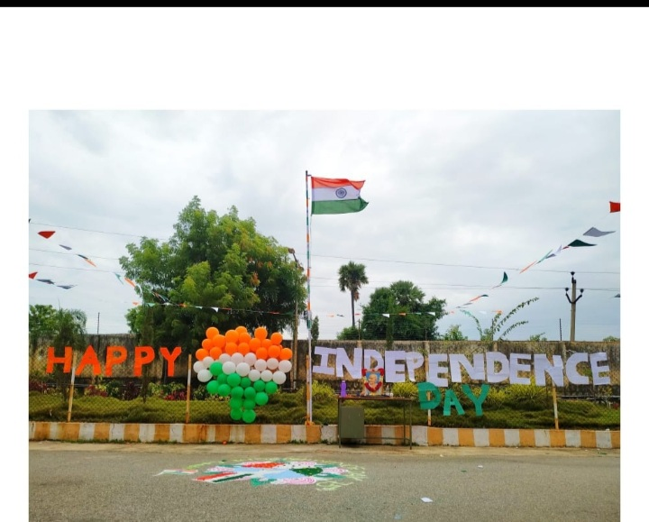
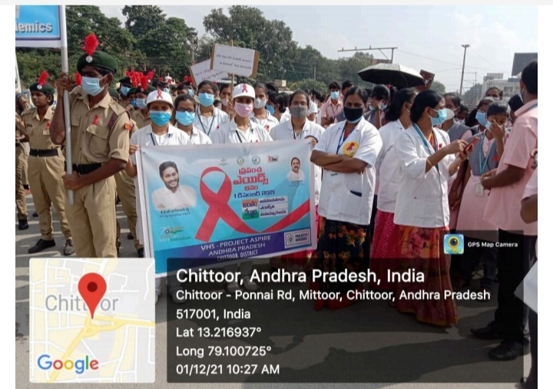
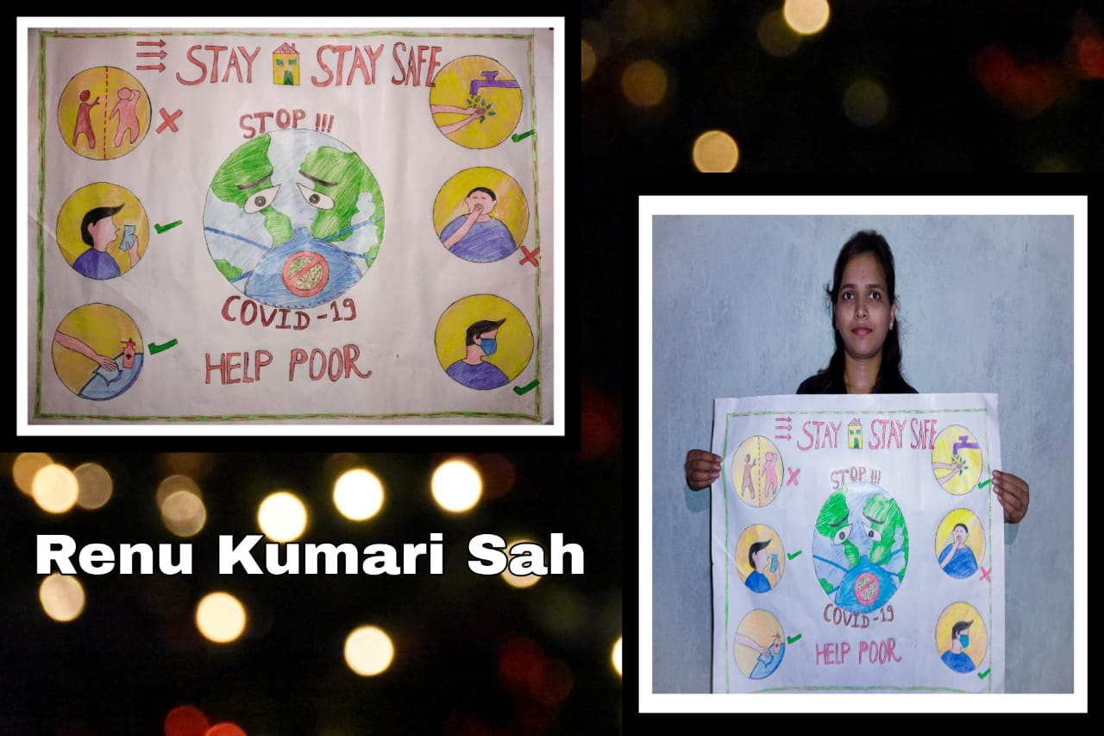
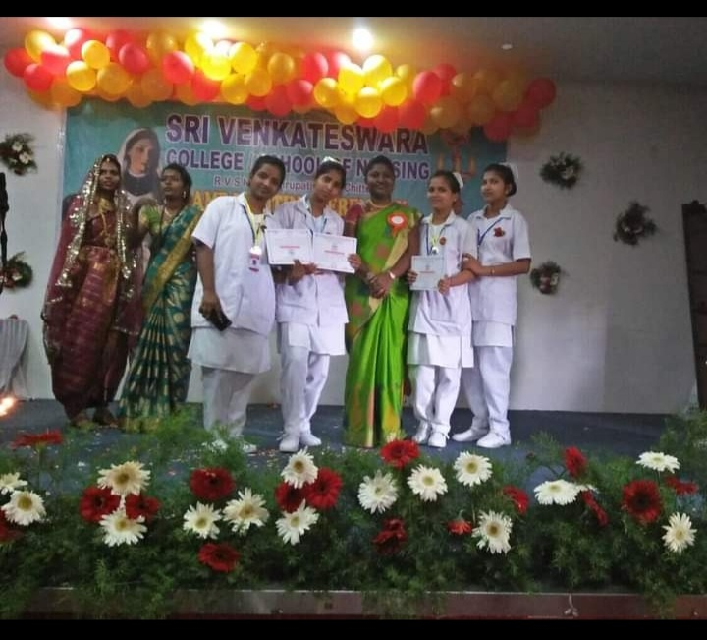
SRI VENKATESWARA COLLEGE OF NURSING
Recognized by Govt. AP & APNMC, Vijayawada,
Accredited with ‘A’ Grade by NAAC, Bengaluru,
Approved by Indian Nursing Council, New Delhi,
Affiliated to Dr. NTR University of Health Sciences, Vijayawada,
_RVS Nagar, Tirupati Road, Chittoor, Andhra Pradesh
SNA ACTIVITES FOR THE ACADEMIC YEAR –2017-2018
S.NO | NAME OF THE EVENT | DATE | ACTIVITIES CONDUCTED | SNA ADVISER
1 | Republic day | 26/1/2018 | - Hoisted National flag  - Group song  - Individual speech-8 students | Mrs.Rathiga
2 | World Tuberculosis Day | 24/3/2018 | Quiz  Measures control of tuberculosis | Mrs.Rathiga
3 | World Health Day | 7/4/2018 | Poster presentation on steps for improvement of health status | Mrs.Rathiga
4 | Nurses Day | 12/5/2018 | Quiz competition  Ralley | Mrs.Rathiga
5 | World population day | 11/7/2018 | Essay competition  Ralley  Debate competition | Mrs.Rathiga
6 | World Hepatitis Day | 28/7/2018 | Slide show on prevention of jaundice | Mrs.Rathiga
7  8  9 | Independence Day  World breast feeding week  Teachers Day | 15/8/2018  1/8/2018 to 7/8/2018  5/9/2018 | - Hoisted National flag  - Group song  Individual speech-8 students  Role play on Breast feeding, Health education on breast feeding  Indoor games  Quiz competitions  Speech | Mrs.Rathiga  Mrs.Rathiga  Mrs.Rathiga

PRINCIPAL

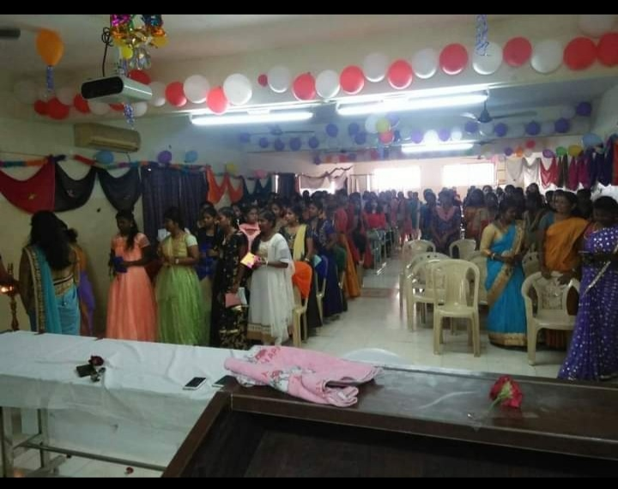
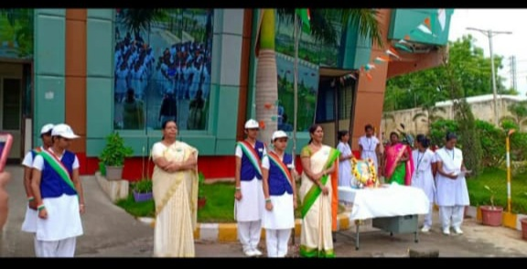
SRI VENKATESWARA COLLEGE OF NURSING
Recognized by Govt. AP & APNMC, Vijayawada,
Accredited with ‘A’ Grade by NAAC, Bengaluru,
Approved by Indian Nursing Council, New Delhi,
Affiliated to Dr. NTR University of Health Sciences, Vijayawada,
_RVS Nagar, Tirupati Road, Chittoor, Andhra Pradesh
SNA ACTIVITES FOR THE ACADEMIC YEAR –2018-2019
S.NO | NAME OF THE EVENT | DATE | ACTIVITIES CONDUCTED | SNA ADVISER
1 | Republic day | 26/1/2019 | - Hoisted National flag  - Group song  - Group dance | Mrs.Rathiga
2 | World Tuberculosis Day | 24/3/2019 | Quiz  Rally on united TB | Mrs.Rathiga
3 | World Health Day | 7/4/2019 | Poster presentation on steps for improvement of health status | Mrs.Rathiga
4 | Nurses Day | 12/5/2019 | Quiz competition  Ralley  Advaced technology | Mrs.Rathiga
5 | World population day | 11/7/2019 | Essay competition  Rally for creating awareness on this year theme vulnerable populations in emergencies | Mrs.Rathiga
6 | World Hepatitis Day | 28/7/2019 | Slide show on prevention of jaundice | Mrs.Rathiga
7  8  9 | Independence Day  World breast feeding week  Teachers Day | 15/8/2019  1/8/2019 to 7/8/2019  5/9/2019 | - Hoisted National flag  - Group song  Individual speech-8 students  Role play on Breast feeding, Health education on breast feeding  Indoor games  Quiz competitions  Speech | Mrs.Rathiga  Mrs.Rathiga  Mrs.Rathiga

PRINCIPAL

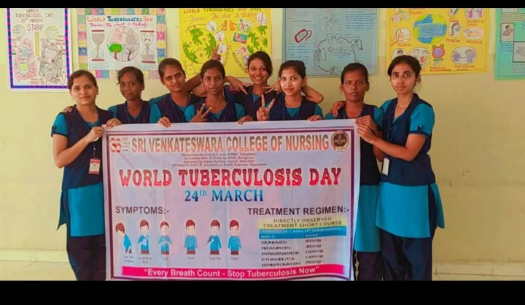

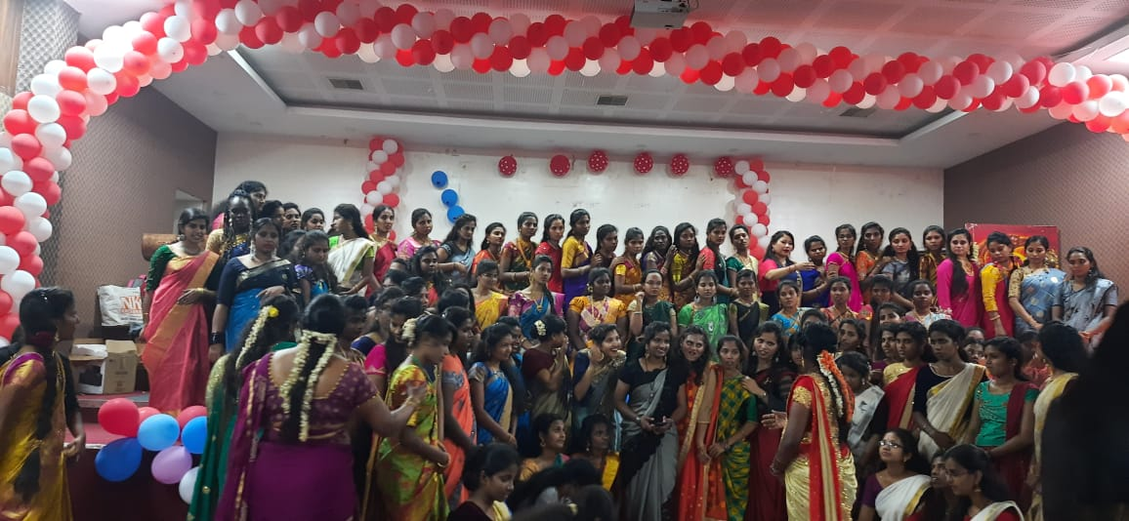
National Nurses Week - 2019

National Nurses Week was celebrated on May 12th 2019 at Sri Venkateswara College of Nursing campus to create awareness among the general public and students about the Prevention and control measures for Diabetes Mellitus.
National Nurses Week Celebrations at Sri Venkateswara College of Nursing commenced on May 12th 2019. As a part of the celebrations, patient counseling was conducted at RVS Hospital, Chittoor. The program was inaugurated by Our Honorable Chairman Dr. Ravuri Venkataswami Garu and Vice Chairman Mr. R. V. Srinivas Garu. Around 100 patients were counseled on Prevention and control measures for Diabetes Mellitus.
Slide show presentation was prepared on topics such as Diet control, Exercises in order to prevent the occurrence of Diabetes Mellitus etc.,
B.Sc Nursing students of 3rd and 4th year given wonderful performance “Preventive measures of obesity and diabetes mellitus” as well as the message conveyed was highly appreciated.
The program concluded on May12th. The Vice Principal Mrs. V Sujatha Naidu., Principal, Sri Venkateswara College of Nursing inaugurated the valedictory function.
Mrs. C. Radhiga presented the report of events and activities of Nursing Day Celebrations. The program concluded with the play performances by B.Sc Nursing students.

PRINCIPAL

SRI VENKATESWARA COLLEGE OF NURSING
Recognized by Govt. AP & APNMC, Vijayawada,
Accredited with ‘A’ Grade by NAAC, Bengaluru,
Approved by Indian Nursing Council, New Delhi,
Affiliated to Dr. NTR University of Health Sciences, Vijayawada,
_RVS Nagar, Tirupati Road, Chittoor, Andhra Pradesh
SNA ACTIVITES FOR THE ACADEMIC YEAR –2019-2020
S.NO | NAME OF THE EVENT | DATE | ACTIVITIES CONDUCTED | SNA ADVISER
1 | Republic day | 26/1/2020 | - Hoisted National flag  - Group song  - Group dance | Mrs. Vasatha kumara
2 | World Tuberculosis Day | 24/3/2020 | Quiz  Rally on united TB | Mrs. Vasatha kumara
3 | World Health Day | 7/4/2020 | Poster presentation on steps for improvement of health status | Mrs. Vasatha kumara

PRINCIPAL

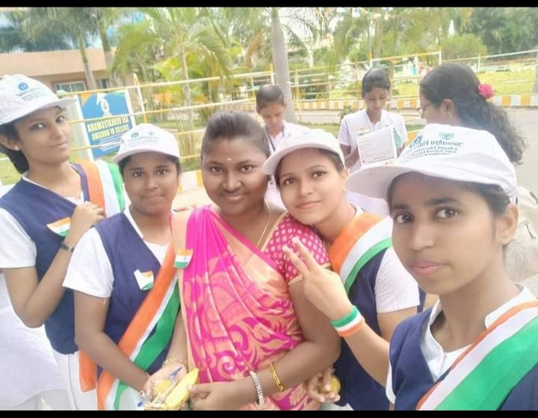
SRI VENKATESWARA COLLEGE OF NURSING
Recognized by Govt. AP & APNMC, Vijayawada,
Accredited with ‘A’ Grade by NAAC, Bengaluru,
Approved by Indian Nursing Council, New Delhi,
Affiliated to Dr. NTR University of Health Sciences, Vijayawada,
_RVS Nagar, Tirupati Road, Chittoor, Andhra Pradesh
SNA ACTIVITES FOR THE ACADEMIC YEAR –2020-2021
S.NO | NAME OF THE EVENT | DATE | ACTIVITIES CONDUCTED | SNA ADVISER
1 | Teachers Day | 5/9/2021 | Indoor games  Quiz competitions  Speech | Mrs.Vasantha kumara
2 | World Heart Day | 29/9/2021 | Quiz  Measures control of cardiac diseases | Mrs.Vasantha kumara
3 | Gandhi Jayanthi | 2/10/2021 | Distribution of sweets to the Children’s | Mrs.Vasantha kumara
4 | New born assessment week | 7/11/21 | Quiz competition  Ralley  Mime  Postal presentation | Mrs.Vasantha kumara
5 | World Diabetes Day | 11/11/2021 | Slide show on prevention of DM | Mrs.Vasantha kumara
6 | World AIDS Day | 1/12/2021 | Ralley  Postal presentation | Mrs.Vasantha kumara
PRINCIPAL
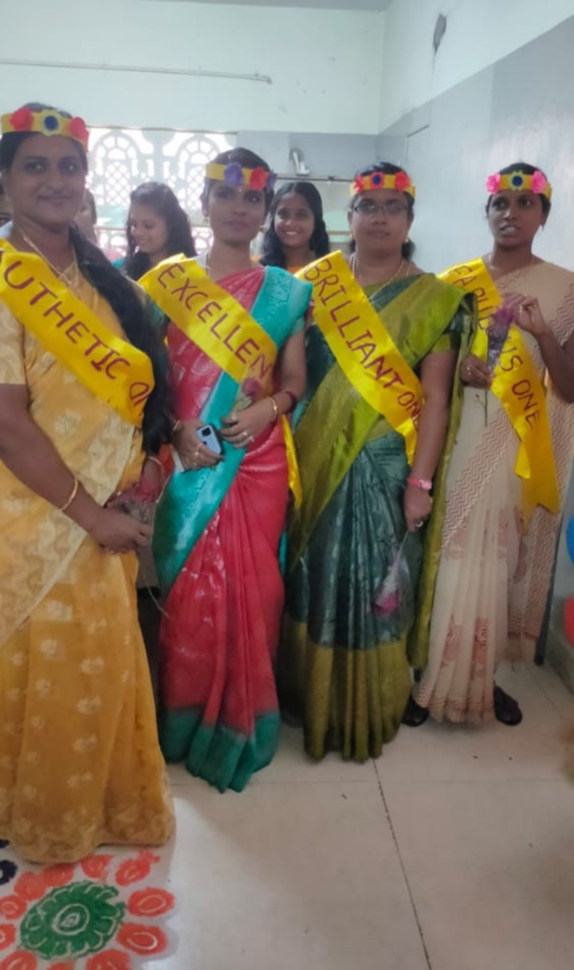
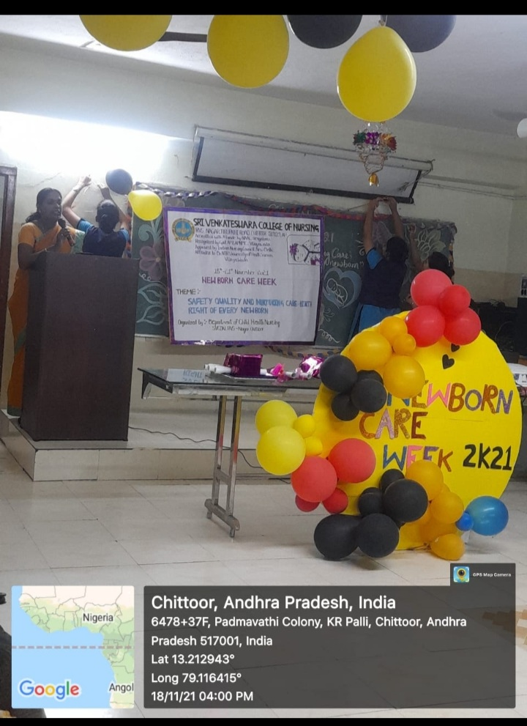

SRI VENKATESWARA COLLEGE OF NURSING
Recognized by Govt. AP & APNMC, Vijayawada,
Accredited with ‘A’ Grade by NAAC, Bengaluru,
Approved by Indian Nursing Council, New Delhi,
Affiliated to Dr. NTR University of Health Sciences, Vijayawada,
_RVS Nagar, Tirupati Road, Chittoor, Andhra Pradesh
MEDICAL CAMP FOR THE ACADEMIC YEAR 2017-2018
S.NO | NAME OF THE EVENT | DATE AND PLACE | ACTIVITIES CONDUCTED | NO OF VOLUNTERES PARTICIPATED | EVENT COORDINATOR
1.  2 | Medical camp  Medical camp | 2-4-2017,kalakunta  Village, penumur Mandal  7-10-2017,  Snthambakam village,penumur madal | Registration  Measuring height  Checking vital signs  General Physical Examination  Investigations-Urine Albumin and Blood Sugar  Distribution of Drugs and administration of Injections  Dressing  Counseling  Registration  Measuring height  Checking vital signs  General Physical Examination  Investigations-Urine Albumin and Blood Sugar  Distribution of Drugs and administration of Injections  Dressing  Counseling | 50  50 | MS.Vasanttha kumari  MS.Vasanttha kumari
PRINCIPAL
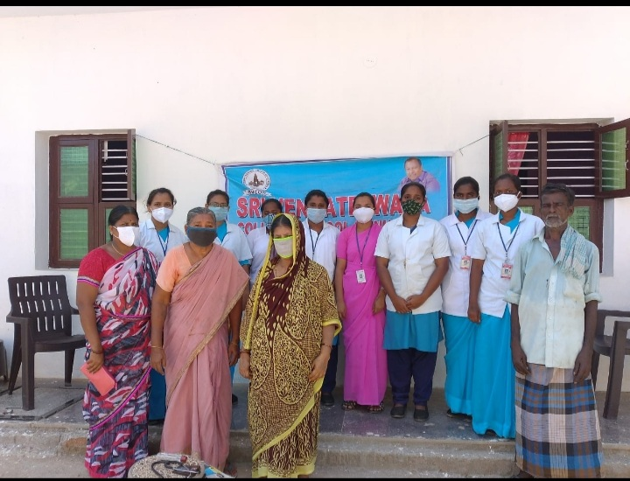

SRI VENKATESWARA COLLEGE OF NURSING
Recognized by Govt. AP & APNMC, Vijayawada,
Accredited with ‘A’ Grade by NAAC, Bengaluru,
Approved by Indian Nursing Council, New Delhi,
Affiliated to Dr. NTR University of Health Sciences, Vijayawada,
_RVS Nagar, Tirupati Road, Chittoor, Andhra Pradesh
MEDICAL CAMP FOR THE ACADEMIC YEAR 2018-2019
S.NO | NAME OF THE EVENT | DATE AND PLACE | ACTIVITIES CONDUCTED | NO OF VOLUNTERES PARTICIPATED | EVENT COORDINATOR
1.  2 | Medical camp  Medical camp | 2-4-2018,Penumur  Village, penumur Mandal  7-10-2018,  Kanikapuram village,penumur madal | Registration  Measuring height  Checking vital signs  General Physical Examination  Investigations-Urine Albumin and Blood Sugar  Distribution of Drugs and administration of Injections  Dressing  Counseling  Registration  Measuring height  Checking vital signs  General Physical Examination  Investigations-Urine Albumin and Blood Sugar  Distribution of Drugs and administration of Injections  Dressing  Counseling | 50  50 | MS.G.Anusha  Mrs.Radhika
PRINCIAL
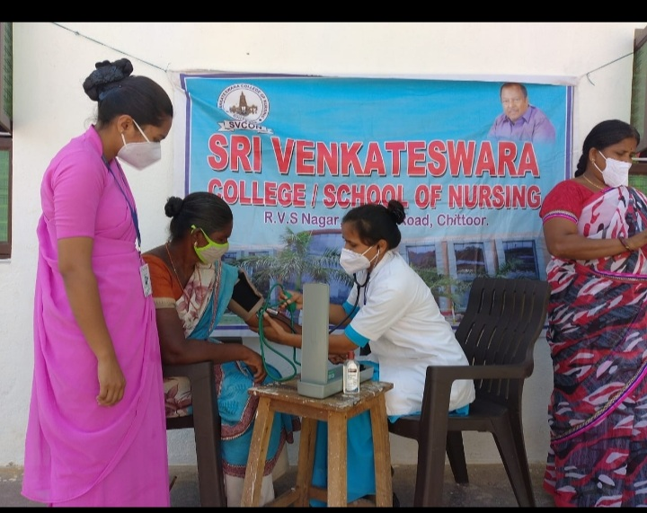
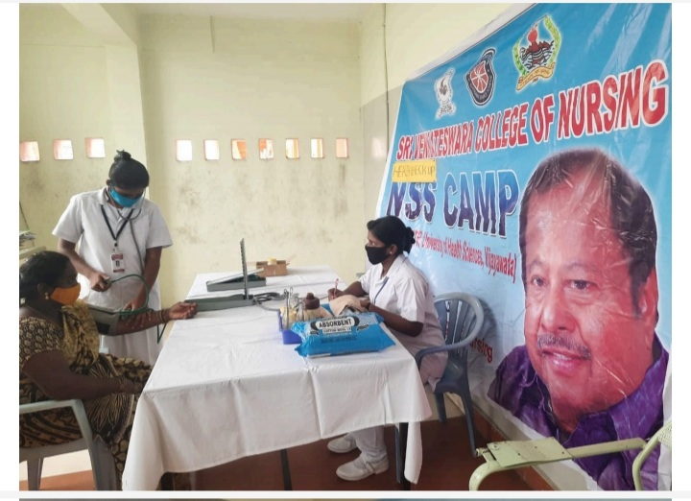
SRI VENKATESWARA COLLEGE OF NURSING
Recognized by Govt. AP & APNMC, Vijayawada,
Accredited with ‘A’ Grade by NAAC, Bengaluru,
Approved by Indian Nursing Council, New Delhi,
Affiliated to Dr. NTR University of Health Sciences, Vijayawada,
_RVS Nagar, Tirupati Road, Chittoor, Andhra Pradesh
MEDICAL CAMP FOR THE ACADEMIC YEAR 2019-2020
S.NO | NAME OF THE EVENT | DATE AND PLACE | ACTIVITIES CONDUCTED | NO OF VOLUNTERES PARTICIPATED | EVENT COORDINATOR
1.  2 | Medical camp  Medical camp | 2-4-2019,Sathambakam  Village, penumur Mandal  7-10-2019,  Sanyasipalli village,penumur madal | Registration  Measuring height  Checking vital signs  General Physical Examination  Investigations-Urine Albumin and Blood Sugar  Distribution of Drugs and administration of Injections  Dressing  Counseling  Registration  Measuring height  Checking vital signs  General Physical Examination  Investigations-Urine Albumin and Blood Sugar  Distribution of Drugs and administration of Injections  Dressing  Counseling | 50  50 | MS.Vasanttha kumari  MS.Vasanttha kumari
PRINCIAL
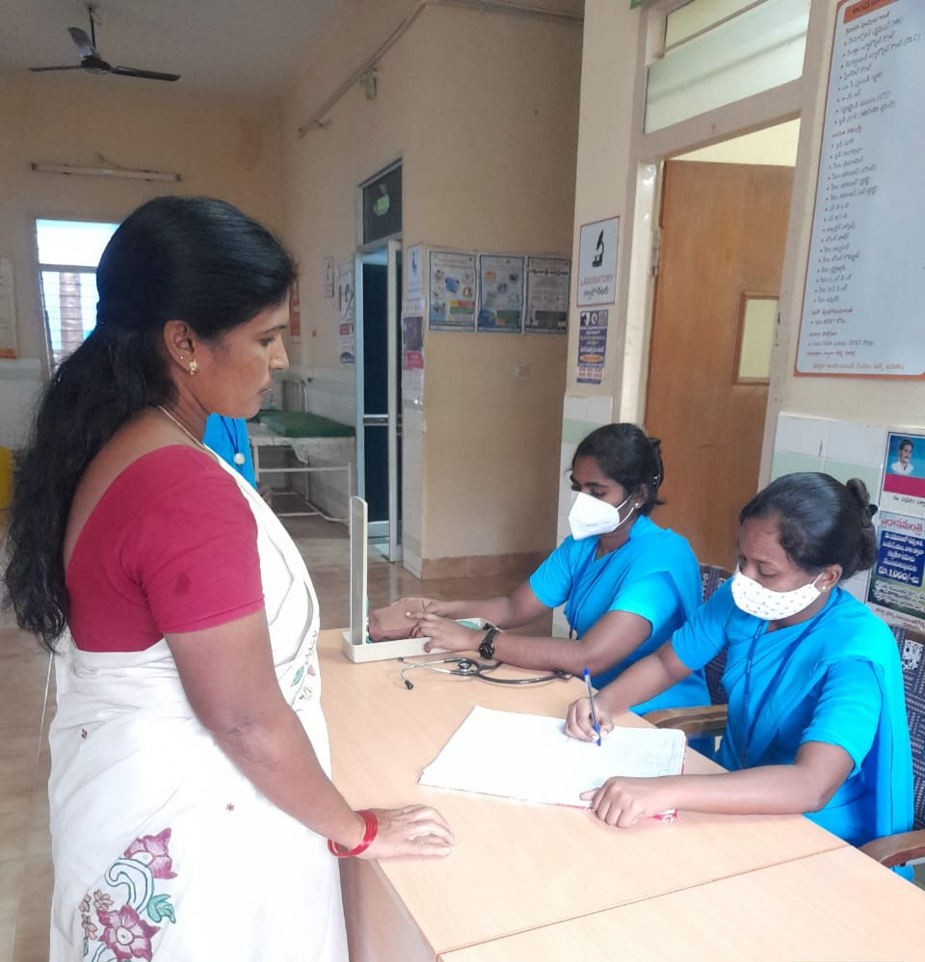

SRI VENKATESWARA COLLEGE OF NURSING
Recognized by Govt. AP & APNMC, Vijayawada,
Accredited with ‘A’ Grade by NAAC, Bengaluru,
Approved by Indian Nursing Council, New Delhi,
Affiliated to Dr. NTR University of Health Sciences, Vijayawada,
_RVS Nagar, Tirupati Road, Chittoor, Andhra Pradesh
MEDICAL CAMP FOR THE ACADEMIC YEAR 2020-2021
S.NO | NAME OF THE EVENT | DATE AND PLACE | ACTIVITIES CONDUCTED | NO OF VOLUNTERES PARTICIPATED | EVENT COORDINATOR
1.  2 | Medical camp  Medical camp | 2-4-2020,kalakunta  Village, penumur Mandal  7-10-2021,  Snthambakam village,penumur madal | Registration  Measuring height  Checking vital signs  General Physical Examination  Investigations-Urine Albumin and Blood Sugar  Distribution of Drugs and administration of Injections  Dressing  Counseling  Registration  Measuring height  Checking vital signs  General Physical Examination  Investigations-COVID Rapid test  Distribution of Drugs and administration of Injections  Dressing  Counseling | 50  50 | MS.Vasanttha kumari  MS.Vasanttha kumari
PRINCIPAL
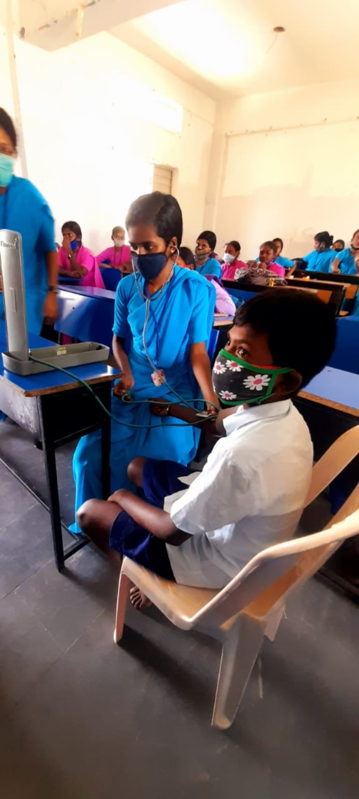

SRI VENKATESWARA COLLEGE OF NURSING
Recognized by Govt. AP & APNMC, Vijayawada,
Accredited with ‘A’ Grade by NAAC, Bengaluru,
Approved by Indian Nursing Council, New Delhi,
Affiliated to Dr. NTR University of Health Sciences, Vijayawada,
_RVS Nagar, Tirupati Road, Chittoor, Andhra Pradesh
SPECIAL DAYS FOR THE ACADEMIC YEAR 2017-2018
S.NO | NAME OF THE EVENT | DATE | ACTIVITIES CONDUCTED | NO OF VOLUNTERES PARTICIPATED | EVENT COORDINATOR
1 | Ugadi | 29/3/2018 | Preparation of ugadi pachadi and Culturai Programmes | 150 | MS.G.Anusha
2 | Holi | 13/4/2018 | Distribution of colours and celebrations | 150 | MS.G.Anusha
3 | Chairman birthday | 1/6/2018 | Cake cutting, distribution of sweets | 150 | K.chamudeswari
4 | Onam | 6/9/2018 | Cultural programmes ,Onam skit,Rangoli with flowers | 150 | Ms.G.Vannila
5 | Chrismas | 24/12/2018 | Cultural programmes ,cake cutting,skit on importance of chrismas celebrations | 150 | K.chamudeswari

PRINCIPAL

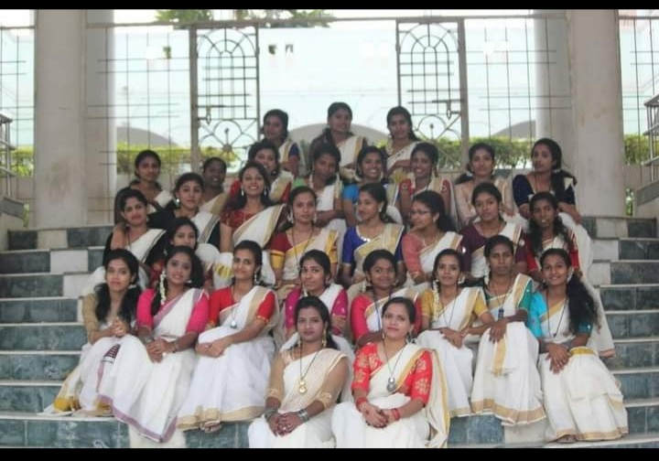
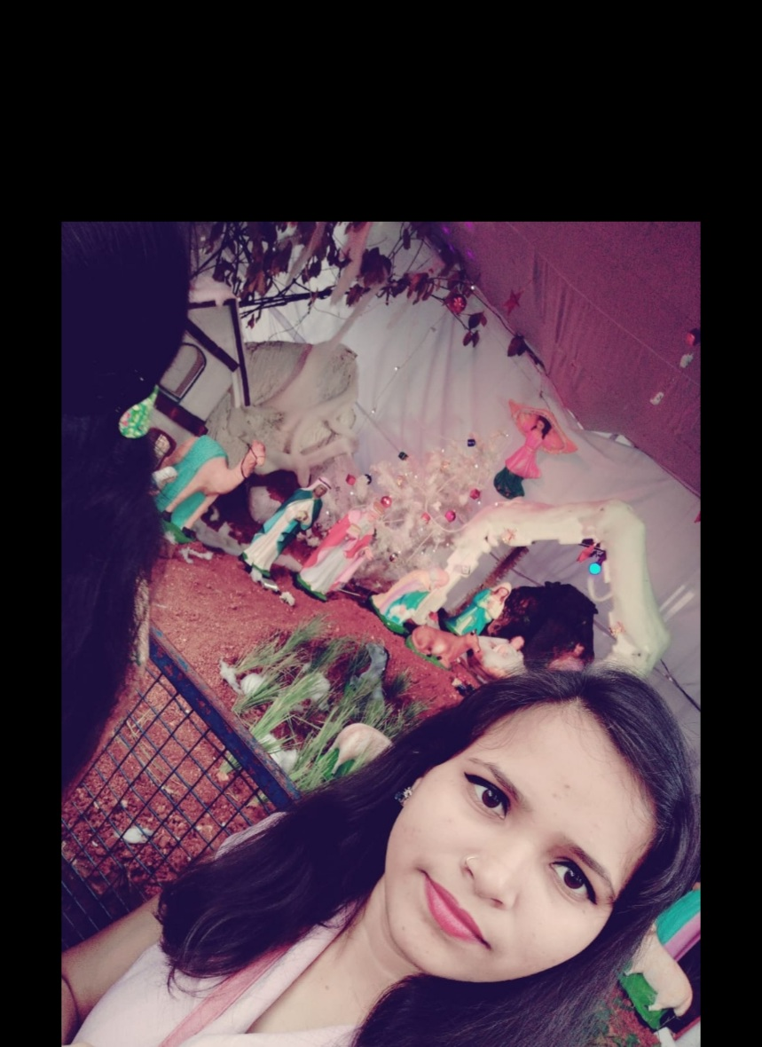

SRI VENKATESWARA COLLEGE OF NURSING
Recognized by Govt. AP & APNMC, Vijayawada,
Accredited with ‘A’ Grade by NAAC, Bengaluru,
Approved by Indian Nursing Council, New Delhi,
Affiliated to Dr. NTR University of Health Sciences, Vijayawada,
_RVS Nagar, Tirupati Road, Chittoor, Andhra Pradesh
SPECIAL DAYS FOR THE ACADEMIC YEAR 2018-2019
S.NO | NAME OF THE EVENT | DATE | ACTIVITIES CONDUCTED | NO OF VOLUNTERES PARTICIPATED | EVENT COORDINATOR
1 | Ugadi | 6/4/2019 | Preparation of ugadi pachadi and Culturai Programmes | 150 | MS.G.Anusha
2 | Holi | 20/3/2019 | Distribution of colours and celebrations | 150 | MS.G.Anusha
3 | Viayakachavithi | 1/9/2019 | Cake cutting, distribution of sweets | 150 | K.chamudeswari
4 | Onam | 27/8/2019 | Cultural programmes ,Onam skit,Rangoli with flowers | 150 | Ms.G.Vannila
5 | Chrismas | 24/12/2019 | Cultural programmes ,cake cutting,skit on importance of chrismas celebrations | 150 | K.chamudeswari

PRINCIPAL

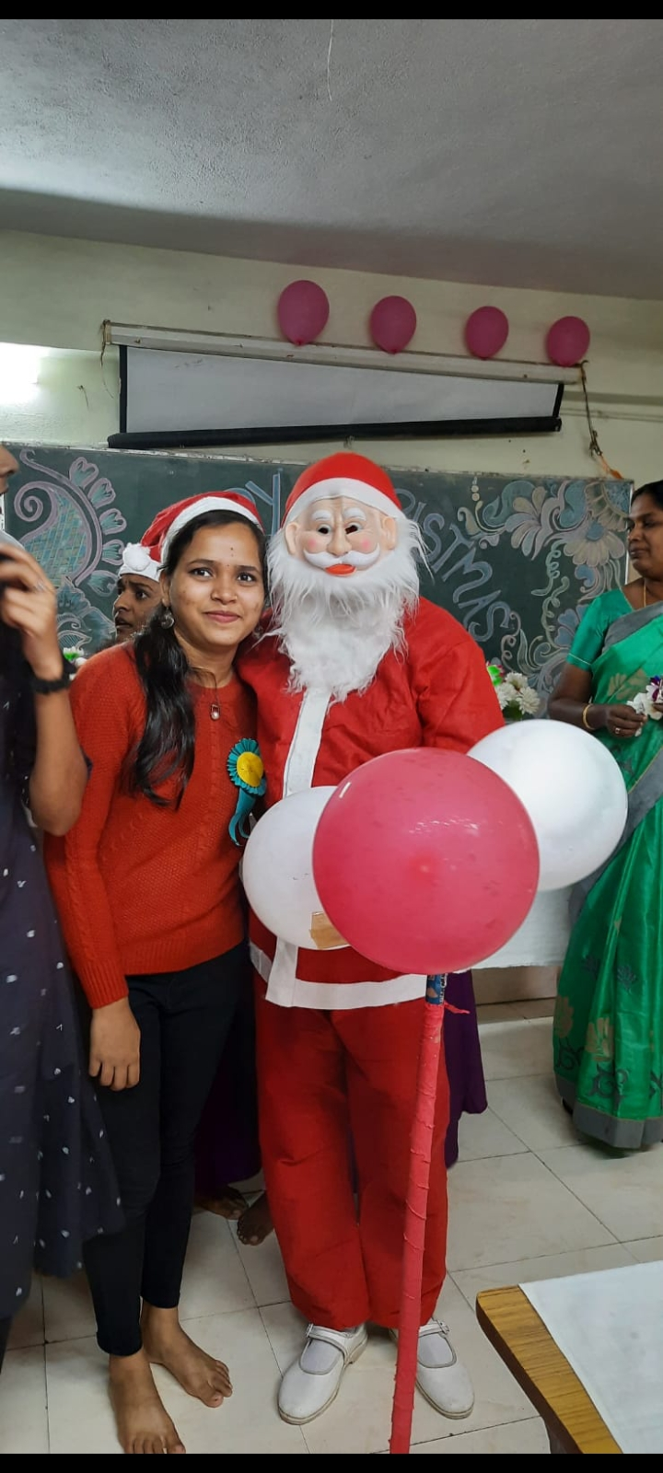

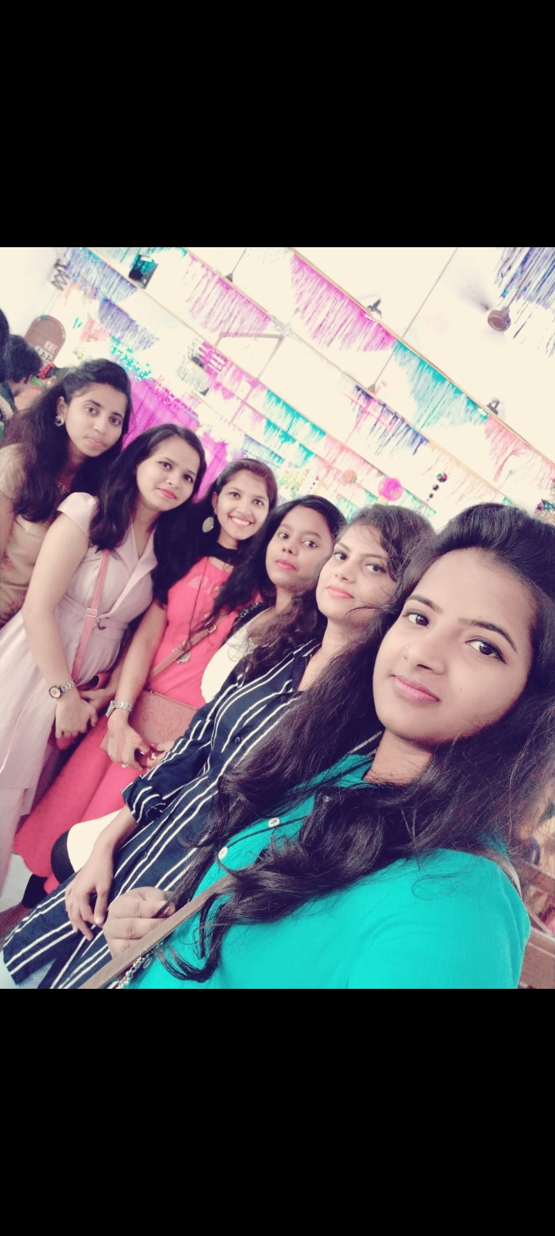
SRI VENKATESWARA COLLEGE OF NURSING
Recognized by Govt. AP & APNMC, Vijayawada,
Accredited with ‘A’ Grade by NAAC, Bengaluru,
Approved by Indian Nursing Council, New Delhi,
Affiliated to Dr. NTR University of Health Sciences, Vijayawada,
_RVS Nagar, Tirupati Road, Chittoor, Andhra Pradesh
SPECIAL DAYS FOR THE ACADEMIC YEAR 2019-2020
S.NO | NAME OF THE EVENT | DATE | ACTIVITIES CONDUCTED | NO OF VOLUNTERES PARTICIPATED | EVENT COORDINATOR
1 | Ugadi | 6/4/2020 | Preparation of ugadi pachadi and Culturai Programmes | 150 | Mrs.Vasantha kumari
2 | Holi | 20/3/2020 | Distribution of colours and celebrations | 150 | Mrs.Vasantha kumari

PRINCIPAL
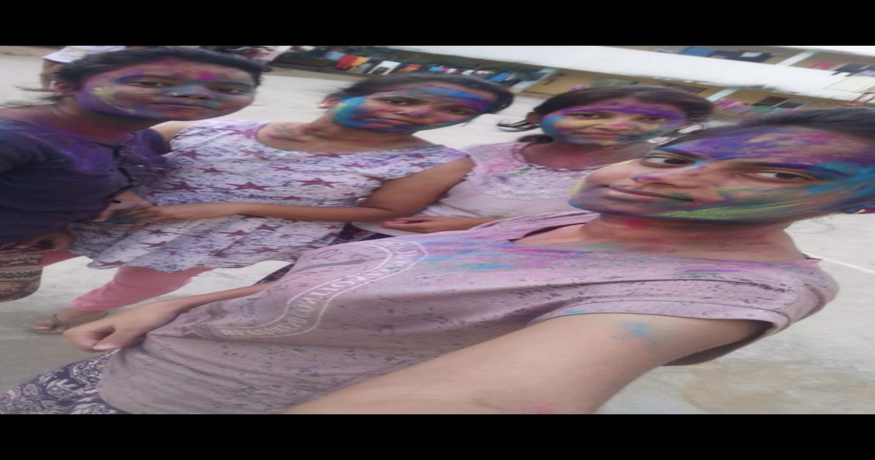
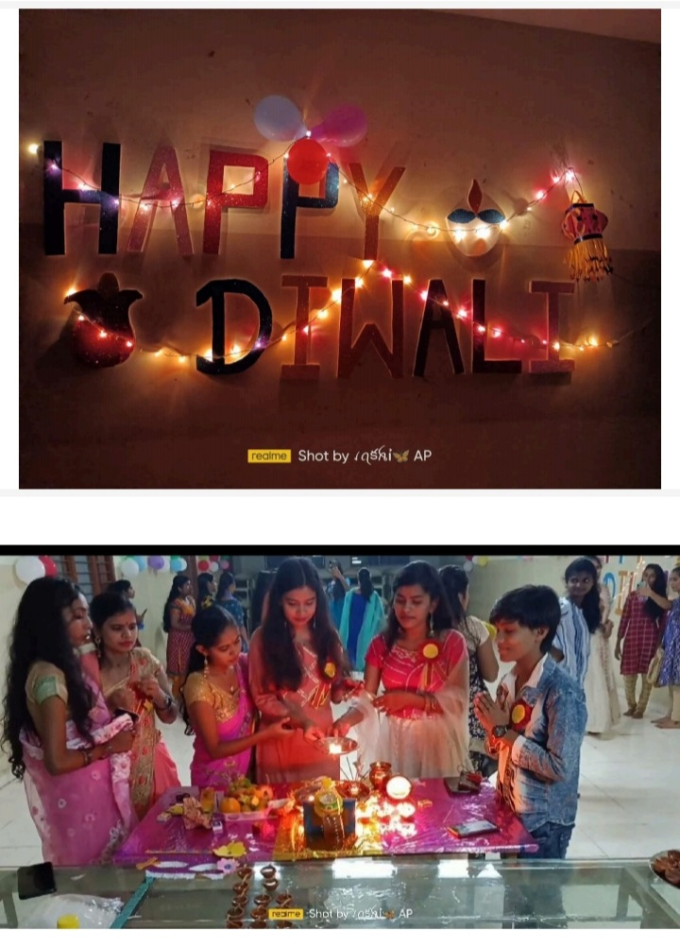
SRI VENKATESWARA COLLEGE OF NURSING
Recognized by Govt. AP & APNMC, Vijayawada,
Accredited with ‘A’ Grade by NAAC, Bengaluru,
Approved by Indian Nursing Council, New Delhi,
Affiliated to Dr. NTR University of Health Sciences, Vijayawada,
_RVS Nagar, Tirupati Road, Chittoor, Andhra Pradesh
SPECIAL DAYS FOR THE ACADEMIC YEAR 2020-2021
S.NO | NAME OF THE EVENT | DATE | ACTIVITIES CONDUCTED | NO OF VOLUNTERES PARTICIPATED | EVENT COORDINATOR
1 | Onam | 6/9/2021 | Cultural programmes ,Onam skit,Rangoli with flowers | 150 | Mrs.Vasantha kumari
2 | Chrismas | 24/12/2021 | Cultural programmes ,cake cutting,skit on importance of chrismas celebrations | 150 | Mrs.vasantha kumara

PRINCIPAL
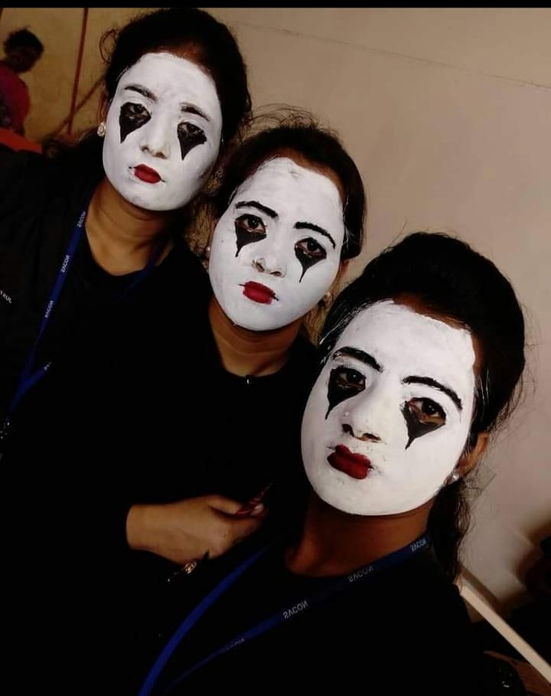

SRI VENKATESWARA COLLEGE OF NURSING
Recognized by Govt. AP & APNMC, Vijayawada,
Accredited with ‘A’ Grade by NAAC, Bengaluru,
Approved by Indian Nursing Council, New Delhi,
Affiliated to Dr. NTR University of Health Sciences, Vijayawada,
_RVS Nagar, Tirupati Road, Chittoor, Andhra Pradesh
GUEST LECTURES
The following are list of the eminent professors and researchers who visited our institutions:
S.NO | DATE AND YEAR | NAME OF EMINENT PROFESSORS AND RESEARCHERS | TOPIC
1 | 12.2.2018 | Dr.K.P. Yadav,Director IIMT,Greater Noida | Seminar on Nursing ethics and Principles
2 | 16.7.2018 | Mr.Basival Akram Thyagi Principal , Ananda College of Nursing, U.P | Seminar on Nursing challenges and trends
3 | 25.8.2019 | Dr. S.Indira, M.Sc(N),Ph.D Principal, Narayana College Nursing,Nellore,A.P | Seminar on CPR
4 | 17.4.2019 | Mrs.C.R.Shamshad Begum, M.Sc(N), Principal, Govt of College Nursing, Hyderabad | Seminar on Newborn Care
5 | 15.2.2020 | Dr.K.P. Yadav, Director KCCITM,Greater Noida | Seminar on Year of the Nurse and Midwife 2020
6 | 20.9.2019 | Mr. Anantha Ram, Co-Ordinator and Member (Evaluator) in peer team of NAAC | Webinar on Prevention of covid -19
7 | 25.8.2020 | Mrs.Ch.Roja Rani,M.Sc(N), Register, A.P.Nurses and Midwives Council, Hyderabad | Webinar on car T-cell theraphy
8 | 11.8.2020. | Mrs.C.R.Shamshad Begum, M.Sc(N), Principal, Govt of College of Nursing, Hyderabad | Webinar on breastfeeding during Covid-19 pandemic

PRINCIPAL
BY SEMINARS/WORKSHOPS ATTENDED / PRESENTED STUDENTS
2017-2018
ONE DAY NATIONAL SEMIAR ON “NURSING ETHICS AND PRINCIPAL” at Sri Venkateswara College of Nursing , R.V.S Nagar, Chittoor, during 12 August 2018.
Participants from 1st year
 | S.No. | Name of the student | Year
 | 1 | Aleena Devasia | 1st year
 | 2 | Amala james | 1st year
 | 3 | Anjaly Sabu | 1st year
 | 4 | Anjana V.S | 1st year
 | 5 | Anju E.k | 1st year
 | 6 | Anju mol gopi | 1st year
 | 7 | Annu elsa Kuruvilla | 1st year
 | 8 | Anuja OmanaKuttan | 1st year
 | 9 | Aparna Das | 1st year
 | 10 | Aswathy N.J | 1st year
 | 11 | C. Latha | 1st year
 | 12 | Diksha Gupta | 1st year
 | 13 | Donna Ann Jacob | 1st year
 | 14 | G.Hemeema | 1st year
 | 15 | Haripriya Santosh | 1st year
 | 16 | Haritha Santosh | 1st year
 | 17 | Ishrat Khatoon | 1st year
 | 18 | J.pallavi | 1st year
 | 19 | Jintamol Chacko | 1st year
 | 20 | Kavya Binnu | 1st year
 | 21 | K. Ammulu | 1st year
 | 22 | M. Versha | 1st year
 | 23 | S. Madhumitha | 1st year
 | 24 | Meenu Mohanan | 1st year
25 |  | Menka Chaudhary | 1st year
26 |  | Mintumol joy | 1st year
27 |  | G.Narmadha | 1st year
28 |  | Princy kurian | 1st year
29 |  | Pulicherla Pavithra | 1st year
30 |  | N.Navnitha | 1st year

Participatnts from 2nd year
S.No | Name of the student | Year
1 | Alshiya banno | 2nd Year
2 | Anuka pradhan | 2nd Year
3 | Y.S Anusha | 2nd Year
4 | S. Asha | 2nd Year
5 | M. Aswini | 2nd Year
6 | B.Baby | 2nd Year
7 | V.jennifer | 2nd Year
8 | P.Hemalatha | 2nd Year
9 | K.bharathi | 2nd Year
10 | R.Bhargavi | 2nd Year
11 | R.chandanpriya | 2nd Year
12 | Deepalakshmi | 2nd Year
13 | L.Divya | 2nd Year
14 | K.Geetha | 2nd Year
15 | Y.Geetha | 2nd Year
16 | M.Haritha | 2nd Year
17 | R.Jhanshi | 2nd Year
18 | Kusuma kumari | 2nd Year
19 | K.lakshmi | 2nd Year
20 | Mamtha | 2nd Year
Participant from 3rd year
1 | Glory Selvam | 3rd Year
2 | Gnanavika.T:C | 3rd Year
3 | Haritha.M | 3rd Year
4 | Jyoti,A.K | 3rd Year
5 | Jyothsna.C | 3rd Year
6 | Kamilika.S | 3rd Year
7 | Kaveri.S | 3rd Year
8 | Komala.B | 3rd Year
9 | Kumari,B | 3rd Year
10 | Lavanya.R | 3rd Year
11 | Leelavathi.B | 3rd Year
12 | Manisha.T | 3rd Year
13 | Manju Rai | 3rd Year
14 | Abhirami | 3rd Year
15 | Anju Vijayan | 3rd Year
16 | Archana bashkar | 3rd Year
17 | Ashika Ashokan | 3rd Year
18 | Budhha maya subha | 3rd Year
19 | Chamundeswari.K | 3rd Year
20 | Epsiba.T | 3rd Year
Participant from 4th yr
S.No | Name of the student | Year
1 | Aastha shah | 4th Year
2 | Amutha.E | 4th Year
3 | Anandhi.M | 4th Year
4 | Archana.A | 4th Year
5 | Aruna.N | 4th Year
6 | Aswini priya.B | 4th Year
7 | Athira Benny | 4th Year
8 | Bimdu priya .A | 4th Year
9 | Divya.ss | 4th Year
10 | Esther Nirmala.P | 4th Year
11 | Gaja lakshmi.B | 4th Year
12 | Girija.V | 4th Year
13 | Harathi.G | 4th Year
14 | Haripriya | 4th Year
15 | Hyndavi.M | 4th Year
16 | Indhu | 4th Year
17 | Jamimah.M | 4th Year
18 | Kaveri.J | 4th Year
19 | Kousalya.N | 4th Year
20 | Kousalya.Y.B | 4th Year

SRI VENKATESWARA COLLEGE OF NURSING
Recognized by govt.A.P&APNMC,vijayawada.,Accredited with “A”Grade by NAAC,bengaluru
Approved by Indian Nursing Council,New Delhi,,Affiliated to Dr.NTR University of Health Sciences.vijayawada.
RVS Nagar, Tirupati Road,Chitoor,A.P.

BY SEMINARS/WORKSHOPS ATTENDED / PRESENTED STUDENTS
2017-2018
ONE DAY NATIONAL SEMIAR ON “NURSING CHALANGES AND TRENDS ” at Sri Venkateswara College of Nursing , R.V.S Nagar, Chittoor, during 16th July 2018.
Participatnts from 2nd year
S.No | Name of the student | Year
1 | Alshiya banno | 2nd Year
2 | Anuka pradhan | 2nd Year
3 | Y.S Anusha | 2nd Year
4 | S. Asha | 2nd Year
5 | M. Aswini | 2nd Year
6 | B.Baby | 2nd Year
7 | V.jennifer | 2nd Year
8 | P.Hemalatha | 2nd Year
9 | K.bharathi | 2nd Year
10 | R.Bhargavi | 2nd Year
11 | R.chandanpriya | 2nd Year
12 | Deepalakshmi | 2nd Year
13 | L.Divya | 2nd Year
14 | K.Geetha | 2nd Year
15 | Y.Geetha | 2nd Year
16 | M.Haritha | 2nd Year
17 | R.Jhanshi | 2nd Year
18 | Kusuma kumari | 2nd Year
19 | K.lakshmi | 2nd Year
20 | Mamtha | 2nd Year
Participant from 3rd year
1 | Glory Selvam | 3rd Year
2 | Gnanavika.T:C | 3rd Year
3 | Haritha.M | 3rd Year
4 | Jyoti,A.K | 3rd Year
5 | Jyothsna.C | 3rd Year
6 | Kamilika.S | 3rd Year
7 | Kaveri.S | 3rd Year
8 | Komala.B | 3rd Year
9 | Kumari,B | 3rd Year
10 | Lavanya.R | 3rd Year
11 | Leelavathi.B | 3rd Year
12 | Manisha.T | 3rd Year
13 | Manju Rai | 3rd Year
14 | Abhirami | 3rd Year
15 | Anju Vijayan | 3rd Year
16 | Archana bashkar | 3rd Year
17 | Ashika Ashokan | 3rd Year
18 | Budhha maya subha | 3rd Year
19 | Chamundeswari.K | 3rd Year
20 | Epsiba.T | 3rd Year
Participant from 4th yr
S.No | Name of the student | Year
1 | Aastha shah | 4th Year
2 | Amutha.E | 4th Year
3 | Anandhi.M | 4th Year
4 | Archana.A | 4th Year
5 | Aruna.N | 4th Year
6 | Aswini priya.B | 4th Year
7 | Athira Benny | 4th Year
8 | Bimdu priya .A | 4th Year
9 | Divya.ss | 4th Year
10 | Esther Nirmala.P | 4th Year
11 | Gaja lakshmi.B | 4th Year
12 | Girija.V | 4th Year
13 | Harathi.G | 4th Year
14 | Haripriya | 4th Year
15 | Hyndavi.M | 4th Year
16 | Indhu | 4th Year
17 | Jamimah.M | 4th Year
18 | Kaveri.J | 4th Year
19 | Kousalya.N | 4th Year
20 | Kousalya.Y.B | 4th Year

SRI VENKATESWARA COLLEGE OF NURSING
Recognized by govt.A.P&APNMC,vijayawada.,Accredited with “A”Grade by NAAC,bengaluru
Approved by Indian Nursing Council,New Delhi,,Affiliated to Dr.NTR University of Health Sciences.vijayawada.
RVS Nagar, Tirupati Road,Chitoor,A.P.

BY SEMINARS/WORKSHOPS ATTENDED / PRESENTED STUDENTS
2017-2018
ONE DAY NATIONAL SEMIAR ON “NURSING ETHICS AND PRINCIPAL” at Sri Venkateswara College of Nursing , R.V.S Nagar, Chittoor, during 12 August 2018.
Participants from 1st year
 | S.No. | Name of the student | Year
 | 1 | Aleena Devasia | 1st year
 | 2 | Amala james | 1st year
 | 3 | Anjaly Sabu | 1st year
 | 4 | Anjana V.S | 1st year
 | 5 | Anju E.k | 1st year
 | 6 | Anju mol gopi | 1st year
 | 7 | Annu elsa Kuruvilla | 1st year
 | 8 | Anuja OmanaKuttan | 1st year
 | 9 | Aparna Das | 1st year
 | 10 | Aswathy N.J | 1st year
 | 11 | C. Latha | 1st year
 | 12 | Diksha Gupta | 1st year
 | 13 | Donna Ann Jacob | 1st year
 | 14 | G.Hemeema | 1st year
 | 15 | Haripriya Santosh | 1st year
 | 16 | Haritha Santosh | 1st year
 | 17 | Ishrat Khatoon | 1st year
 | 18 | J.pallavi | 1st year
 | 19 | Jintamol Chacko | 1st year
 | 20 | Kavya Binnu | 1st year
 | 21 | K. Ammulu | 1st year
 | 22 | M. Versha | 1st year
 | 23 | S. Madhumitha | 1st year
 | 24 | Meenu Mohanan | 1st year
25 |  | Menka Chaudhary | 1st year
26 |  | Mintumol joy | 1st year
27 |  | G.Narmadha | 1st year
28 |  | Princy kurian | 1st year
29 |  | Pulicherla Pavithra | 1st year
30 |  | N.Navnitha | 1st year

Participatnts from 2nd year
S.No | Name of the student | Year
1 | Alshiya banno | 2nd Year
2 | Anuka pradhan | 2nd Year
3 | Y.S Anusha | 2nd Year
4 | S. Asha | 2nd Year
5 | M. Aswini | 2nd Year
6 | B.Baby | 2nd Year
7 | V.jennifer | 2nd Year
8 | P.Hemalatha | 2nd Year
9 | K.bharathi | 2nd Year
10 | R.Bhargavi | 2nd Year
11 | R.chandanpriya | 2nd Year
12 | Deepalakshmi | 2nd Year
13 | L.Divya | 2nd Year
14 | K.Geetha | 2nd Year
15 | Y.Geetha | 2nd Year
16 | M.Haritha | 2nd Year
17 | R.Jhanshi | 2nd Year
18 | Kusuma kumari | 2nd Year
19 | K.lakshmi | 2nd Year
20 | Mamtha | 2nd Year
Participant from 3rd year
1 | Glory Selvam | 3rd Year
2 | Gnanavika.T:C | 3rd Year
3 | Haritha.M | 3rd Year
4 | Jyoti,A.K | 3rd Year
5 | Jyothsna.C | 3rd Year
6 | Kamilika.S | 3rd Year
7 | Kaveri.S | 3rd Year
8 | Komala.B | 3rd Year
9 | Kumari,B | 3rd Year
10 | Lavanya.R | 3rd Year
11 | Leelavathi.B | 3rd Year
12 | Manisha.T | 3rd Year
13 | Manju Rai | 3rd Year
14 | Abhirami | 3rd Year
15 | Anju Vijayan | 3rd Year
16 | Archana bashkar | 3rd Year
17 | Ashika Ashokan | 3rd Year
18 | Budhha maya subha | 3rd Year
19 | Chamundeswari.K | 3rd Year
20 | Epsiba.T | 3rd Year
Participant from 4th yr
S.No | Name of the student | Year
1 | Aastha shah | 4th Year
2 | Amutha.E | 4th Year
3 | Anandhi.M | 4th Year
4 | Archana.A | 4th Year
5 | Aruna.N | 4th Year
6 | Aswini priya.B | 4th Year
7 | Athira Benny | 4th Year
8 | Bimdu priya .A | 4th Year
9 | Divya.ss | 4th Year
10 | Esther Nirmala.P | 4th Year
11 | Gaja lakshmi.B | 4th Year
12 | Girija.V | 4th Year
13 | Harathi.G | 4th Year
14 | Haripriya | 4th Year
15 | Hyndavi.M | 4th Year
16 | Indhu | 4th Year
17 | Jamimah.M | 4th Year
18 | Kaveri.J | 4th Year
19 | Kousalya.N | 4th Year
20 | Kousalya.Y.B | 4th Year
BY SEMINARS/WORKSHOPS ATTENDED / PRESENTED STUDENTS
2017-2018
ONE DAY NATIONAL SEMIAR ON “NURSING ETHICS AND PRINCIPAL” at Sri Venkateswara College of Nursing , R.V.S Nagar, Chittoor, during 12 August 2018.
Participants from 1st year
 | S.No. | Name of the student | Year
 | 1 | Aleena Devasia | 1st year
 | 2 | Amala james | 1st year
 | 3 | Anjaly Sabu | 1st year
 | 4 | Anjana V.S | 1st year
 | 5 | Anju E.k | 1st year
 | 6 | Anju mol gopi | 1st year
 | 7 | Annu elsa Kuruvilla | 1st year
 | 8 | Anuja OmanaKuttan | 1st year
 | 9 | Aparna Das | 1st year
 | 10 | Aswathy N.J | 1st year
 | 11 | C. Latha | 1st year
 | 12 | Diksha Gupta | 1st year
 | 13 | Donna Ann Jacob | 1st year
 | 14 | G.Hemeema | 1st year
 | 15 | Haripriya Santosh | 1st year
 | 16 | Haritha Santosh | 1st year
 | 17 | Ishrat Khatoon | 1st year
 | 18 | J.pallavi | 1st year
 | 19 | Jintamol Chacko | 1st year
 | 20 | Kavya Binnu | 1st year
 | 21 | K. Ammulu | 1st year
 | 22 | M. Versha | 1st year
 | 23 | S. Madhumitha | 1st year
 | 24 | Meenu Mohanan | 1st year
25 |  | Menka Chaudhary | 1st year
26 |  | Mintumol joy | 1st year
27 |  | G.Narmadha | 1st year
28 |  | Princy kurian | 1st year
29 |  | Pulicherla Pavithra | 1st year
30 |  | N.Navnitha | 1st year

Participatnts from 2nd year
S.No | Name of the student | Year
1 | Alshiya banno | 2nd Year
2 | Anuka pradhan | 2nd Year
3 | Y.S Anusha | 2nd Year
4 | S. Asha | 2nd Year
5 | M. Aswini | 2nd Year
6 | B.Baby | 2nd Year
7 | V.jennifer | 2nd Year
8 | P.Hemalatha | 2nd Year
9 | K.bharathi | 2nd Year
10 | R.Bhargavi | 2nd Year
11 | R.chandanpriya | 2nd Year
12 | Deepalakshmi | 2nd Year
13 | L.Divya | 2nd Year
14 | K.Geetha | 2nd Year
15 | Y.Geetha | 2nd Year
16 | M.Haritha | 2nd Year
17 | R.Jhanshi | 2nd Year
18 | Kusuma kumari | 2nd Year
19 | K.lakshmi | 2nd Year
20 | Mamtha | 2nd Year
Participant from 3rd year
1 | Glory Selvam | 3rd Year
2 | Gnanavika.T:C | 3rd Year
3 | Haritha.M | 3rd Year
4 | Jyoti,A.K | 3rd Year
5 | Jyothsna.C | 3rd Year
6 | Kamilika.S | 3rd Year
7 | Kaveri.S | 3rd Year
8 | Komala.B | 3rd Year
9 | Kumari,B | 3rd Year
10 | Lavanya.R | 3rd Year
11 | Leelavathi.B | 3rd Year
12 | Manisha.T | 3rd Year
13 | Manju Rai | 3rd Year
14 | Abhirami | 3rd Year
15 | Anju Vijayan | 3rd Year
16 | Archana bashkar | 3rd Year
17 | Ashika Ashokan | 3rd Year
18 | Budhha maya subha | 3rd Year
19 | Chamundeswari.K | 3rd Year
20 | Epsiba.T | 3rd Year
Participant from 4th yr
S.No | Name of the student | Year
1 | Aastha shah | 4th Year
2 | Amutha.E | 4th Year
3 | Anandhi.M | 4th Year
4 | Archana.A | 4th Year
5 | Aruna.N | 4th Year
6 | Aswini priya.B | 4th Year
7 | Athira Benny | 4th Year
8 | Bimdu priya .A | 4th Year
9 | Divya.ss | 4th Year
10 | Esther Nirmala.P | 4th Year
11 | Gaja lakshmi.B | 4th Year
12 | Girija.V | 4th Year
13 | Harathi.G | 4th Year
14 | Haripriya | 4th Year
15 | Hyndavi.M | 4th Year
16 | Indhu | 4th Year
17 | Jamimah.M | 4th Year
18 | Kaveri.J | 4th Year
19 | Kousalya.N | 4th Year
20 | Kousalya.Y.B | 4th Year

SRI VENKATESWARA COLLEGE OF NURSING
Recognized by govt.A.P&APNMC,vijayawada.,Accredited with “A”Grade by NAAC,bengaluru
Approved by Indian Nursing Council,New Delhi,,Affiliated to Dr.NTR University of Health Sciences.vijayawada.
RVS Nagar, Tirupati Road,Chitoor,A.P.

BY SEMINARS/WORKSHOPS ATTENDED / PRESENTED STUDENTS
2017-2018
ONE DAY NATIONAL SEMIAR ON “NURSING CHALANGES AND TRENDS ” at Sri Venkateswara College of Nursing , R.V.S Nagar, Chittoor, during 16th July 2018.
Participatnts from 2nd year
S.No | Name of the student | Year
1 | Alshiya banno | 2nd Year
2 | Anuka pradhan | 2nd Year
3 | Y.S Anusha | 2nd Year
4 | S. Asha | 2nd Year
5 | M. Aswini | 2nd Year
6 | B.Baby | 2nd Year
7 | V.jennifer | 2nd Year
8 | P.Hemalatha | 2nd Year
9 | K.bharathi | 2nd Year
10 | R.Bhargavi | 2nd Year
11 | R.chandanpriya | 2nd Year
12 | Deepalakshmi | 2nd Year
13 | L.Divya | 2nd Year
14 | K.Geetha | 2nd Year
15 | Y.Geetha | 2nd Year
16 | M.Haritha | 2nd Year
17 | R.Jhanshi | 2nd Year
18 | Kusuma kumari | 2nd Year
19 | K.lakshmi | 2nd Year
20 | Mamtha | 2nd Year
Participant from 3rd year
1 | Glory Selvam | 3rd Year
2 | Gnanavika.T:C | 3rd Year
3 | Haritha.M | 3rd Year
4 | Jyoti,A.K | 3rd Year
5 | Jyothsna.C | 3rd Year
6 | Kamilika.S | 3rd Year
7 | Kaveri.S | 3rd Year
8 | Komala.B | 3rd Year
9 | Kumari,B | 3rd Year
10 | Lavanya.R | 3rd Year
11 | Leelavathi.B | 3rd Year
12 | Manisha.T | 3rd Year
13 | Manju Rai | 3rd Year
14 | Abhirami | 3rd Year
15 | Anju Vijayan | 3rd Year
16 | Archana bashkar | 3rd Year
17 | Ashika Ashokan | 3rd Year
18 | Budhha maya subha | 3rd Year
19 | Chamundeswari.K | 3rd Year
20 | Epsiba.T | 3rd Year
Participant from 4th yr
S.No | Name of the student | Year
1 | Aastha shah | 4th Year
2 | Amutha.E | 4th Year
3 | Anandhi.M | 4th Year
4 | Archana.A | 4th Year
5 | Aruna.N | 4th Year
6 | Aswini priya.B | 4th Year
7 | Athira Benny | 4th Year
8 | Bimdu priya .A | 4th Year
9 | Divya.ss | 4th Year
10 | Esther Nirmala.P | 4th Year
11 | Gaja lakshmi.B | 4th Year
12 | Girija.V | 4th Year
13 | Harathi.G | 4th Year
14 | Haripriya | 4th Year
15 | Hyndavi.M | 4th Year
16 | Indhu | 4th Year
17 | Jamimah.M | 4th Year
18 | Kaveri.J | 4th Year
19 | Kousalya.N | 4th Year
20 | Kousalya.Y.B | 4th Year

SRI VENKATESWARA COLLEGE OF NURSING
Recognized by govt.A.P&APNMC,vijayawada.,Accredited with “A”Grade by NAAC,bengaluru
Approved by Indian Nursing Council,New Delhi,,Affiliated to Dr.NTR University of Health Sciences.vijayawada.
RVS Nagar, Tirupati Road,Chitoor,A.P.

BY SEMINARS/WORKSHOPS ATTENDED / PRESENTED STUDENTS
2017-2018
ONE DAY NATIONAL SEMIAR ON “NURSING ETHICS AND PRINCIPAL” at Sri Venkateswara College of Nursing , R.V.S Nagar, Chittoor, during 12 August 2018.
Participants from 1st year
S.No. | Name of the student | Year
1 | Aleena Devasia | 1st year
2 | Amala james | 1st year
3 | Anjaly Sabu | 1st year
4 | Anjana V.S | 1st year
5 | Anju E.k | 1st year
6 | Anju mol gopi | 1st year
7 | Annu elsa Kuruvilla | 1st year
8 | Anuja OmanaKuttan | 1st year
9 | Aparna Das | 1st year
10 | Aswathy N.J | 1st year
11 | C. Latha | 1st year
12 | Diksha Gupta | 1st year
13 | Donna Ann Jacob | 1st year
14 | G.Hemeema | 1st year
15 | Haripriya Santosh | 1st year
16 | Haritha Santosh | 1st year
17 | Ishrat Khatoon | 1st year
18 | J.pallavi | 1st year
19 | Jintamol Chacko | 1st year
20 | Kavya Binnu | 1st year
21 | K. Ammulu | 1st year
22 | M. Versha | 1st year
23 | S. Madhumitha | 1st year
24 | Meenu Mohanan | 1st year
25 | Menka Chaudhary | 1st year
26 | Mintumol joy | 1st year
27 | G.Narmadha | 1st year
28 | Princy kurian | 1st year
29 | Pulicherla Pavithra | 1st year
30 | N.Navnitha | 1st year

Participatnts from 2nd year
S.No | Name of the student | Year
1 | Alshiya banno | 2nd Year
2 | Anuka pradhan | 2nd Year
3 | Y.S Anusha | 2nd Year
4 | S. Asha | 2nd Year
5 | M. Aswini | 2nd Year
6 | B.Baby | 2nd Year
7 | V.jennifer | 2nd Year
8 | P.Hemalatha | 2nd Year
9 | K.bharathi | 2nd Year
10 | R.Bhargavi | 2nd Year
11 | R.chandanpriya | 2nd Year
12 | Deepalakshmi | 2nd Year
13 | L.Divya | 2nd Year
14 | K.Geetha | 2nd Year
15 | Y.Geetha | 2nd Year
16 | M.Haritha | 2nd Year
17 | R.Jhanshi | 2nd Year
18 | Kusuma kumari | 2nd Year
19 | K.lakshmi | 2nd Year
20 | Mamtha | 2nd Year
Participant from 3rd year
1 | Glory Selvam | 3rd Year
2 | Gnanavika.T:C | 3rd Year
3 | Haritha.M | 3rd Year
4 | Jyoti,A.K | 3rd Year
5 | Jyothsna.C | 3rd Year
6 | Kamilika.S | 3rd Year
7 | Kaveri.S | 3rd Year
8 | Komala.B | 3rd Year
9 | Kumari,B | 3rd Year
10 | Lavanya.R | 3rd Year
11 | Leelavathi.B | 3rd Year
12 | Manisha.T | 3rd Year
13 | Manju Rai | 3rd Year
14 | Abhirami | 3rd Year
15 | Anju Vijayan | 3rd Year
16 | Archana bashkar | 3rd Year
17 | Ashika Ashokan | 3rd Year
18 | Budhha maya subha | 3rd Year
19 | Chamundeswari.K | 3rd Year
20 | Epsiba.T | 3rd Year
Participant from 4th yr
S.No | Name of the student | Year
1 | Aastha shah | 4th Year
2 | Amutha.E | 4th Year
3 | Anandhi.M | 4th Year
4 | Archana.A | 4th Year
5 | Aruna.N | 4th Year
6 | Aswini priya.B | 4th Year
7 | Athira Benny | 4th Year
8 | Bimdu priya .A | 4th Year
9 | Divya.ss | 4th Year
10 | Esther Nirmala.P | 4th Year
11 | Gaja lakshmi.B | 4th Year
12 | Girija.V | 4th Year
13 | Harathi.G | 4th Year
14 | Haripriya | 4th Year
15 | Hyndavi.M | 4th Year
16 | Indhu | 4th Year
17 | Jamimah.M | 4th Year
18 | Kaveri.J | 4th Year
19 | Kousalya.N | 4th Year
20 | Kousalya.Y.B | 4th Year

SRI VENKATESWARA COLLEGE OF NURSING
Recognized by govt.A.P&APNMC,vijayawada.,Accredited with “A”Grade by NAAC,bengaluru
Approved by Indian Nursing Council,New Delhi,,Affiliated to Dr.NTR University of Health Sciences.vijayawada.
RVS Nagar, Tirupati Road,Chitoor,A.P.

BY SEMINARS/WORKSHOPS ATTENDED / PRESENTED STUDENTS
2018-19
ONE DAY NATIONAL SEMIAR ON“CARDIO PULMONARY RESUSTATION”at Sri Venkateswara College of Nursing , R.V.S Nagar, Chittoor, during 25 August 2019.
Participants from 2nd year
 | S.No. | Name of the student | Year
 | 1 | Aleena Devasia | 2nd year
 | 2 | Amala james | 2nd year
 | 3 | Anjaly Sabu | 2nd year
 | 4 | Anjana V.S | 2ndyear
 | 5 | Anju E.k | 2nd year
 | 6 | Anju mol gopi | 2nd year
 | 7 | Annu elsa Kuruvilla | 2nd year
 | 8 | Anuja OmanaKuttan | 2nd year
 | 9 | Aparna Das | 2nd year
 | 10 | Aswathy N.J | 2nd year
 | 11 | C. Latha | 2nd year
 | 12 | Diksha Gupta | 2nd year
 | 13 | Donna Ann Jacob | 2ndyear
 | 14 | G.Hemeema | 2nd year
 | 15 | Haripriya Santosh | 2nd year
 | 16 | Haritha Santosh | 2nd year
 | 17 | Ishrat Khatoon | 2nd year
 | 18 | J.pallavi | 2nd year
 | 19 | Jintamol Chacko | 2nd year
 | 20 | Kavya Binnu | 2nd year
 | 21 | K. Ammulu | 2nd year
 | 22 | M. Versha | 2nd year
 | 23 | S. Madhumitha | 2nd year
 | 24 | Meenu Mohanan | 2nd Year
25 |  | Menka Chaudhary | 2nd year
26 |  | Mintumol joy | 2ndyear
27 |  | G.Narmadha | 2nd year
28 |  | Princy kurian | 2nd year
29 |  | Pulicherla Pavithra | 2nd year
30 |  | N.Navnitha | 2nd year

Participatnts from 3rd year
S.No | Name of the student | Year
1 | Alshiya banno | 3rd Year
2 | Anuka pradhan | 3rd Year
3 | Y.S Anusha | 3rd Year
4 | S. Asha | 3rd Year
5 | M. Aswini | 3rd Year
6 | B.Baby | 3rd Year
7 | V.jennifer | 3rd Year
8 | P.Hemalatha | 3rd Year
9 | K.bharathi | 3rd Year
10 | R.Bhargavi | 3rd Year
11 | R.chandanpriya | 3rd Year
12 | Deepalakshmi | 3rd Year
13 | L.Divya | 3rd Year
14 | K.Geetha | 3rd Year
15 | Y.Geetha | 3rd Year
16 | M.Haritha | 3rd Year
17 | R.Jhanshi | 3rd Year
18 | Kusuma kumari | 3rd Year
19 | K.lakshmi | 3rd Year
20 | Mamtha | 3rd Year
Participant from 4th year
1 | Glory Selvam | 4th Year
2 | Gnanavika.T:C | 4th Year
3 | Haritha.M | 4th Year
4 | Jyoti,A.K | 4th Year
5 | Jyothsna.C | 4th Year
6 | Kamilika.S | 4th Year
7 | Kaveri.S | 4th Year
8 | Komala.B | 4th Year
9 | Kumari,B | 4th Year
10 | Lavanya.R | 4th Year
11 | Leelavathi.B | 4th Year
12 | Manisha.T | 4th Year
13 | Manju Rai | 4th Year
14 | Abhirami | 4th Year
15 | Anju Vijayan | 4th Year
16 | Archana bashkar | 4th Year
17 | Ashika Ashokan | 4th Year
18 | Budhha maya subha | 4th Year
19 | Chamundeswari.K | 4th Year
20 | Epsiba.T | 4th Year

SRI VENKATESWARA COLLEGE OF NURSING
Recognized by govt.A.P&APNMC,vijayawada.,Accredited with “A”Grade by NAAC,bengaluru
Approved by Indian Nursing Council,New Delhi,,Affiliated to Dr.NTR University of Health Sciences.vijayawada.
RVS Nagar, Tirupati Road,Chitoor,A.P.

BY SEMINARS/WORKSHOPS ATTENDED / PRESENTED STUDENTS
2018-19
ONE DAY NATIONAL SEMIAR ON“SEMINAR ON NEWBORN CARE”at Sri Venkateswara College of Nursing , R.V.S Nagar, Chittoor, during 17th April 2019.
Participatnts from 3rd year
S.No | Name of the student | Year
1 | Alshiya banno | 3rd Year
2 | Anuka pradhan | 3rd Year
3 | Y.S Anusha | 3rd Year
4 | S. Asha | 3rd Year
5 | M. Aswini | 3rd Year
6 | B.Baby | 3rd Year
7 | V.jennifer | 3rd Year
8 | P.Hemalatha | 3rd Year
9 | K.bharathi | 3rd Year
10 | R.Bhargavi | 3rd Year
11 | R.chandanpriya | 3rd Year
12 | Deepalakshmi | 3rd Year
13 | L.Divya | 3rd Year
14 | K.Geetha | 3rd Year
15 | Y.Geetha | 3rd Year
16 | M.Haritha | 3rd Year
17 | R.Jhanshi | 3rd Year
18 | Kusuma kumari | 3rd Year
19 | K.lakshmi | 3rd Year
20 | Mamtha | 3rd Year
Participant from 4th year
1 | Glory Selvam | 4th Year
2 | Gnanavika.T:C | 4th Year
3 | Haritha.M | 4th Year
4 | Jyoti,A.K | 4th Year
5 | Jyothsna.C | 4th Year
6 | Kamilika.S | 4th Year
7 | Kaveri.S | 4th Year
8 | Komala.B | 4th Year
9 | Kumari,B | 4th Year
10 | Lavanya.R | 4th Year
11 | Leelavathi.B | 4th Year
12 | Manisha.T | 4th Year
13 | Manju Rai | 4th Year
14 | Abhirami | 4th Year
15 | Anju Vijayan | 4th Year
16 | Archana bashkar | 4th Year
17 | Ashika Ashokan | 4th Year
18 | Budhha maya subha | 4th Year
19 | Chamundeswari.K | 4th Year
20 | Epsiba.T | 4th Year

SRI VENKATESWARA COLLEGE OF NURSING
Recognized by govt.A.P&APNMC,vijayawada.,Accredited with “A”Grade by NAAC,bengaluru
Approved by Indian Nursing Council,New Delhi,,Affiliated to Dr.NTR University of Health Sciences.vijayawada.
RVS Nagar, Tirupati Road,Chitoor,A.P.

BY SEMINARS/WORKSHOPS ATTENDED / PRESENTED STUDENTS
2018-19
ONE DAY NATIONAL SEMIAR ON“CARDIO PULMONARY RESUSTATION”at Sri Venkateswara College of Nursing , R.V.S Nagar, Chittoor, during 25 August 2019.
Participants from 2nd year
 | S.No. | Name of the student | Year
 | 1 | Aleena Devasia | 2nd year
 | 2 | Amala james | 2nd year
 | 3 | Anjaly Sabu | 2nd year
 | 4 | Anjana V.S | 2ndyear
 | 5 | Anju E.k | 2nd year
 | 6 | Anju mol gopi | 2nd year
 | 7 | Annu elsa Kuruvilla | 2nd year
 | 8 | Anuja OmanaKuttan | 2nd year
 | 9 | Aparna Das | 2nd year
 | 10 | Aswathy N.J | 2nd year
 | 11 | C. Latha | 2nd year
 | 12 | Diksha Gupta | 2nd year
 | 13 | Donna Ann Jacob | 2ndyear
 | 14 | G.Hemeema | 2nd year
 | 15 | Haripriya Santosh | 2nd year
 | 16 | Haritha Santosh | 2nd year
 | 17 | Ishrat Khatoon | 2nd year
 | 18 | J.pallavi | 2nd year
 | 19 | Jintamol Chacko | 2nd year
 | 20 | Kavya Binnu | 2nd year
 | 21 | K. Ammulu | 2nd year
 | 22 | M. Versha | 2nd year
 | 23 | S. Madhumitha | 2nd year
 | 24 | Meenu Mohanan | 2nd Year
25 |  | Menka Chaudhary | 2nd year
26 |  | Mintumol joy | 2ndyear
27 |  | G.Narmadha | 2nd year
28 |  | Princy kurian | 2nd year
29 |  | Pulicherla Pavithra | 2nd year
30 |  | N.Navnitha | 2nd year

Participatnts from 3rd year
S.No | Name of the student | Year
1 | Alshiya banno | 3rd Year
2 | Anuka pradhan | 3rd Year
3 | Y.S Anusha | 3rd Year
4 | S. Asha | 3rd Year
5 | M. Aswini | 3rd Year
6 | B.Baby | 3rd Year
7 | V.jennifer | 3rd Year
8 | P.Hemalatha | 3rd Year
9 | K.bharathi | 3rd Year
10 | R.Bhargavi | 3rd Year
11 | R.chandanpriya | 3rd Year
12 | Deepalakshmi | 3rd Year
13 | L.Divya | 3rd Year
14 | K.Geetha | 3rd Year
15 | Y.Geetha | 3rd Year
16 | M.Haritha | 3rd Year
17 | R.Jhanshi | 3rd Year
18 | Kusuma kumari | 3rd Year
19 | K.lakshmi | 3rd Year
20 | Mamtha | 3rd Year
Participant from 4th year
1 | Glory Selvam | 4th Year
2 | Gnanavika.T:C | 4th Year
3 | Haritha.M | 4th Year
4 | Jyoti,A.K | 4th Year
5 | Jyothsna.C | 4th Year
6 | Kamilika.S | 4th Year
7 | Kaveri.S | 4th Year
8 | Komala.B | 4th Year
9 | Kumari,B | 4th Year
10 | Lavanya.R | 4th Year
11 | Leelavathi.B | 4th Year
12 | Manisha.T | 4th Year
13 | Manju Rai | 4th Year
14 | Abhirami | 4th Year
15 | Anju Vijayan | 4th Year
16 | Archana bashkar | 4th Year
17 | Ashika Ashokan | 4th Year
18 | Budhha maya subha | 4th Year
19 | Chamundeswari.K | 4th Year
20 | Epsiba.T | 4th Year

SRI VENKATESWARA COLLEGE OF NURSING
Recognized by govt.A.P&APNMC,vijayawada.,Accredited with “A”Grade by NAAC,bengaluru
Approved by Indian Nursing Council,New Delhi,,Affiliated to Dr.NTR University of Health Sciences.vijayawada.
RVS Nagar, Tirupati Road,Chitoor,A.P.

BY SEMINARS/WORKSHOPS ATTENDED / PRESENTED STUDENTS
2018-19
ONE DAY NATIONAL SEMIAR ON“SEMINAR ON NEWBORN CARE”at Sri Venkateswara College of Nursing , R.V.S Nagar, Chittoor, during 17th April 2019.
Participatnts from 3rd year
S.No | Name of the student | Year
1 | Alshiya banno | 3rd Year
2 | Anuka pradhan | 3rd Year
3 | Y.S Anusha | 3rd Year
4 | S. Asha | 3rd Year
5 | M. Aswini | 3rd Year
6 | B.Baby | 3rd Year
7 | V.jennifer | 3rd Year
8 | P.Hemalatha | 3rd Year
9 | K.bharathi | 3rd Year
10 | R.Bhargavi | 3rd Year
11 | R.chandanpriya | 3rd Year
12 | Deepalakshmi | 3rd Year
13 | L.Divya | 3rd Year
14 | K.Geetha | 3rd Year
15 | Y.Geetha | 3rd Year
16 | M.Haritha | 3rd Year
17 | R.Jhanshi | 3rd Year
18 | Kusuma kumari | 3rd Year
19 | K.lakshmi | 3rd Year
20 | Mamtha | 3rd Year
Participant from 4th year
1 | Glory Selvam | 4th Year
2 | Gnanavika.T:C | 4th Year
3 | Haritha.M | 4th Year
4 | Jyoti,A.K | 4th Year
5 | Jyothsna.C | 4th Year
6 | Kamilika.S | 4th Year
7 | Kaveri.S | 4th Year
8 | Komala.B | 4th Year
9 | Kumari,B | 4th Year
10 | Lavanya.R | 4th Year
11 | Leelavathi.B | 4th Year
12 | Manisha.T | 4th Year
13 | Manju Rai | 4th Year
14 | Abhirami | 4th Year
15 | Anju Vijayan | 4th Year
16 | Archana bashkar | 4th Year
17 | Ashika Ashokan | 4th Year
18 | Budhha maya subha | 4th Year
19 | Chamundeswari.K | 4th Year
20 | Epsiba.T | 4th Year

SRI VENKATESWARA COLLEGE OF NURSING
Recognized by govt.A.P&APNMC,vijayawada.,Accredited with “A”Grade by NAAC,bengaluru
Approved by Indian Nursing Council,New Delhi,,Affiliated to Dr.NTR University of Health Sciences.vijayawada.
RVS Nagar, Tirupati Road,Chitoor,A.P.

BY SEMINARS/WORKSHOPS ATTENDED / PRESENTED STUDENTS
2019-2020
ONE DAY NATIONAL SEMIAR ON “PREVENTION OF COVID-19” at Sri Venkateswara College of Nursing , R.V.S Nagar, Chittoor, during 20th August 2020
PARTICIPANT FROM 1ST YEAR
 | S.No. | Name of the student | Year
 | 1 | Puja kumari | 1st year
 | 2 | Rashmi kumari | 1st year
 | 3 | Sapna tuddu | 1st year
 | 4 | Pritee kumari | 1st year
 | 5 | Neha praveen | 1st year
 | 6 | Jyoti kumari | 1st year
 | 7 | Anju kumari | 1st year
 | 8 | Anku kumari | 1st year
 | 9 | Anshu kumari | 1st year
 | 10 | Anshu kumari | 1st year
 | 11 | Indira karunasree | 1st year
 | 12 | D.Reshma | 1st year
 | 13 | G.vani | 1st year
 | 14 | Deepmala Raj | 1st year
 | 15 | Firdaus parveen | 1st year
 | 16 | Hema Rani | 1st year
 | 17 | Ishika Banerjee | 1st year
 | 18 | Jeena alphonsha joseph | 1st year
 | 19 | J.Jeeva Jothi | 1st year
 | 20 | Juhi singh | 1st year
 | S.No | Name of the student | Year
 | 1 | A. princy | 2nd Year
 | 2 | Achu Mariam Antony | 2nd Year
 | 3 | Anju.wilson | 2nd Year
 | 4 | D.sangeetha | 2nd Year
5 |  | G.Devayani | 2nd Year
6 |  | G.sravani | 2nd Year
7 |  | G.Nagrani | 2nd Year
8 |  | J.janni | 2nd Year
9 |  | K.Archana | 2nd Year
10 |  | K.sravani | 2nd Year
11 |  | M.jayasree | 2nd Year
12 |  | R.charitha | 2nd Year
13 |  | R.keerthi | 2nd Year
14 |  | R.Nirisha | 2nd Year
15 |  | S,sindhu | 2nd Year
16 |  | P,saranaya | 2nd Year
17 |  | Shinta shaji | 2nd Year
18 |  | Suchithra.S | 2nd Year
19 |  | S,jayasree | 2nd Year
20 |  | T.Bhargavi | 2nd Year

Participants from 3rd year
 | S.No. | Name of the student | Year
 | 1 | Aleena Devasia | 3rd year
 | 2 | Amala james | 3rd year
 | 3 | Anjaly Sabu | 3rd year
 | 4 | Anjana V.S | 3rd year
 | 5 | Anju E.k | 3rd year
 | 6 | Anju mol gopi | 3rd year
 | 7 | Annu elsa Kuruvilla | 3rd year
 | 8 | Anuja OmanaKuttan | 3rd year
 | 9 | Aparna Das | 3rd year
 | 10 | Aswathy N.J | 3rd year
 | 11 | C. Latha | 3rd year
 | 12 | Diksha Gupta | 3rd year
 | 13 | Donna Ann Jacob | 3rd year
 | 14 | G.Hemeema | 3rd year
 | 15 | Haripriya Santosh | 3rd year
 | 16 | Haritha Santosh | 3rd year
 | 17 | Ishrat Khatoon | 3rd year
 | 18 | J.pallavi | 3rd year
 | 19 | Jintamol Chacko | 3rd year
 | 20 | Kavya Binnu | 3rd year
 | 21 | K. Ammulu | 3rd year
 | 22 | M. Versha | 3rd year
 | 23 | S. Madhumitha | 3rd year
 | 24 | Meenu Mohanan | 3rd year
25 |  | Menka Chaudhary | 3rd year
26 |  | Mintumol joy | 3rd year
27 |  | G.Narmadha | 3rd year
28 |  | Princy kurian | 3rd year
29 |  | Pulicherla Pavithra | 3rd year
30 |  | N.Navnitha | 3rd year
Participatnts from 4th year
S.No | Name of the student | Year
1 | Alshiya banno | 4th year
2 | Anuka pradhan | 4th year
3 | Y.S Anusha | 4th year
4 | S. Asha | 4th year
5 | M. Aswini | 4th year
6 | B.Baby | 4th year
7 | V.jennifer | 4th year
8 | P.Hemalatha | 4th year
9 | K.bharathi | 4th year
10 | R.Bhargavi | 4th year
11 | R.chandanpriya | 4th year
12 | Deepalakshmi | 4th year
13 | L.Divya | 4th year
14 | K.Geetha | 4th year
15 | Y.Geetha | 4th year
16 | M.Haritha | 4th year
17 | R.Jhanshi | 4th year
18 | Kusuma kumari | 4th year
19

SRI VENKATESWARA COLLEGE OF NURSING
Recognized by govt.A.P&APNMC,vijayawada.,Accredited with “A”Grade by NAAC,bengaluru
Approved by Indian Nursing Council,New Delhi,,Affiliated to Dr.NTR University of Health Sciences.vijayawada.
RVS Nagar, Tirupati Road,Chitoor,A.P.

BY SEMINARS/WORKSHOPS ATTENDED / PRESENTED STUDENTS
2019-2020
ONE DAY NATIONAL SEMIAR ON “YEAR OF THE NURSE AND WIDWIFE” at Sri Venkateswara College of Nursing , R.V.S Nagar, Chittoor, during 15th Feb 2020

Participants list of 2nd year
 | S.No | Name of the student | Year
 | 1 | A. princy | 2nd Year
 | 2 | Achu Mariam Antony | 2nd Year
 | 3 | Anju.wilson | 2nd Year
 | 4 | D.sangeetha | 2nd Year
5 |  | G.Devayani | 2nd Year
6 |  | G.sravani | 2nd Year
7 |  | G.Nagrani | 2nd Year
8 |  | J.janni | 2nd Year
9 |  | K.Archana | 2nd Year
10 |  | K.sravani | 2nd Year
11 |  | M.jayasree | 2nd Year
12 |  | R.charitha | 2nd Year
13 |  | R.keerthi | 2nd Year
14 |  | R.Nirisha | 2nd Year
15 |  | S,sindhu | 2nd Year
16 |  | P,saranaya | 2nd Year
17 |  | Shinta shaji | 2nd Year
18 |  | Suchithra.S | 2nd Year
19 |  | S,jayasree | 2nd Year
20 |  | T.Bhargavi | 2nd Year

Participants from 3rd year
 | S.No. | Name of the student | Year
 | 1 | Aleena Devasia | 3rd year
 | 2 | Amala james | 3rd year
 | 3 | Anjaly Sabu | 3rd year
 | 4 | Anjana V.S | 3rd year
 | 5 | Anju E.k | 3rd year
 | 6 | Anju mol gopi | 3rd year
 | 7 | Annu elsa Kuruvilla | 3rd year
 | 8 | Anuja OmanaKuttan | 3rd year
 | 9 | Aparna Das | 3rd year
 | 10 | Aswathy N.J | 3rd year
 | 11 | C. Latha | 3rd year
 | 12 | Diksha Gupta | 3rd year
 | 13 | Donna Ann Jacob | 3rd year
 | 14 | G.Hemeema | 3rd year
 | 15 | Haripriya Santosh | 3rd year
 | 16 | Haritha Santosh | 3rd year
 | 17 | Ishrat Khatoon | 3rd year
 | 18 | J.pallavi | 3rd year
 | 19 | Jintamol Chacko | 3rd year
 | 20 | Kavya Binnu | 3rd year
 | 21 | K. Ammulu | 3rd year
 | 22 | M. Versha | 3rd year
 | 23 | S. Madhumitha | 3rd year
 | 24 | Meenu Mohanan | 3rd year
25 |  | Menka Chaudhary | 3rd year
26 |  | Mintumol joy | 3rd year
27 |  | G.Narmadha | 3rd year
28 |  | Princy kurian | 3rd year
29 |  | Pulicherla Pavithra | 3rd year
30 |  | N.Navnitha | 3rd year

Participants from 4th year
S.No | Name of the student | Year
1 | Alshiya banno | 4th year
2 | Anuka pradhan | 4th year
3 | Y.S Anusha | 4th year
4 | S. Asha | 4th year
5 | M. Aswini | 4th year
6 | B.Baby | 4th year
7 | V.jennifer | 4th year
8 | P.Hemalatha | 4th year
9 | K.bharathi | 4th year
10 | R.Bhargavi | 4th year
11 | R.chandanpriya | 4th year
12 | Deepalakshmi | 4th year
13 | L.Divya | 4th year
14 | K.Geetha | 4th year
15 | Y.Geetha | 4th year
16 | M.Haritha | 4th year
17 | R.Jhanshi | 4th year
18 | Kusuma kumari | 4th year

SRI VENKATESWARA COLLEGE OF NURSING
Recognized by govt.A.P&APNMC,vijayawada.,Accredited with “A”Grade by NAAC,bengaluru
Approved by Indian Nursing Council,New Delhi,,Affiliated to Dr.NTR University of Health Sciences.vijayawada.
RVS Nagar, Tirupati Road,Chitoor,A.P.

BY SEMINARS/WORKSHOPS ATTENDED / PRESENTED STUDENTS
2019-2020
ONE DAY NATIONAL SEMIAR ON “PREVENTION OF COVID-19” at Sri Venkateswara College of Nursing , R.V.S Nagar, Chittoor, during 20th August 2020
PARTICIPANT FROM 1ST YEAR
 | S.No. | Name of the student | Year
 | 1 | Puja kumari | 1st year
 | 2 | Rashmi kumari | 1st year
 | 3 | Sapna tuddu | 1st year
 | 4 | Pritee kumari | 1st year
 | 5 | Neha praveen | 1st year
 | 6 | Jyoti kumari | 1st year
 | 7 | Anju kumari | 1st year
 | 8 | Anku kumari | 1st year
 | 9 | Anshu kumari | 1st year
 | 10 | Anshu kumari | 1st year
 | 11 | Indira karunasree | 1st year
 | 12 | D.Reshma | 1st year
 | 13 | G.vani | 1st year
 | 14 | Deepmala Raj | 1st year
 | 15 | Firdaus parveen | 1st year
 | 16 | Hema Rani | 1st year
 | 17 | Ishika Banerjee | 1st year
 | 18 | Jeena alphonsha joseph | 1st year
 | 19 | J.Jeeva Jothi | 1st year
 | 20 | Juhi singh | 1st year
 | S.No | Name of the student | Year
 | 1 | A. princy | 2nd Year
 | 2 | Achu Mariam Antony | 2nd Year
 | 3 | Anju.wilson | 2nd Year
 | 4 | D.sangeetha | 2nd Year
5 |  | G.Devayani | 2nd Year
6 |  | G.sravani | 2nd Year
7 |  | G.Nagrani | 2nd Year
8 |  | J.janni | 2nd Year
9 |  | K.Archana | 2nd Year
10 |  | K.sravani | 2nd Year
11 |  | M.jayasree | 2nd Year
12 |  | R.charitha | 2nd Year
13 |  | R.keerthi | 2nd Year
14 |  | R.Nirisha | 2nd Year
15 |  | S,sindhu | 2nd Year
16 |  | P,saranaya | 2nd Year
17 |  | Shinta shaji | 2nd Year
18 |  | Suchithra.S | 2nd Year
19 |  | S,jayasree | 2nd Year
20 |  | T.Bhargavi | 2nd Year

Participants from 3rd year
 | S.No. | Name of the student | Year
 | 1 | Aleena Devasia | 3rd year
 | 2 | Amala james | 3rd year
 | 3 | Anjaly Sabu | 3rd year
 | 4 | Anjana V.S | 3rd year
 | 5 | Anju E.k | 3rd year
 | 6 | Anju mol gopi | 3rd year
 | 7 | Annu elsa Kuruvilla | 3rd year
 | 8 | Anuja OmanaKuttan | 3rd year
 | 9 | Aparna Das | 3rd year
 | 10 | Aswathy N.J | 3rd year
 | 11 | C. Latha | 3rd year
 | 12 | Diksha Gupta | 3rd year
 | 13 | Donna Ann Jacob | 3rd year
 | 14 | G.Hemeema | 3rd year
 | 15 | Haripriya Santosh | 3rd year
 | 16 | Haritha Santosh | 3rd year
 | 17 | Ishrat Khatoon | 3rd year
 | 18 | J.pallavi | 3rd year
 | 19 | Jintamol Chacko | 3rd year
 | 20 | Kavya Binnu | 3rd year
 | 21 | K. Ammulu | 3rd year
 | 22 | M. Versha | 3rd year
 | 23 | S. Madhumitha | 3rd year
 | 24 | Meenu Mohanan | 3rd year
25 |  | Menka Chaudhary | 3rd year
26 |  | Mintumol joy | 3rd year
27 |  | G.Narmadha | 3rd year
28 |  | Princy kurian | 3rd year
29 |  | Pulicherla Pavithra | 3rd year
30 |  | N.Navnitha | 3rd year
Participatnts from 4th year
S.No | Name of the student | Year
1 | Alshiya banno | 4th year
2 | Anuka pradhan | 4th year
3 | Y.S Anusha | 4th year
4 | S. Asha | 4th year
5 | M. Aswini | 4th year
6 | B.Baby | 4th year
7 | V.jennifer | 4th year
8 | P.Hemalatha | 4th year
9 | K.bharathi | 4th year
10 | R.Bhargavi | 4th year
11 | R.chandanpriya | 4th year
12 | Deepalakshmi | 4th year
13 | L.Divya | 4th year
14 | K.Geetha | 4th year
15 | Y.Geetha | 4th year
16 | M.Haritha | 4th year
17 | R.Jhanshi | 4th year
18 | Kusuma kumari | 4th year
19

SRI VENKATESWARA COLLEGE OF NURSING
Recognized by govt.A.P&APNMC,vijayawada.,Accredited with “A”Grade by NAAC,bengaluru
Approved by Indian Nursing Council,New Delhi,,Affiliated to Dr.NTR University of Health Sciences.vijayawada.
RVS Nagar, Tirupati Road,Chitoor,A.P.

BY SEMINARS/WORKSHOPS ATTENDED / PRESENTED STUDENTS
2020-2021
ONE DAY NATIONAL WEBINAR ON “CAR T-CELL THERAPY” at Sri Venkateswara College of Nursing , R.V.S Nagar, Chittoor, during 25th August 2021
Participants from 3rd year
 | S.No | Name of the student | Year
 | 1 | A. princy | 3rdYear
 | 2 | Achu Mariam Antony | 3rdYear
 | 3 | Anju.wilson | 3rdYear
 | 4 | D.sangeetha | 3rdYear
5 |  | G.Devayani | 3rdYear
6 |  | G.sravani | 3rdYear
7 |  | G.Nagrani | 3rdYear
8 |  | J.janni | 3rdYear
9 |  | K.Archana | 3rdYear
10 |  | K.sravani | 3rdYear
11 |  | M.jayasree | 3rdYear
12 |  | R.charitha | 3rdYear
13 |  | R.keerthi | 3rdYear
14 |  | R.Nirisha | 3rdYear
15 |  | S,sindhu | 3rdYear
16 |  | P,saranaya | 3rdYear
17 |  | Shinta shaji | 3rdYear
18 |  | Suchithra.S | 3rdYear
19 |  | S,jayasree | 3rdYear
20 |  | T.Bhargavi | 3rdYear

Participants from4th year
 | S.No. | Name of the student | Year
 | 1 | Aleena Devasia | 4th year
 | 2 | Amala james | 4th year
 | 3 | Anjaly Sabu | 4th year
 | 4 | Anjana V.S | 4th year
 | 5 | Anju E.k | 4th year
 | 6 | Anju mol gopi | 4th year
 | 7 | Annu elsa Kuruvilla | 4th year
 | 8 | Anuja OmanaKuttan | 4th year
 | 9 | Aparna Das | 4th year
 | 10 | Aswathy N.J | 4th year
 | 11 | C. Latha | 4th year
 | 12 | Diksha Gupta | 4th year
 | 13 | Donna Ann Jacob | 4th year
 | 14 | G.Hemeema | 4th year
 | 15 | Haripriya Santosh | 4th year
 | 16 | Haritha Santosh | 4th year
 | 17 | Ishrat Khatoon | 4th year
 | 18 | J.pallavi | 4th year
 | 19 | Jintamol Chacko | 4th year
 | 20 | Kavya Binnu | 4th year
 | 21 | K. Ammulu | 4th year
 | 22 | M. Versha | 4th year
 | 23 | S. Madhumitha | 4th year
 | 24 | Meenu Mohanan | 4th year
25 |  | Menka Chaudhary | 4th year
26 |  | Mintumol joy | 4th year
27 |  | G.Narmadha | 4th year
28 |  | Princy kurian | 4th year
29 |  | Pulicherla Pavithra | 4th year
30 |  | N.Navnitha | 4th year

SRI VENKATESWARA COLLEGE OF NURSING
Recognized by govt.A.P&APNMC,vijayawada.,Accredited with “A”Grade by NAAC,bengaluru
Approved by Indian Nursing Council,New Delhi,,Affiliated to Dr.NTR University of Health Sciences.vijayawada.
RVS Nagar, Tirupati Road,Chitoor,A.P.

BY SEMINARS/WORKSHOPS ATTENDED / PRESENTED STUDENTS
2020-2021
ONE DAY NATIONAL WEBINAR ON “IMPACT OF BREASTFEEDING DURSING COVID-19PENDENT” at Sri Venkateswara College of Nursing , R.V.S Nagar, Chittoor, during 11th August 2021

Participants from4th year
 | S.No. | Name of the student | Year
 | 1 | Aleena Devasia | 4th year
 | 2 | Amala james | 4th year
 | 3 | Anjaly Sabu | 4th year
 | 4 | Anjana V.S | 4th year
 | 5 | Anju E.k | 4th year
 | 6 | Anju mol gopi | 4th year
 | 7 | Annu elsa Kuruvilla | 4th year
 | 8 | Anuja OmanaKuttan | 4th year
 | 9 | Aparna Das | 4th year
 | 10 | Aswathy N.J | 4th year
 | 11 | C. Latha | 4th year
 | 12 | Diksha Gupta | 4th year
 | 13 | Donna Ann Jacob | 4th year
 | 14 | G.Hemeema | 4th year
 | 15 | Haripriya Santosh | 4th year
 | 16 | Haritha Santosh | 4th year
 | 17 | Ishrat Khatoon | 4th year
 | 18 | J.pallavi | 4th year
 | 19 | Jintamol Chacko | 4th year
 | 20 | Kavya Binnu | 4th year
 | 21 | K. Ammulu | 4th year
 | 22 | M. Versha | 4th year
 | 23 | S. Madhumitha | 4th year
 | 24 | Meenu Mohanan | 4th year
25 |  | Menka Chaudhary | 4th year
26 |  | Mintumol joy | 4th year
27 |  | G.Narmadha | 4th year
28 |  | Princy kurian | 4th year
29 |  | Pulicherla Pavithra | 4th year
30 |  | N.Navnitha | 4th year

Participants from 3rd year
 | S.No | Name of the student | Year
 | 1 | A. princy | 3rdYear
 | 2 | Achu Mariam Antony | 3rdYear
 | 3 | Anju.wilson | 3rdYear
 | 4 | D.sangeetha | 3rdYear
5 |  | G.Devayani | 3rdYear
6 |  | G.sravani | 3rdYear
7 |  | G.Nagrani | 3rdYear
8 |  | J.janni | 3rdYear
9 |  | K.Archana | 3rdYear
10 |  | K.sravani | 3rdYear
11 |  | M.jayasree | 3rdYear
12 |  | R.charitha | 3rdYear
13 |  | R.keerthi | 3rdYear
14 |  | R.Nirisha | 3rdYear
15 |  | S,sindhu | 3rdYear
16 |  | P,saranaya | 3rdYear
17 |  | Shinta shaji | 3rdYear
18 |  | Suchithra.S | 3rdYear
19 |  | S,jayasree | 3rdYear
20 |  | T.Bhargavi | 3rdYear

SRI VENKATESWARA COLLEGE OF NURSING
Recognized by govt.A.P&APNMC,vijayawada.,Accredited with “A”Grade by NAAC,bengaluru
Approved by Indian Nursing Council,New Delhi,,Affiliated to Dr.NTR University of Health Sciences.vijayawada.
RVS Nagar, Tirupati Road,Chitoor,A.P.

BY SEMINARS/WORKSHOPS ATTENDED / PRESENTED STUDENTS
2020-2021
ONE DAY NATIONAL WEBINAR ON “CAR T-CELL THERAPY” at Sri Venkateswara College of Nursing , R.V.S Nagar, Chittoor, during 25th August 2021
Participants from 3rd year
 | S.No | Name of the student | Year
 | 1 | A. princy | 3rdYear
 | 2 | Achu Mariam Antony | 3rdYear
 | 3 | Anju.wilson | 3rdYear
 | 4 | D.sangeetha | 3rdYear
5 |  | G.Devayani | 3rdYear
6 |  | G.sravani | 3rdYear
7 |  | G.Nagrani | 3rdYear
8 |  | J.janni | 3rdYear
9 |  | K.Archana | 3rdYear
10 |  | K.sravani | 3rdYear
11 |  | M.jayasree | 3rdYear
12 |  | R.charitha | 3rdYear
13 |  | R.keerthi | 3rdYear
14 |  | R.Nirisha | 3rdYear
15 |  | S,sindhu | 3rdYear
16 |  | P,saranaya | 3rdYear
17 |  | Shinta shaji | 3rdYear
18 |  | Suchithra.S | 3rdYear
19 |  | S,jayasree | 3rdYear
20 |  | T.Bhargavi | 3rdYear

Participants from4th year
 | S.No. | Name of the student | Year
 | 1 | Aleena Devasia | 4th year
 | 2 | Amala james | 4th year
 | 3 | Anjaly Sabu | 4th year
 | 4 | Anjana V.S | 4th year
 | 5 | Anju E.k | 4th year
 | 6 | Anju mol gopi | 4th year
 | 7 | Annu elsa Kuruvilla | 4th year
 | 8 | Anuja OmanaKuttan | 4th year
 | 9 | Aparna Das | 4th year
 | 10 | Aswathy N.J | 4th year
 | 11 | C. Latha | 4th year
 | 12 | Diksha Gupta | 4th year
 | 13 | Donna Ann Jacob | 4th year
 | 14 | G.Hemeema | 4th year
 | 15 | Haripriya Santosh | 4th year
 | 16 | Haritha Santosh | 4th year
 | 17 | Ishrat Khatoon | 4th year
 | 18 | J.pallavi | 4th year
 | 19 | Jintamol Chacko | 4th year
 | 20 | Kavya Binnu | 4th year
 | 21 | K. Ammulu | 4th year
 | 22 | M. Versha | 4th year
 | 23 | S. Madhumitha | 4th year
 | 24 | Meenu Mohanan | 4th year
25 |  | Menka Chaudhary | 4th year
26 |  | Mintumol joy | 4th year
27 |  | G.Narmadha | 4th year
28 |  | Princy kurian | 4th year
29 |  | Pulicherla Pavithra | 4th year
30 |  | N.Navnitha | 4th year

SRI VENKATESWARA COLLEGE OF NURSING
Recognized by govt.A.P&APNMC,vijayawada.,Accredited with “A”Grade by NAAC,bengaluru
Approved by Indian Nursing Council,New Delhi,,Affiliated to Dr.NTR University of Health Sciences.vijayawada.
RVS Nagar, Tirupati Road,Chitoor,A.P.

BY SEMINARS/WORKSHOPS ATTENDED / PRESENTED STUDENTS
2020-2021
ONE DAY NATIONAL WEBINAR ON “IMPACT OF BREASTFEEDING DURSING COVID-19PENDENT” at Sri Venkateswara College of Nursing , R.V.S Nagar, Chittoor, during 11th August 2021

Participants from4th year
 | S.No. | Name of the student | Year
 | 1 | Aleena Devasia | 4th year
 | 2 | Amala james | 4th year
 | 3 | Anjaly Sabu | 4th year
 | 4 | Anjana V.S | 4th year
 | 5 | Anju E.k | 4th year
 | 6 | Anju mol gopi | 4th year
 | 7 | Annu elsa Kuruvilla | 4th year
 | 8 | Anuja OmanaKuttan | 4th year
 | 9 | Aparna Das | 4th year
 | 10 | Aswathy N.J | 4th year
 | 11 | C. Latha | 4th year
 | 12 | Diksha Gupta | 4th year
 | 13 | Donna Ann Jacob | 4th year
 | 14 | G.Hemeema | 4th year
 | 15 | Haripriya Santosh | 4th year
 | 16 | Haritha Santosh | 4th year
 | 17 | Ishrat Khatoon | 4th year
 | 18 | J.pallavi | 4th year
 | 19 | Jintamol Chacko | 4th year
 | 20 | Kavya Binnu | 4th year
 | 21 | K. Ammulu | 4th year
 | 22 | M. Versha | 4th year
 | 23 | S. Madhumitha | 4th year
 | 24 | Meenu Mohanan | 4th year
25 |  | Menka Chaudhary | 4th year
26 |  | Mintumol joy | 4th year
27 |  | G.Narmadha | 4th year
28 |  | Princy kurian | 4th year
29 |  | Pulicherla Pavithra | 4th year
30 |  | N.Navnitha | 4th year

Participants from 3rd year
 | S.No | Name of the student | Year
 | 1 | A. princy | 3rdYear
 | 2 | Achu Mariam Antony | 3rdYear
 | 3 | Anju.wilson | 3rdYear
 | 4 | D.sangeetha | 3rdYear
5 |  | G.Devayani | 3rdYear
6 |  | G.sravani | 3rdYear
7 |  | G.Nagrani | 3rdYear
8 |  | J.janni | 3rdYear
9 |  | K.Archana | 3rdYear
10 |  | K.sravani | 3rdYear
11 |  | M.jayasree | 3rdYear
12 |  | R.charitha | 3rdYear
13 |  | R.keerthi | 3rdYear
14 |  | R.Nirisha | 3rdYear
15 |  | S,sindhu | 3rdYear
16 |  | P,saranaya | 3rdYear
17 |  | Shinta shaji | 3rdYear
18 |  | Suchithra.S | 3rdYear
19 |  | S,jayasree | 3rdYear
20 |  | T.Bhargavi | 3rdYear

SRI VENKATESWARA COLLEGE OF NURSING
Recognized by Govt. AP & APNMC, Vijayawada,
Accredited with ‘A’ Grade by NAAC, Bengaluru,
Approved by Indian Nursing Council, New Delhi,
Affiliated to Dr. NTR University of Health Sciences, Vijayawada,
_RVS Nagar, Tirupati Road, Chittoor, Andhra Pradesh
STUDENT SEMINAR DETAILS ACADEMIC YEAR 2017
I YEAR BSC(N)
S.no | Name of the students | Reg No | Title of Seminar
1 | Menka chowdari | 17142018 | Functions and Qualities of a Nurse.
2 | Ishrat khatoon | 17142018 | Documentation and reporting
3 | Rashmi pandit | 17142026 | Structure of heart
4 | Navaneetha | 17142036 | Water and electrolyte balance
5 | Rosily | 17142039 | Cooking principles

II YEAR BSC(N)
S.no | Name of the students | Reg No | Title of Seminar
1 | Asha | 16142004 | Pain
2 | K.Alsiya Bhanu | 16142022 | BPH
3 | Y.S. Anusha | 16142045 | Marriage and family problems in India
4 | Anka pradhan | 16142047 | Down’s Syndrome
5 | K.kusuma | 16142010 | Levels of prevention

III YEAR BSC (N)
S.no | Name of the students | Reg No | Title of Seminar
1 | - Vinitha | 15142035 | Otitismedia
2 | Manju Rani | 15142026 | Hydrocephalus
3 | Archana Bhaskar | 15142003 | Schizophrenia
4 | P.Glory Selvam | 15142018 | Physiology of menstrual cycle.
5 | K.Chamundeswari | 15142020 | Infants growth and development

IV YEAR BSC (N)
S.no | Name of the students | Reg No | Title of Seminar
1 | Neerja | 14142006 | PERT
2 | - kaveri | 14142015 | Review of literature
3 | - Nivya | 14142022 | Health agencies
4 | - Pavithra | 14142032 | Episiotomy and suturing
 | R.Monisha | 14142036 | Audit

PRINCIPAL

STUDENT SEMINAR DETAILS ACADEMIC YEAR 2018
I YEAR BSC(N)
S.no | Name of the students | Reg No | Title of Seminar
1 | J.janani | 18N101008010 | Structure and functions of liver.
2 | P.saranya | 18N101008022 | Immunity
3 | Prisy | 18N101008014 | Hospital admission
4 | Charitha | 18N101008017 | Hospitals
5 | Nagarani | 18N101008010 | Methods of psychology.

II YEAR BSC(N)
S.no | Name of the students | Reg No | Title of Seminar
1 | Ammulu | 17142023 | Bronchial asthma
2 | M.varsha | 17142025 | Human relations in context of nursing
3 | G.Narmadha | 17142030 | Rights of human being
4 | Renu kumari | 17142037 | fracture
5 | - Anjana | 171420024 | Peptic ulcer

III YEAR BSC (N)
S.no | Name of the students | Reg No | Title of Seminar
1 | Sriya | 15142035 | Female pelvis
2 | chandana | 15142026 | Difference between an adult and child
3 | lavanya | 15142003 | Mania and depression
4 | Stella preethi | 15142018 | Myasthenia gravis
5 | Lakshmi | 15142020 | Assessment of new born

IV YEAR BSC (N)
S.no | Name of the students | Reg No | Title of Seminar
1 | Neerja | 14142006 | Principles of management problem
2 | - kaveri | 14142015 | Problem Statement
3 | - Nivya | 14142022 | Health Problem in India
4 | - Pavithra | 14142032 | Perineal care
 | R.Monisha | 14142036 | Recruitment

PRINCIPAL

STUDENT SEMINAR DETAILS ACADEMIC YEAR 2019
I YEAR BSC(N)
S.no | Name of the students | Reg No | Title of Seminar
1 | Pallabi chatterjee | 19N101008033 | Pressure Ulcer
2 | Anju kumari | 19N101008001 | Structure of Bacteria
3 | B.Indira karuna sree | 19N101008005 | Classification of Nutrients
4 | jeevajyothi | 19N101008014 | Functions of Stomach
5 | Shruti Shreya | 19N101008052 | Intelligent

II YEAR BSC(N)
S.no | Name of the students | Reg No | Title of Seminar
1 | R.keerthi | 18N101008017 | Pnemonia
2 | R.Nirosha | 18N101008018 | Peptic ulcer
3 | T.Nagamalleswari | 18N101008027 | Structure of genes
4 | - Devayani | 18N101008008 | Tuberculosis
5 | R.Chariitha | 18N101008007 | Lesson planning

III YEAR BSC (N)
S.no | Name of the students | Reg No | Title of Seminar
1 | Shrijana sah | 17142046 | Structure of heart
2 | T.sowmya | 17142049 | Hip dislocation
3 | P.pavithra | 17142032 | National mental health programmes
4 | G.Narmadha | 17142030 | cataract
5 | Shalat | 17142043 | Down syndrome

IV YEAR BSC (N)
S.no | Name of the students | Reg No | Title of Seminar
1 | A.Thalakavathi | 16142002 | Principles of management problem
2 | A.Saradha | 16142001 | Problem Statement
3 | M.Divya | 16142013 | Health Problem in India
4 | Veenamol | 16142042 | Perineal care
 | Anka pradhan | 16142047 | Recruitment

PRINCIPAL

STUDENT SEMINAR DETAILS ACADEMIC YEAR 2020
I YEAR BSC(N)
S.no | Name of the students | Reg No | Title of Seminar
1 | Priya bharathi | 20N101008047 | Structure and functions brain
2 | Priya kumaari | 20N101008049 | Immunity
3 | Jyothi kumari | 20N101008028 | Documentation
4 | Akansha kumari | 20N101008006 | prevention
5 | Aditi patel | 20N101008003 | Guidance and counseling

II YEAR BSC(N)
S.no | Name of the students | Reg No | Title of Seminar
1 | Anju kumari | 19N101008001 | COPD
2 | Anshu kumari | 19N101008003 | Human relations in context of nursing
3 | Ushmita bhattacharjee | 19N101008060 | Seminars
4 | Mantasha jamil | 19N101008021 | Hernia
5 | Neha kumari.D | 19N101008026 | BPH

III YEAR BSC (N)
S.no | Name of the students | Reg No | Title of Seminar
1 | Anju willson | 18N101008004 | Female pelvis
2 | - Sangetha | 18N101008005 | Weaning
3 | G.devayani | 18N101008007 | Mental retardation
4 | G.Sravani | 18N101008008 | meningitis
5 | G.Nagarani | 18N101008009 | Assessment of new born

IV YEAR BSC (N)
S.no | Name of the students | Reg No | Title of Seminar
1 | Allena devasia | 17142001 | Budget
2 | S.jeswanthi | 17142040 | Review of literature
3 | P.Pavithra | 17142032 | Health Problem in India
4 | C.Latha | 17142011 | Stages of labour
5 | P.Hemalatha | 171420017 | Deployment

PRINCIPAL

SRI VENKATESWARA COLLEGE OF NURSING
Recognized by Govt. AP & APNMC, Vijayawada,
Accredited with ‘A’ Grade by NAAC, Bengaluru,
Approved by Indian Nursing Council, New Delhi,
Affiliated to Dr. NTR University of Health Sciences, Vijayawada,
_RVS Nagar, Tirupati Road, Chittoor, Andhra Pradesh
STUDENTS MINOR RESEARCH PROJECTS
Research by both faculty and students is highly encouraged by the SVCON management as well as the Sri Venkateswara College of nursing. All the staff members are constantly encouraged their work in students Minor Research Projects.
Students Minor Research Projects
S.NO | Year | No of minor projects
1 | 2017-2018 | 6
2 | 2018-2019 | 9
3 | 2019-2020 | 7
4 | 2020-2021 | 16

.PRINCIPAL

SRI VENKATESWARA COLLEGE OF NURSING
Recognized by Govt. AP & APNMC, Vijayawada,
Accredited with ‘A’ Grade by NAAC, Bengaluru,
Approved by Indian Nursing Council, New Delhi,
Affiliated to Dr. NTR University of Health Sciences, Vijayawada,
_RVS Nagar, Tirupati Road, Chittoor, Andhra Pradesh
B.SC NURSING RESEARCH TOPICS-2017-2018

S.NO | STATEMENT OF THE PROBLEM | NAME OF THE STUDENT | NAME OF THE GUIDE
1  2  3.  4.  5.  6. | A Descriptive study to assess the knowledge level regarding purification and storage of drinking water among the women of punepalli  A Descriptive study to assess the knowledge of safety precaution to be followed by senior citizens home setting in punepalli area.  A Study to assess the effectiveness of structure teaching programme on knowledge regarding factors influencing suicidal ideation and its coping strategies among adolescents in the little flower school,chittoor.  A Pre experimental study to determine the effectiveness of Kangaroo Mother care on physiological parameters of low birth weight Infants in Government Hospital of chittoor, dst.  A Study to assess the knowledge regarding Dysmenorrhoea and its management among the adults and girls of Srividhaya vikas junior college ,chittoor,A.P  A Quasi experimental study to assess the defectiveness of structured teaching programme on knowledge regarding Breast Cancer and Practice of BREAST SELF examination among adolescent girls in selected colleges at chittoor, A.P. | - Esthernimale  K.pavithra  sneha dahal  P.praveena  R.monisha  sanam sharma  B.Bindhu priya  K.moniaha  Athira benny  N.Aruna  R.Haripriya  D.thejaswaiini  Prathibha mishra  Tehering chokey  V.Girija  T. Sandhaya  T.Sandhiya  R, sandhya  R.Swapana  C.saravanthi  T.Sireesha  - Soundari  S. Sandhya  Prathibha mishra  Tehering chokey  V.Girija  T. Sandhaya  T.Sandhiya  R, sandhya  R.Swapana  C.saravanthi  T.Sireesha  C.Soundari  S. Sandhya  Aastha shah  - Amutha  - Anadhi  - Archana  - Ashwini priya  B,Neeraja  - Niramala  - Pushapavathi  - Divya  - Lavanya  B.Gajalakshmi  Madhumala kumari  Sanam sharma majgaiya  p Esther nirmala  Monisha.k  Omanakuttan  - Aruna  Athiraberry  K.Pavithra  P.Praveena  Snhadonal  R.Hripriya  B.Bindhupriya  R.Mounisha  D.Thejashwini  Nehalabar  Nehadahal  - Poojitha  M.Maneesha  G.Harathi  M.Hyandhavi  K.V.Ramya  K.Viniyavani  M.Hiviya  M.Jemmima  N.Kowsalya | Mrs. Usha Rani  M,sc (N) lecture  Mrs.R.Usha rani  M,sc (N) lecture  Miss. R.Snehalatha  M,sc (N) lecture  Mrs.Gangadev  iM,sc (N) Asso.professor  Mrs.Ayessha  M,sc (N) lecture  Miss.G.Anushya  M,sc (N) Asso.professor

SRI VENKATESWARA COLLEGE OF NURSING
Recognized by Govt. AP & APNMC, Vijayawada,
Accredited with ‘A’ Grade by NAAC, Bengaluru,
Approved by Indian Nursing Council, New Delhi,
Affiliated to Dr. NTR University of Health Sciences, Vijayawada,
_RVS Nagar, Tirupati Road, Chittoor, Andhra Pradesh
B.SC NURSING RESEARCH TOPICS-2018-2019
S.NO | STATEMENT OF THE PROBLEM | NAME OF THE STUDENT | NAME OF THE GUIDE
1.  2.  3.  4.  5.  6.  7. | A Study to assess the effectiveness of structured teaching programme on knowledge regarding general waste management among the women of 22-35 years age group of women at Sathambakam village,chittoor.  A comparative study to assess the knowledge and practice regarding food hygiene among the women of 22-50 years in guttakindha palli and punepalli, chittoor.  A Quasi experimental study to evaluate the efficacy of Back care in reducing the back pain among the post operative patients (20-50) years in district head quarters hospital .  A Study to assess the effectiveness of planned tea aching programme on knowledge regarding first aid measures among selected school children (13-15) years at BZ(bangari zamindar) high school ,chittoor.  A Study to assess the effectiveness of structured teaching programme on knowledge regarding human rights of mentally ill clients in Srivenkateswara school of nursing at chittoor.  An experimental study to assess the effectiveness of intradialytic stretaching exercises on muscle cramps among patients under going Hemodialysis at district headquarters hospital,chittoor.  A Study to assess the knowledge and practice regarding prevention of mosquito bite among mother of 30-50 years age group at sathambakam(v),penumur(m),chittoor. | DC.Sweety  D.Mounika  D.Renuka  D.Sireesha  G,Soni  P.Glory sellvi  G.Vinnoodha  K.Chamundeswari  K.sushimitha  M.haritha  M.Mgileshwari  A.S.Manju  Marlin johnson  N.Santhi priya  P.Sandhya  R.Abirani  R.Lavanya  S.Kamalika  M.Mgileshwari  A.S.Manju  Marlin johnson  N.Santhi priya  P.Sandhya  R.Abirani  R.Lavanya  S.Kamalika  AK.Jyothi  Anjuvijayan  Ashikaashokan  Leelavathi  B Kuamari  B.Tejovathi  B.Nandhini  B.Komala  Buddha maya subba  Jhoshana  S.Sindhumathi  S. Venitha  S.Kaveri  G.Sevanthi  Sheeba mariam jacob  TC.Granaviki  T.Epsiba  T.Swaranasudha  T.Manisha  T.Mounka  MV.Vidhya  DC.Sweety  D.Mounika  D.Renuka  D.Sireesha  G,Soni  P.Glory sellvi  G.Vinnoodha  K.Chamundeswari  K.sushimitha  M.haritha  S.Sindhumathi  S. Venitha  S.Kaveri  G.Sevanthi  Sheeba mariam jacob  TC.Granaviki  T.Epsiba  T.Swaranasudha  T.Manisha  T.Mounka  MV.Vidhya | Miss.Sumithra  M.sc Nursing(lecturee)  S.Kavitha  M.SC Nursing(lecture)  Miss.C.Vasantha kumari  M.sc Nursing(lecturee)  Miss.Yamini shankar  M.sc (N) Asst.Professor  MS.annie Rebecca  M.sc Nursing(lecturee)  Ms.G.Anusha  M.sc(N) Assistant professor  Miss.Sumithra  M.SC(N) leacturer

SRI VENKATESWARA COLLEGE OF NURSING
Recognized by Govt. AP & APNMC, Vijayawada,
Accredited with ‘A’ Grade by NAAC, Bengaluru,
Approved by Indian Nursing Council, New Delhi,
Affiliated to Dr. NTR University of Health Sciences, Vijayawada,
_RVS Nagar, Tirupati Road, Chittoor, Andhra Pradesh
B.SC NURSING RESEARCH TOPICS-2019-2020

S.No. | Problem statements | Name of the students | Name of the Guide
01 | A descriptive study of assess the knowledge regarding stem cell preservation among III year B.Sc. Nursing student in Sri Venkateswara college of Nursing, Rvs-Nagar, Chittoor, AP | H.Divya  Haritha.M  J.Thejasree  K. Stella Preethi  K.Lakhshmi  K.Koushlya  K. Bharathi  K. Geetha  L.Divya  L. Alsiya Bannu  Lin chinnu thomas | Mrs.Sireesha  M.Sc.(N)  Lecturer
02 | A study of evaluate the effectiveness of structured teaching program me on knowledge regarding nursing intervention on the compliances of the hemodialysis patient with end stage renal disease at district head Quarters hospital, Chittoor. | M.Aswini  M.Mamatha  N.Monisha  M.S.Keerthi  N.Sai Prasanna  Nimisha shaji  N.Punitha kumari  R.Jansi  M.Thriveni  R.Bhargavi  S.Momintaz | Mrs. Vasantha kumari.C. M.SC(N) Assistant professor
03 | A study to assess the effectiveness of planned teaching programme on knowledge practice and attitude among mothers of under five children regarding upper respiratory tract infections in chinnavepenjeri village G.D Nellore Mandal ,Chittoor ,Andhra pradesh | T.Manjusha  V.Hemalatha  Veenamol Santosh  W.Rekha  Y.Sreevani  Y.S.Anusha  Y.Geetha  Anuka Pradhan  Phuntsho wangmo  Toma jaffar khadijah | Mrs. Rekha. M.SC(N)  Assistant Professor
04. | A comparative study on awareness regarding dengue fever among mothers age group of (30-50) years at punepalli, Sanyasapalli, Chittoor, Andhra Pradesh. | M.Aswini  M.Mamatha  N.Monisha  M.S.Keerthi  N.Sai Prasanna  Nimisha Shaji  N.Punitha kumari  R.Jansi  M.Thriveni  R.Bhargavi  S.Momintaz | Miss Sumithra  M.SC(N)  Lecturer.
05. | A descriptive study to assess the level of knowledge regarding diabetes mellitus complication nephropathy Among above 35 years of age group people residing in the selected rural area of penumur mandal,Chittoor (A.P) | A.Saradha  A.Thilkavathi  Ariya.K.Biju  S.Asha  B.R.Lavanya  B.Baby  C.Suma  S.V.Deepa  Lakshmi  E.Kusuma Kumari  G.Sriya  G.R.Cttandana Priya | Mrs.  M.Kavitha  M.SC(N)
06. | A descriptive study assess the level of knowledge regarding oral hygiene among school children (6-12) years in govt. High school, Penumus, Chittoor, Andhra pradesh | H.Divya  Haritha.M  J.Tejassee  K.Stella Preethi  K.Lakshmi  K.Bharathi  K.Geetha  L.Divya  L.Alasiya Bhanu  Lin chinnu Thomas | Mrs. P.Anusha, M.SC(N)  Assistant Professor

SRI VENKATESWARA COLLEGE OF NURSING
Recognized by Govt. AP & APNMC, Vijayawada,
Accredited with ‘A’ Grade by NAAC, Bengaluru,
Approved by Indian Nursing Council, New Delhi,
Affiliated to Dr. NTR University of Health Sciences, Vijayawada,
_RVS Nagar, Tirupati Road, Chittoor, Andhra Pradesh
B.SC NURSING RESEARCH TOPICS-2020-2021

S.No | Problem Statement | Group | Name of the student | Name of the Guide
1 | A descriptive study to assess the knowledge and attitude regarding Prevention of anemia among adolescent girls in kalavakunta village. | A1 | Anju Omanakuttan  Princy Kurian | Miss. Sumithra
2 | A study to evaluate the effectiveness of structured teaching Programme on knowledge regarding 5 f ‘s of disease transmission (Food, Finger, Fomite, Faces) among mothers of Under-Five children at Muthirevula Village, Chittoor, Andhra Pradesh. | A2 | Reshmi Pandit  Jinta Mol Choko  Soundarya | Miss. Sumithra
3 | A study to evaluate the effectiveness of planned teaching programme on knowledge regarding the risk factors of coronary Artery disease among the patients (40-60 years) attending Medical output patient department in Government District Head Quarters Hospital, Chittoor, Andhra Pradesh. | B1 | Roshily. P. Mathew  Aparna Das  Rittu Regi | Mrs.P.Anusha
4 | A study to evaluate the effectiveness of Vedio assisted teaching programme on knowledge regarding defibrillation among the second year B.Sc Nursing Students in Sri Venkateswara college of Nursing, Chittoor, Andhra Pradesh. | B2 | Saritha. S.Nair  Suruthi Mol Chacko  V.Jenifer | Mrs.P.Anusha
5 | A study to evaluate the effectiveness of Vedio assisted teaching programme Knowledge regarding prevention and home management of dehydration among the mothers of under-five children in selected area of Muthirevula, Chittoor, Andhra Pradesh. | C1 | Madhumitha.S  Narmadha .G  U.Swathi | Mrs. Lakshmi
6 | A study to evaluate the effectiveness of structured teaching programme on knowledge regarding cardio pulmonary Resuscitation among 1st year B.Sc(N) Students in the selected college of Sri Venkateswara College of Nursing. RVS Nagar, Chittoor, Andhra Pradesh. | C2 | Sriya Babu  Dona. Ann Jacob  T.Sowmya | Mrs. Lakshmi
7 | A study to evaluate the effectiveness of structured teaching programme on knowledge regarding prevention of osteoporosis among (46-45) years of age group in muthervula village, Chittoor, Andhra Pradesh. | D1 | C. Latha  Sheena Shaji  Shrijana Sah | Mrs.Sireesha
8 | A comparative study to assess the knowledge regarding practice of antenatal care among primi Gravida mothers in two different groups in district Head Quarter, Government Hospital, Chittoor, Andhra Pradesh. | D2 | Ishrath Kathoon  Diksha Kupta  R.Rasi | Mrs.Sireesha
9 | A Descriptive study to assess the knowledge regarding polycystic ovarian syndrome among adolescent girls in Sri Venkateswara College of Nursing, Chittoor. | E1 | J.Pallavi  Mintu Mol Joy  Haripriya Santhosh | Mrs.Madhura Vani
10 | A study to assess the effectiveness of structure teaching programme on knowledge regarding Pre.menstural syndrome among adolescent girls in Sri Venkateswara College of Nursing, Chittoor. | E2 | Ashwathy  Ammulu  Navaneetha | Mrs.Madhura Vani
11 | A study to assess the effectiveness of structure teaching programme on knowledge regarding oral Rehydration therapy among children at penumur village, Chittoor district, Andhra Pradesh. | F1 | S.Jashwanthi  S.Soniya  Amala James | Mrs.Sujitha
12 | A study to assess the effectiveness of structure teaching programme on knowledge regarding Exclusive Breast Feeding techniques among primi Gravida Mothers at Government Hospital, Chittoor district, Andhra Pradesh, India. | F2 | Renu Kumari Sah  P.Pavithra  Aleena Devasia | Mrs. Vasantha
13 | The study was conducted to assess the effectiveness of structured teaching Programme on knowledge regarding awareness on preventive Measures of COVID-19 among first year B.Sc(N) Students at Sri Venkateswara College of Nursing Chittoor. | G1 | M.Varsha  Kavya Binu  Annu Elsa Kuruvila | Mrs. Vasantha
14 | A study to assess the effectiveness of knowledge on vedio assisted teaching programme regarding prevention of vitamin-D Deficiency among 18-30 years of adults in the selected area of punepalli village, Chittoor. | G2 | Anjali Sabu  Anjana V.S  P.Hemalatha | Mrs. Vasantha
15  16 | A descriptive study to assess the level of knowledge regarding importance of weaning a among Primi Gravida Mothers of 6-12 Months Baby in Pune palli Village,  Penumur Mandal, Chittoor, Andhra Pradesh.  A Study to assess the level of knowledge regarding Reproductive Health among adolescent girls age group of 18-22 years in 1st year B.Sc(N) Students in Sri Venkateswara College of Nursing, Chittoor, Andhra Pradesh. | H1  H2 | G.Hemeema  Meenu Mohanan  Menka Chowahary  Haritha Santhosh  Anju Mol Gopi  Anju E.K | Mrs.Delli Rani  Mrs.Delli Rani

SRI VENKATESWARA COLLEGE OF NURSING
Recognized by Govt. AP & APNMC, Vijayawada,
Accredited with ‘A’ Grade by NAAC, Bengaluru,
Approved by Indian Nursing Council, New Delhi,
Affiliated to Dr. NTR University of Health Sciences, Vijayawada,
_RVS Nagar, Tirupati Road, Chittoor, Andhra Pradesh
e-Governance

The institution is governed by Srinivasa educational academy and is affiliated to Dr. NTR University of Health Sciences, (Dr.NTRUHS), Vijayawada, and Andhra Pradesh. The institution is approved by Indian Nursing Council, New Delhi.
The institution has its own Governing Body and Advisory Council for its smooth administration and policy making. Apart from the Head of the Institute, heads of various departments, and heads of various academic, administrative and activities committees ensure the leadership initiatives in the various events of the Institute. The three main target groups that can be distinguished in governance concepts are government, citizens and business/interest groups. In e-Governance there are no distinct boundaries so our institution also have various e- Governances like
    - NSS activities,
    - SVV programs and
    - PPV programmes…..ets.., which are passing information through e-Governance.
PRINCPAL

ALUMNI COMMITTEE
ALUMIN:
- The alumni members may provide materials in the existing local community can very well substitute for what are needed to implement the curriculum and included in the college boards.
- Some can become resources speakers that can provide local and indigenous knowledge in the college curriculum and can provide books, materials and facilities in the college.
- Focus group, because they are a measure of the long-term success of our program.
- Alumni feedback helps in curriculum design to meet recent trends in nursing sciences.
- Recollect their existence during their program study and advise the department with necessary inputs in point of student career.
- The Alumni committee meets meets regularly every year, various activities like interactions of technical knowledge, sources of placements and cultural events have been organized during the meet.
Alumni contribute to development of the institution in the following aspect:
- Alumni members are placed in various sectors. So they serve as a source to know about various opportunities for their juniors.
- The information about the current scenario in the industrial and marketing sector can be discussed with the current batch of students.
- The experiences of the alumni serve as a practical evidence and motivation for the upcoming batches.
- Gathering feed-back form Alumni to improve the improve the institution activities.

ALUMNI COMMITTEE:
S.NO | NAME & DESIGNATION
1 | Mrs. Sujitha Mohan, President
2 | Mrs. Bhavya, Treasurer
3 | Mrs. p.Anusha
4 | All other HOD’S and Staff members,Co-patrons

A FEW PROMINENT ALUMNI OF THE INSTITUTION
1 | NAME OF THE ALUMNI | CURRENT POSITION
2 | Mrs. Vyshnavi | ZIPMER, Pudhucherry
3 | Ms. Renjitjhha | APOLLO Hospital, Chennai
4 | Ms. Aswini | Vijay cardiac centre, Chennai
5 | Ms. Jennifer | PES Hospitals, kuppam
6 | Ms. Lavanya | APOLLO Hospital, Chennai
7 | Mrs. Ausha | Svcon, Chittoor
8 | Mrs. Bhargavi | Kkc, putturu
9 | Mrs. Prathiba | Kkc, putturu
10 | Mrs. Bhavya | Svcon, Chittoor
11 | Mrs. Sujitha Mohan | Svcon, Chittoor
12 | Mrs. Reshma | ESI HOSPITAL, Hyderabad
13 | M. kavitha | Najran ECMHN Hospital, Saudi Arabia.

The institution organizes alumni meet once in every year.
- The institution invites the alumni as resource person. Providing platform to interact with other alumni through website.
- The Grievance Redressal cell collects the feedback from the alumni and if any suggestion given by them, then appropriate action were taken by
- Grievance redressal cell.

Circular

The meet of Alumni Association committee for the year of 2019 will be at 11.00Am on 16/9/2019 at college premises. All the members of Alumni Association Executive Committee are requested to attend the meeting without fail.
Agenda
- Deciding the date of Alumni Association Meeting.
- Planning for successful Alumni Association Meeting.

12th Batch (2013-2017)

S.No | Name of the student | Address | Mobile No
1 | Veni priya.S | D/O S.Ravi,S.v.Nagar, Perumalpalli(p.o)  Tirupathi road,chittoor. | 9676343691
2 | M.Haripriya | D/O A.Mohan, pathuru village,palameru(p.o),chittoor. | 9177040135
3 | S. Jayasree | D/O g. selvaraju,75Doddipalli village,vengamuthu street,Chittoor. | 9966299305
4 | C. Preemalatha | D/O C.yesaiah,Uppilipalli village,Vedurukuppam Mandalam,Chittoor. | 8978329262
5 | S.Mamatha | D/O S.Janardhan,padamanu street,greamspet,chittoor. | 9985609190
6 | R.Revathi | D/O Narayana,vadduru street,bangarupalem,chittoor. | 9949107981
7 | P.Saipriya | D/OPadmanabam,  Goolingspet,chittoor. | 9885580283
8 | Y.Divya | D/O Y.Ramadas,Glory garden,palamaneru road,Chittoor. | 8142591078
9 | A.Kusuma | D/O Kanayareddy,errachenu village,yadamarrimandal,chittoor. | 9505989346
10 | B.Monitha | D/O Muralidhar Rao,Gyarampalli,  KV Palli ,Chittoor. | 9000716875

CIRCULAR

The meet of Alumni Association committee for the year of 2017 will be at 11.00Am on 16/7/2017 at college premises. All the members of Alumni Association Executive Committee are requested to attend the meeting without fail.
Agenda
- Deciding the date of Alumni Association Meeting.
- Planning for successful Alumni Association Meeting.

13th Batch (2014-2018)

S.No | Name of the student | Address | Mobile No
1 | Aastha Shah, | D/O Gynendra Shah,  Dhopasi-7,  Kathmandu, Nepal. | 9502991272
2 | E.Amutha | D/O S.Ezumalai,  No-45,krishnapillai,  Kovil street,  - K.M.college Road,sainathapuram,  - Vellore-632001(T.N) | 9600818611
3 | M.Anandhi | D/o.Mr.c.murugesan,  NO.99/13-A,  Sainagunda village,  Gudiyatham,vellore-632601 | 9581982300
4 | A.Archana | D/O A.Muragaiah,N0-8-42 Mamidigunta palli (v)  Bytapalli(p)  Irala manda,  Chittoor Dst, | 88868856944
5 | N.Aruna | D/O .y.nagaraj  DNO.15-30-25  Sankarayankunta,  Greams peta ,Chtittoor Dist, | 8500384649
6 | B.Gajalakshmi | D/O. S. Balakrishana,  D.No.29-1,  Subiram Iyer street,  Siaidapet,Vellore-12 | 7812802373
7 | V.Girija | D/O M.C. Vekatesh,  D.NO.2-841  Periyambadi village,  Yadamari mandal,Chittoor | 9490420377
8 | G.Harithi | D/O G.Sankara pathapet,kallure, Pullicherala MandalChittoor. | 9966674002
9 | M.Hynadhavi | D/O P.Murthi,D.NO-14-581 New Kainikat street,chittoor. | --
10 | K.V.Ramya | D/O Nagaraj,D.N0-28-1328,New balaji colony,chittoor | 9177209899

Circular

The meet of Alumni Association committee for the year of 2019 will be at 2 PM on 18/4/2019 at college premises. All the members of Alumni Association Executive Committee are requested to attend the meeting without fail.
Agenda
- Deciding the date, events, venue, members for the following vice chairmen, secretary, Treasure, members for whole year
of Alumni Association Meeting.
- Planning for successful functions , budget of Alumni Association Meeting

14th Batch (2015-2019)

S.No | Name of the student | Address | Mobile No
1 | R.Abirami | D/O J.Ramesh Babu  Pacanapalli (v/p)  Chottoor(M/D) | 8374243887
2 | Anju vijayan | D/O vijayan A.K.  Assariparambii(H)  Manthuruthy P.O.  Karuckachal  Kottayam District  Kerala-686542 | 9747571192
3 | Epsiba .p | D/O J.Margarate,D.NO-4-87,Abdhikar nagar ,old pet,pulmaner,,Chittoor. | 7799386437
4 | Glory selvam.P | D/O.S. Prasadh,D.NO-48,Madha kovil,Vennam palli,Vellore Dist | 9943243713
5 | T.C.Gnanavika | D/O T.Chandraiah,N Kouru,bangarupallam,thumbakuppam post,chittoor. | 9963613929
6 | M.Haritha | D/O Mudhuraj, varadharajula palli,yadharamari mandal,chittoor. | 9676409069
7 | C.Jyothsana | D/O . c. Ravi, gutikannikauram, Omshanthi anagaram ,penumuru mandal,chittoor. | 9490922250
8 | R.lavanya | D/O Nagireddy,Dasanam palli,peddapanjani mandal,royalapeta post ,Chittoor. | 9573676245
9 | D.Mounika | D/O D.Ramakrishana,Ragimanu pet(v/p),chittoor. | 89788273489
10 | N.Santhipriya | D/O N.Thammaiah naidu,bellu palli(v/p),bireddy palli mandal ,Chittoor. | 9490837174

Circular

The meet of Alumni Association committee for the year of 2019 will be at 2 PM on 18/4/2019 at college premises. All the members of Alumni Association Executive Committee are requested to attend the meeting without fail.
Agenda
- Deciding the date, events, venue, members for the following vice chairmen, secretary, Treasure, members for whole year
of Alumni Association Meeting.
- Planning for successful functions , budget of Alumni Association Meeting

15th Batch (2016-2020)

S.No | Name of the student | Address | Mobile No
1 | Alisaya bhanu | D/O L.Basheet,D.NO.6-106, Nehru bajar strret ,piler  Chottoor(M/D) | 7396856593
2 | Anuku pradhana | D/O Ballbdr pradhan late, Chirgharey,samtese,Bhutan | 7995040433
3 | H.Divya | D/O.Haridhas,nanaicheruu  thummindhapall  am,Chittoor. | 9676365565
4 | S.Humersbhanu | D/O. S.Ameer basha,D.NO-25-143,Pallamenur,chittoor Dist | 9703444391
5 | M.S.Keerthi | d/om.b.shivappa, d.no.5-3,patthikonda (vl) ganagavaram chittoor. | 770782197
6 | - Kusuma kumari | D/O Mogilappa,D.NO-1-320,Banagarupallam,chittoor. | 917989858057
7 | M.Mamtha | D/O .G.marimuthu 158 kottalam(v) ,Yadamari mandal,chittoor. | 9177504008
8 | B.R.lavanya | D/O Rajaram, D.NO-1-24,Veenamala(v/p)Ramakuppam(m) ,Chittoor. | 9652620640
9 | D.Mounika | D/O D.Ramakrishana,Ragimanu pet(v/p),chittoor. | 89788273489
10 | N.Santhipriya | D/O N.Thammaiah naidu,bellu palli(v/p),bireddy palli mandal ,Chittoor. | 9490837174

SRI VENKATESWARA COLLEGE OF NURSING
Recognized by Govt. AP & APNMC, Vijayawada,
Accredited with ‘A’ Grade by NAAC, Bengaluru,
Approved by Indian Nursing Council, New Delhi,
Affiliated to Dr. NTR University of Health Sciences, Vijayawada,
_RVS Nagar, Tirupati Road, Chittoor, Andhra Pradesh

INTERACTION WITH STAKEHOLDERS
ALUMNI COMMITTEE

SRI VENKATESWARA COLLEGE OF NURSING
Recognized by Govt. AP & APNMC, Vijayawada,
Accredited with ‘A’ Grade by NAAC, Bengaluru,
Approved by Indian Nursing Council, New Delhi,
Affiliated to Dr. NTR University of Health Sciences, Vijayawada,
_RVS Nagar, Tirupati Road, Chittoor, Andhra Pradesh

REINFORCEING CULTURE OF EXCELLENCE
Mentoring the students
Displaying Vision &Mission in th board/Handbooks
Displaying Vision & Mission in the Website

Rewarding
Community oriented research activities
NATIONAL SCHEME SERVICES (NSS)

SPECIAL DAYS CELEBRATIONS

CO-CURRICULAR ACTIVITIES

MENTOR-MENTEE SYSTEM
2017-2018 BATCH- Mentor mentee students list

S.No. | Name of the student | NAME OF THE MENTOR
1 | Aleena Devasia | MIS. SNEHALATHA
2 | Amala james
3 | Anjaly Sabu
4 | Anjana V.S
5 | Anju E.k
6 | Anju mol gopi
7 | Annuelsa Kuruvilla
8 | AnujaOmanaKuttan
9 | Aparna Das
10 | AswathyN.J
11 | C. Latha
12 | Diksha Gupta
13 | Donna Ann Jacob
14 | G.Hemeema
15 | Haripriya Santosh
16 | Haritha Santosh
17 | Ishrat Khatoon
18 | J.pallavi
19 | Jintamol Chacko
20 | Kavya Binnu

21 | K. Ammulu
22 | M. Versha | MIS. USHA RANI
23 | S. Madhumitha
24 | MeenuMohanan
25 | Menka Chaudhary
26 | Mintumol joy
27 | G.Narmadha
28 | Princy Kurian
29 | Pulicherla Pavithra
30 | R.Nvaneetha
31 | R.Rasi
32 | Rashmi Pandit
33 | Renukumari Sah
34 | Ritturegi
35 | Roshily p. Mathew
36 | S. jashwanthi
37 | S. soniya
38 | Saritha Nair
39 | Shalat
40 | Sheena shaji

41 | Shrijanasah
42 | Sriya babu
43 | Sruthimol Chacko
44 | T.sowmya
45 | U.Swathi
46. | V.jennifer | MISS VASANTHA KUMARI. C
47. | P.Hemalatha
48. | Alshiyabanno
49. | Anuka Pradhan
50. | y.s. Anusha
51. | Ariya k biju
52. | S. Asha
53. | M. Aswini
54 | B.baby
55. | K.bharathi
56. | R.bhargavi
57. | R.ChandanPriya
58. | Deepalakshmi
59 | L. divya
60 | K. Geetha

61 | y.geetha
62 | m. Haritha
63 | v.hemalatha
64 | V.jenifer
65 | s. humerra | MRS. GANGA DEVI
66 | R. Jhansi
67 | Koushalya
68 | s. Keerthi
69. | Kusuma kumari
70. | k. Lakshmi
71 | B.R.lavanya
72 | Lin chinnu Thomas
73 | Mamtha
74 | t.manjusha
75 | s. momintaz
76 | Nimisha shaji
77 | Phuntshowangmo
78 | s. Priyanka
79 | N.punitha
80 | Rekha

81 | Revathi
82 | Sai prassnna | MRS. DIVYA REKHA
83 | Sardha
84 | T.soundhrya
85 | Y sreevani
86 | g. sriya
87 | Stellapreeti
88 | C.summa
89 | j. thesasree
90 | Thilkawathi
91 | Toma jaffar Khadijah
92 | m. threven
93 | Veenamol
94 | Abhirami
95 | Anju Vijayan
96 | Archana bashkar
97 | AshikaAshokan
98 | Budhha maya subha
99 | Chamundeswari.K
100 | Epsiba.T

101  102  103  104  105  106  107  108  109  110  111  112  113  114  115  116  117  118  119  120120 | 101  102  103  104  105  106  107  108  109  110  111  112  113  114  115  116  117  118  119  120  121  122  123  124  125  126 | Glory Selvam  Gnanavika.T:C  Haritha.M  Jyothi.A.K  Jyothsna.C  Kamilika.S  Kavéri.S  Komala.B  Kumari.B  Lavanya.R  Leelavathi.B  Manisha.T,  Manju Rai  Manju.A.S  Merlin Jhonson  Mogileswari  Mounika.D  MounikaT  Muveena.m | MRS.JEEVITHA
121
MENTOR:- MRS. CHANDRAKALA
121  122  123  124  125  126  127  128  129  130  131  132  133  134  135  136  137  138  139  140 | Rajani Priya.N,  Renuka.D  Sandhya.P  Sevanthi.G  Shanthi Priya.N  Sheeba Mariam Jacob  Sindhunathi.S: .  Sirèesha.D  Soni.G  Susmitha.K  adeatixsSwarña Sudha. T  Sweety.D.C  Tejovathi  Vidhya.M.V  Vinitha.S  Vinoothna  Aastha Shah  Amutha.E  Anandhi.M  Archana.A | MRS. CHANDRAKALA

141  142  143  144  145  146  147  148  149  150  151  152  153  154  155  156  157  158  159  160 | Aruna.N  Aswinipriya.B  Athira Benny  Bindu priya.A  Divya.sS  Esther Nirmala.P  Gajalakshmi.B  Girija.V  Harathi.G  Hari Priya  Hyndavi.M  Indhu  Jamimah.M  Kaveri.J  Kousalya.N  Kousalya. Y.B  Lavanya.G  Madhumala Kumari  Maneesha.M  Monisha K Omanakuttan | MRS. BHABYA

MENTOR- MRS. RADHIGA
161  162  163  164  165  166  167  168  169  170  171  172  173  174  175  176  178  179  180  181  182  183  184  185  186  187 | Monisha K Omanakuttan  Monisha.R  Neha Dahal  Neha labar  Neeraja.B  Nirmala.C  Nivya.M  Pavithra.K  Poojitha.E_  Pratibha Kumari Mishra  Praveena.P  Pushpavathi. K  Ramya.K  Sanam Sharma Majgaiya  Sandhya.R  Sandhya.S  Sandhya.T-  Sandhiya.T  Sireesha.T  Sneha Dahal  Soundari.C  Swapna.R  Tejaswani.  Tshering ChoKey  UgyenChoden  Vinayavani.K | MRS. RADHIGA

BATCH-2018-2019- MENTOR MENTEE STUDENT LIST
1  2  3  4  5  6  7  8  9  10  11  12  13  14  `15  16  17  18  19  20 | A.princy  Achu Mariam Antony  Anju.wilson  D. Sangeetha  G.Devayani  G.Sravani  G.Nagrani  J. Janani  k. Archana  k.Sravani  M Jayasree  R. charitha  R.keerthi  R.nirosha  S.Sindhu  p. Saranaya  ShintaShaji  Scuchithra. S  S.Jayasree  T.Bhargavi | MRS. S.SIREESHA

21  22  23  24  25  26  27  28  29  30  31  32  33  34  35  36  37  38  39  40 | T. Naqamaliswari  T.Triveni  V. Munemma  V. Harika  C.Gowri  V.Vani  shilpaShijo  Aleena Devasia  Amalajames  Anjaly Sabu  Anjana V.S  Anju E.k  Anju mol gop  Annuelsa Kuruvilla  AnuiaOmanaKuttan  Aparna Das  ASwathy N  C.Latha  Diksha Gupta  Donna Ann Jacob | MISS G.ANUSHA

MENTOR: MISS T.YAMIN
42  43  44  45  46  47  48  49  50  51  52  53  54  55  56  57  58  59  60 | GHemeema  Haripriya Santosh  Haritha Santosh  Ishrat Khatoon  Jpallavi  Jintamol Chacko  Kavya Binnu  K. Ammulu  M. Versha  S. Madhumitha  MeenuMohanan  Menka Chaudhary  Mintumol joy  G.Narmadha  Princy Kurian  Pulicherla Pavithra  R.Nvaneetha  R.Rasi  Rashmi Pandit | MISS T.YAMINI

61  62  63  64  65  66  67  68  69  70  71  72  73  74  75  76  77  78  79  80 | Renukumari Sah  Ritturegi  Roshily p. Mathew  S. jashwanthi  S. soniya  Saritha Nair  Shalat  Sheena shaji  Shriianasah  Sriya babu  Sruthimol Chacko  T.sowmya  U.Swathi  V.jenniter  P.Hemalatha  Alshiyabanno  Anuka Pradhan  Y:S, Anusha  Ariya k biju  S. Asha | MISS T.YAMINI

81  82  83  84  85  86  87  88  89  90  91  92  93  94  95  96  97  98  99  100 | M. Aswin  B.baby  K.bharathi  R.bhargavi  R.Chandan Priya  Deepalakshmi  L. divya  K. Geetha  Y.geetha  m. Haritha  v.hemalatha  V.jenifer  S. humeLa  R. Jhansi  Koushalya  s. Keerthi  Kusuma kumari  k. Lakshmi  B.R.lavanya  Lin chinnu Thomas | MRS. PADMAJA

101  102  103  104  105  106  107  108  109  110  111  112  113  114  115  116  117  118  119  120  121  122 | Mamtha  t.manjusha  S. momintaz  Nimisha shaj  Phuntshowangmo  S. Priyanka  N.Punitha  Rekha  Revathi  Sai prassnna  Sardha  T.soundhrya  Y sreevani  Sriya  Stellapreeti  summna  thesasree  Thilkawathi  Toma jaffar Khadijah  m. threveni  Veenamol  Abhirami | MRS. KAVITHA

BATCH-2020-2021- MENTOR MENTEE STUDENT LIST
MENTOR- MRS. SUJITHA
1  2  3  4  5  6  7  8  9  10  11  12  13  14  15  16  17  18  19  20 | Abilashakumari  AdhithyaAsok  Aditi Patel  Aiswara Sabu  AiswaraSivadas  Akkanshakumai  Aleena Rose ThomaS  Aleena Sara Saji  Ameesha C geroge  Amrita kumari  Anagha Suresh  Anakha Abraham  Anulatakumai  Apsara Sabu  Athira Biju  Babitakumai  Bibhakumai  ChandraPrabha  Dhanu Tiwari  G. Saritha

MENTOR : MRS. MANJULA
21  22  23  24  25  26  27  28  29  30  31  32  33  34  35  36  37  38  39  40 | G. Sravani  Gayathri  Gnunjankumaí  Helanmariyam  JitteyJoSe  Josmi Elsa Joseph  Julikhatoon  Jyoti kumari  Jyoti kumari  Jyoti kumariSah  Karishma kumai  Kaushalyakumari  khushbookumari  kumariAmrita Raj  kumarikiransah  Manisha kumari  N.Nandini  Nasrin Parween  Neha kumari  Neha kumari

MENTOR: MRS. MADHURAWANI
41  42  43  44  45  46  47  48  49  50  51  52  53  54  55  56  57  58  59  60 | NithyaMariyam Joy  Nusrat parween  Nutankumari  P.Gunavathi  Pratimakumari  Priya bharti  Priya kumari  Priya kumari  Priyanka kumani  Puja kumari  Puja kumani  Puja kumari  Purnima kumari  Romdaykumari  Ranjukumrai  Richa kumrai  Rini Thomas  Rishikakumari  Riya Raj  Rona John Jacob

MENTOR:- MRS VAVYA
61  62  63  64  65  66  67  68  69  70  71  72  73  74  75  76  77  78  79  80  81 | Roshni kumari  SaistaPraween  Sakshi kumari  Sandhya kumari  Sangitakumari  Saumya Sinha  Shobanakumari  Simpikumari  Sinta .S. Puthooran  Sona Jacob  Sonali kumari  Soníkumari  Soorya santosh  SreebhaRavendran  Sreelakshmi .p.m  Sristy Sinha  Sujata kumari  Sushmita kumari  Sweety kumari  Tunamkumari  Yasmin Praween

MENTOR – MRS LAKSHMI
82  83  84  85  86  87  88  89  90  91  92  93  94  95  96  97  98  99  100  101 | AniuKumari  Ankukumari  AnshuKumari  Anshukumari  B. Indira karunasree  D. Reshma  Deepmalaraj  Firdaus Parveen  G.Vani  Hemarani  Ishikabaneergi  JeenaAlphonsa Joseph  JcevaJyothi .J  Juhi singh  Jyoti Kumari  Kamini kumari  Kavitha. P  Keerthiga. P  Khushboo kumari  Mantasha Jamil

MENTOR:- MRS.VASANTHA KUMARI
101  102  103  104  105  106  107  108  109  110  111  112  113  114  115  116  117  118  119  120 | Monikapatel  Naydu Kumari  Neelam Kumari  Neha kumari  Neha kumari  Neha praveen  Nikki kumari  Nishakumari  Nutan Kumari  Pallabichatterjee  P. Rekha  Priteekumari  Priyanka raj  Puja kumari  Rabinakumari  Rashmi kumari  Reshmi kumari  Rinku kumari  Rubina Khatoon  Rupa kumari

MENTOR:- MISS. C. DELLIRANI
121  122  123  124  125  126  127  128  129  130  131  132  133  134  135  136  137 | Salini kumari  Samiksha kumari  Sapna Tuddu  Shabina khatoon  Shivani kumari  Shuruti Shreya  Shuwati Kumari  Shwetakumari  Sonali Kumari  Sonikumari  Sonu Priya  Supriyakumari  Thanushya.P  Usmita Bhattacharjee  Varsha kumari  Vishakhajaiswal  Y. Veena

MENTOR-MRS. S.SIREESHA
138  139  140  141  142  143  144  145  146  147  148  149  150  151  152  153  154  155  156  157 | A.princy  Achu Mariam Antony  Anju.wilson  D. Sangeetha  G.Devayani  G.Sravani  G.Nagrani  J. Janani  k. Archana  k.Sravani  M Jayasree  R. charitha  R.keerthi  R.nirosha  S.Sindhu  p. Saranaya  ShintaShaji  Scuchithra. S  S.Jayasree  T.Bhargavi

MENTOR- MRS. P.ANUSHA
158  159  160  161  162  163  164  165  166  167  168  169  170  171  172  173  174  175  176  177 | T. Naqamaliswari  T.Triveni  V. Munemma  V. Harika  C.Gowri  V.Vani  shilpaShijo  Aleena Devasia  Amalajames  Anjaly Sabu  Anjana V.S  Anju E.k  Anju mol gop  Annuelsa Kuruvilla  AnuiaOmanaKuttan  Aparna Das  ASwathy N  C.Latha  Diksha Gupta  Donna Ann Jacob

MENTOR: MRS. SUSMITHA
178  179  180  181  182  183  184  185  186  187  188  189  190  191  192  193  194  195  196 | GHemeema  Haripriya Santosh  Haritha Santosh  Ishrat Khatoon  Jpallavi  Jintamol Chacko  Kavya Binnu  K. Ammulu  M. Versha  S. Madhumitha  MeenuMohanan  Menka Chaudhary  Mintumol joy  G.Narmadha  Princy Kurian  Pulicherla Pavithra  R.Nvaneetha  R.Rasi  Rashmi Pandit

MENTOR: MRS.AMINI
197  198  199  200  201  202  203  204  205  206  207  208  209  210  211 | Renukumari Sah  Ritturegi  Roshily p. Mathew  S. jashwanthi  S. soniya  Saritha Nair  Shalat  Sheena shaji  Shriianasah  Sriya babu  Sruthimol Chacko  T.sowmya  U.Swathi  V.jenniter  P.Hemalatha

SRI VENKATESWARA COLLEGE OF NURSING
Recognized by Govt. AP & APNMC, Vijayawada,
Accredited with ‘A’ Grade by NAAC, Bengaluru,
Approved by Indian Nursing Council, New Delhi,
Affiliated to Dr. NTR University of Health Sciences, Vijayawada,
_RVS Nagar, Tirupati Road, Chittoor, Andhra Pradesh

VARIOUS COMMITTEE COMPOSITIONS2017-2018
- Anti-ragging committee
- Grievance committee
- Alumni committee
- Library committee
- Student welfare committee
- Sports committee
- Cultural committee
- Mess committee
- Research and development committee
- Ethics committee
- Counseling committee
- Training & placement commitee

SPORTS COMMITTEE MEMBERS

S.NO | NAME & DSIGNATION OF THE PERSON | POSITION IN THE COMMITTEE
1 | Mrs. Sujatha Naidu | Chair person
2 | Mrs. Rathiga c, Vice-Principal | Secretary
3 | Ms.Rekha.k | Member
4 | Ms.Rupa | Member
5 | MS.Diya | Member

ANTI-RAGGING COMMITTEE MEMBERS

S.NO | NAME OF THE PERSON | DESIGNATION
 | Mrs. Sujatha Naidu | Chair person
 | Mrs. Rathiga c, Vice-Principal | Secretary
 | Ms.G.Anusha | Member
 | Ms.P.Anusha | Member
 | MS.jhansi | Member

DISCIPLINARY COMMITT MEMBERS

S.NO | NAME AND DESIGNATION | POAITION IN THE COMMITTEE
1. | Mrs. Sujatha Naidu | Chair person
2. | Mrs. Rathiga c, Vice-Principal | Secretary
3. | Ms.Suguna | Member
4. | Mrs.Vasantha kumara. C | Member
5. | MS.G.Anusha | Member
GRIEVANCE COMMITTEE MEMBERS:

S.NO | NAME | DESIGNATION
1. | Dr.Shalini | Chair person
2. | Mrs.V.Sujatha | Principal
3. | Mrs. C.Rathiga | Assistant professor
4. | MS.G.Anusha | Lecturer
5. | Mrs.Usha rani | Lecturer
6. | Ishart khatoon | Student member
7. | Menka chowdary | Student member
8. | Shalath | Student member

TRAINING AND PLACEMENT COMMITTEE MEMBERS:
MEMBERS | NAME | DESIGNATION
Chief- coordinator | Mrs.Sujitha | Principal
Coordintors | Mrs.Rathiga | Vice-principal&HOD of Department of community health nursing
 | Mrs.G.Anusha | Lecturer Department of medical surgical nursing
 | Mrs.Anuradha | Lecturer Department of Obstetrics& gynecology nursing
 | Mrs.p.Suguna | Lecturer Department of mental health nursing

MESS COMMITTEE INCHARGE:
FACULTY IN INCHARGE; Mr.G.Anusha
STUDENT INCHARGES
S.NO | NAME OF THE STUDENT | YEAR
1. | Irsadh Khatoon | IV year B.SC nursing
2. | Janani | III year B.SC nursing
3. | Y.Bharathi | II year B.SC nursing
4. | S.Baby | I year B.SC nursing

ALUMNI COMMITTEE MEMBERS:
S.NO | NAME | DESIGNATION
 | Mrs. Sujatha Naidu, | President
 | Mrs. Vasantha kumara .c | Treasurer
 | Mrs. p.Anusha | Treasurer
 | All other HOD’S and Staff members,Co-patrons

STUDENT WELFARE COMMITTEE MEMBERS:
S.NO | NAME | DESIGNATION
1. | Mrs.Sujatha naidu | principal
2. | Mrs.C.Rathiga | Vice principal
3. | Mrs.PAnusha | Lecturer
4. | Mrs.P.suguna | Lecturer
5. | Ms.Saipriya | Student member
6. | R.Rasi | Student member
7. | Humera Bhanu | Student member
8. | Lavanya | Student member

CULTURAL COMMITTEE MEMBERS:
S.NO | NAME | DESIGNATION
1. | Mrs. Sujatha | Chairperson
2. | Mrs.Rathiga | Secretery
3. | Ms.Vasantha kumari | Person
4. | Mrs.Usha rani | Person

PRINCIPAL

VARIOUS COMMITTEE COMPOSITIONS2018-2019
- Anti-ragging committee
- Grievance committee
- Alumni committee
- Library committee
- Student welfare committee
- Sports committee
- Cultural committee
- Mess committee
- Research and development committee
- Ethics committee
- Counseling committee
- Training & placement commitee

SPORTS COMMITTEE MEMBERS

S.NO | NAME & DSIGNATION OF THE PERSON | POSITION IN THE COMMITTEE
1 | Mrs. Sujatha Naidu | Chair person
2 | Mrs. Rathiga c, Vice-Principal | Secretary
3 | Mrs. Kavitha | Member
4 | Ms.Dillip | Member
5 | MS.Padmaja | Member

ANTI-RAGGING COMMITTEE MEMBERS

S.NO | NAME OF THE PERSON | DESIGNATION
1. | Mrs. Sujatha Naidu | Chair person
2. | Mrs. Rathiga c, Vice-Principal | Secretary
3. | Ms.Bhavya | Member
4. | Ms.G.Anusha | Member
5. | MS.Diya | Member

DISCIPLINARY COMMITT MEMBERS
S.NO | NAME AND DESIGNATION | POAITION IN THE COMMITTEE
1. | Mrs. Sujatha Naidu | Chair person
2. | Mrs. Rathiga c, Vice-Principal | Secretary
3. | Ms.Susmitha | Member
4. | Mrs.Amani | Member
GRIEVANCE COMMITTEE MEMBERS:

S.NO | NAME | DESIGNATION
1. | Mrs. Sujatha Naidu | Chair person
2. | Mrs. Rathiga c, Vice-Principal | Secretary
3. | Ms.G.anusha | Member

TRAINING AND PLACEMENT COMMITTEE MEMBERS:
MEMBERS | NAME | Designation
Coordinator | MRS. Sujatha | Principal
 | MRS.Rathiga | Vice-principal&HOD of Department of community health nursing
 | Mrs.Bhavya | Lecturer Department of medical surgical nursing  Lecturer Department of Obstetrics& gynecology nursing
 | MRS.P.Anusha | Lecturer Department of medical surgical nursing
MESS COMMITTEE INCHARGE:
FACULTY IN INCHARGE; MS. Sumithra
STUDENT INCHARGES
S.NO | NAME OF THE STUDENT | YEAR
1. | Ms. Sai prasana | IV Year B.SC nursing
2. | Ms.kusuma kumari | III Year B.SC nursing
3. | MS.G. Sravani | II Year B.SC nursing
4. | Ms. Puja kumari | I Year B.SC nursing

ALUMNI COMMITTEE MEMBERS:
S.NO | NAME | DESIGNATION
1. | Mrs. Sujatha Naidu, | President
2. | Mrs. Vasantha kumara .c | Treasurer
3. | Mrs. G.Anusha | Treasurer
4. | All other HOD’S and Staff members,Co-patrons

STUDENT WELFARE COMMITTEE MEMBERS:
S.NO | NAME | DESIGNATION
1. | Mrs.Sujatha naidu | principal
2. | Mrs.C.Rathiga | Vice principal
3. | Mrs.G.Anusha | Lecturer
4. | Mrs.Dillip | Lecturer
5. | Ms.Ammulu | Student member
6. | B.R.Lavanya | Student member
7. | janani | Student member
8. | Indira Karuna sree | Student member
CULTURAL COMMITTEE MEMBERS:
S.NO | NAME | DESIGNATION
1. | Mrs. Sujatha | Chairperson
2. | Mrs.Rathiga | Secretery
3. | Ms.Sumithra | Person
4. | Mrs.P.Anusha | Person
PRINCIPAL
6.2 STATERGY DEVELOPMENT AND DEPLOYMENT

- Policies and strategies
- Organizational Structure: Roles and Responsibilities
        - Governing Body
- Regular meetings
- Grievance redressed cell
- Student feedback form for the faculty
- Auditing of various department
- Developmental needs
- Feedback mechanism and Documentation

CRITERION - VI: GOVERNANCE, LEADERSHIP AND MANAGEMENT

6.1 Institutional Vision and Leadership
6.1.1 State the vision and the mission of the institution.
Sri Venkateswara College of Nursing (SVCON) established in the year of 2002, it is a self-financing institution founded by Srinivasa Educational Academy, RVS Nagar, Chittoor.

Vision
To create leaders in Global Nursing and Health Care Services, who render optimal patient care with passion and compassion for upliftment of the society.
Mission
To provide best nurses for enhancing health care by imparting quality and adopting best global practices in nursing education.
Motto
“Building career with a passion to serve”
6.1.2 Does the mission statement define the institution's distinctive characteristics in terms of addressing the needs of the society, the students it seeks to serve, the institution's tradition and value orientations, its vision for the future, etc.?
The institution believes in developing an individual with strong fundamental and conceptual skills of subject and capability, combined with a deep sense of responsibility towards the society and commitment to the growth of nation.
Various needs of the community are identified and respective actions are initiated to satisfy the needs of the community.
The institution organizes various numbers of camps like medical camps, special camps, blood donation camps through NSS in collaboration with RVS Hospital, Chittoor. The institution also organizes various rally programmes in order to create awareness on Tuberculosis, Polio, Diabetes, Hypertension, leprosy, AIDS and other areas as per prevailing needs of the society. The special needs of the society are addressed by participation of students in Swathya Vidya Vahini Program launched by the Govt of A.P.
The institution helps in enhancing qualities like regularity, dedication and sincerity in the students to develop them as a good professional by strict implementation of rules and regulations.
The institution organizes numerous guest lectures by various eminent personalities from industrial and academic background which helps the students to become aware of latest scenario in nursing field.
The institution motivates the students to engage in research projects to identify the needs of the society.
To develop the research skills among the students, interested students are given minor research projects and the research outcomes are presented in seminar and conferences.
Students are also motivated to participate in national and state level oral and poster presentation in various conferences.
For Institute’s tradition and value orientation, students celebrate all the important festivals like Teachers day, Women’s day etc.
Mission and vision are displayed at various locations in the Institute in with website and is published in the institution brochure, pamphlets.
Thus, the institute has put in action its vision statement through Superior delivery of the Nursing education: Trained staffs for shouldering the responsibility of academic curriculum are available.

6.1.3 How is the leadership involved in
* Developing E-Governance strategies for the institution?
The institution has its own Governing Body and Advisory Council for its smooth administration and policy making. Apart from the Head of the Institute, heads of various departments, and heads of various academic, administrative and activities committees ensure the leadership initiatives in the various events of the Institute.
The involvement and contribution of the management can be seen in every significant aspect of the Institute. We also interact with our stakeholders as a part of continuous improvement through feedback mechanism. Thus the needs are identified and striving efforts are put to fulfill them.
The institution has adopted E-governance strategies by availing the computer along with internet facilities in principal, vice principal, head of the departments, faculty rooms, computer lab, library and office.

* Ensuring the organization's management system development, implementation and continuous improvement?
The governing body formulates the rules and regulations for the institution and implementation is done by the Principal as the Head of the Institution, the members of the Council which includes the H.O.Ds of all departments. Periodical meetings of the Council and frequent interactions with the Staff Club members and Student’s Union ensure the organization’s management system.
Internal Quality Assurance Cell monitors the internal quality through comprehensive feedback mechanism for continuous improvement.

* Interacting with its stakeholders?
The college obtains feedback from the students on teaching and infrastructure facilities, learning resources and student support services and feedback from parents through parent teacher association meetings, academic peers, alumnae members and hospital employers and various extension activities in neighborhood community.

* Reinforcing a culture of excellence?
- Students have mentored, nurtured and rewarded for better performances.
- Students and faculties are motivated to undertake community oriented research activities and to participate in the extension activities through CSR.
- Students are encouraged to participate and take active role in organizing national and international seminars, conferences and workshops.

* Identifying organizational needs and striving to fulfill them?
The institution collects the feedback from the students through mentor system, from the faculty through staff meetings and self appraisal form and from stakeholders to identify the organizational needs. The infrastructural needs of the institution and the individual departments are fulfilled by the optimum utilization of funds received from alumni. It also gets sponsors from industries and non-government organizations for the development of infrastructure.

6.1.4 Were any of the top leadership positions of the institution vacant for more than a year? If so, state the reasons.
All the top leadership positions have been filled up.

6.1.5 Does the institution ensure that all positions in its various statutory bodies are filled and meetings conducted regularly?
- Yes

6.1.6 Does the institution promote a culture of participative management? If yes, indicate the levels of participative management.
Yes, the institution administration is participatory and de-centralized.
The Head of the Department and senior faculties are involved in decision making at various levels.
The institution is always open to discussion with the teaching and non teaching staffs which, in turn, encourages the involvement of the staff for the improvement of effectiveness and efficiency of the institutional process.

6.1.7 Give details of the academic and administrative leadership provided by the university to its affiliated institutions / constituent units and the support and encouragement given to them to become autonomous.
- Principal conducts regular meetings with the academic and non academic staff and their suggestions are taken into consideration.
- IQAC meetings are regularly conducted for review and improvement.
- The departmental meetings are conducted by the HOD’s with the teaching staff focusing on improving the academics, co-curricular and extracurricular activities.

6.1.8 Have any provisions been incorporated / introduced in the University Act and Statutes to provide for conferment of degrees by autonomous institutions?
Not so far.

6.1.9 How does the institution groom leadership at various levels? Give details.
The Principal of the institution plays the role in imparting smooth functioning of administrative and academic processes through various committees such as admission procedure, financial planning and utilization of resources, curricular and co-curricular programs, extension programs, providing infrastructure and their maintenance. Faculties are also given the responsibilities of various administrative and academic and extra and co-curricular activity committees including Governing Body and thus promote participation in the management of Institutional activities. Thus, they are involved in policy making, finance related matters, student welfare matters, preparation of institution norms etc. Thus the faculties get the chance of leadership in the institution activities and to groom their leadership skills. Many training and personality development programmes for teaching and nonteaching staff are also conducted. The management always encourages and supports the involvement of the staff in the improvement of the effectiveness and efficiency of the institutional process. The management through the head of the institution involves the staff members in various activities related to the development of the institution.

6.1.10 has the institution evolved a knowledge management strategy which encompasses the following aspects such as access to
* Information Technology,
* National Knowledge Network (NKN),
* Data Bank,
* Other open access resources along with effective intranet facilities with unrestricted access to learners. If yes, give details. - Yes.

Information Technology
- The institution has well equipped computer lab with high speed LAN and Wi-Fi facilities and the principal, vice principal and all the Head of the departments are provided with computer along with internet facilities.
- Library has subscribed e-journals of TNAI, NJOI (Nursing Journal of India), Stm( Journal of Medical Science & Technology, Journal of Surgery, Advanced Nursing, Journal of Health Professionals).
- The library also provides access to nearly 300 e –books. E-learning modules are available in the website.

6.1.11 how are the following values reflected in the functioning of the institution?
* Contributing to National development
National development is always on top of the Agenda. All National cause and development features are regularly addressed by faculty and student participation through NSS by extension outreach activities. Awareness rallies and social programmes like health camps role-play and health education are organized. They undertake epidemiological survey and research activities in community.
* Fostering global competencies among students
Globalization is the key word and competencies among students are created through various programmes of value addition and all the programs offered are professional in nature and has major focus on experiential learning through practical and clinical experience in hospital and community. Institution motivates the students and faculties to attend seminars, conferences, workshops in other colleges and also encourages for paper presentation.

* Inculcating a sound value system among students
Students are involved in blood donation camps, medical camps, NSS special camps, Swatch Bharat program, health education, Swathya Vidya Vahini program and creating awareness through rallies in public on social issues. Various extra- and co-curricular activities are also focused on hospital and community services and awareness programme which inculcate sound value system among students.

* Promoting use of technology
Students are taught basic computer skills in their first year curriculum. Students are encouraged to deliver seminars through power point presentations and classrooms are equipped with LCD projectors. A computer lab is also provided to help them through preparation of slide shows, poster presentations etc. Wi-Fi facility is available in the college as well as in the hostel campus. Our college has digital library where student can access online journals.

* Quest for excellence
Faculties and students are encouraged to organize and attend workshops, seminar and conferences. Faculties and students are encouraged to undertake research projects. Faculties are encouraged to publish their articles in journals and paper presentation. Students are felicitated for their achievements in the academic and other activities and thus their quest for excellence is kindled and promoted.

6.1.12 Has the institution been indicted / given any adverse reports by National Regulatory bodies? If so, provide details.
The institution has not been given any adverse reports by National Regulatory bodies.

6.1.13 what are the projected budgetary provisions towards teaching, health care services, research, faculty development, etc.?
The institution has budgetary provision towards teaching health care services, research and faculty development. Every year, Institute is preparing proposed budget with help of Principal, HOD’S, account Section and utilization of previous year.

6.2 Strategy Development and Deployment

6.2.1 Does the institution have a perspective plan for development? If yes, what aspects of the following are considered in the development of policies and strategies?

* Vision and mission
Vision
To create leaders in Global Nursing and Health Care Services, who render optimal patient care with passion and compassion for upliftment of the society.
Mission
To provide best nurses for enhancing health care by imparting quality and adopting best global practices in nursing education.
Motto
“Building career with a passion to serve”
* Teaching and learning
The faculty is assigned subjects during the term break. The faculty members are instructed to submit the lesson plan, and lesson notes to the Head of the department. The teaching staff maintains log book and record of daily lectures delivered and practical conducted. Every week Head of the department strictly monitors the log book. The faculty members also use different teaching aids for effective teaching methods.

* Community engagement / outreach activities
The institution is engaged in community activities through NSS. Medical camps, Field visits to surroundings villages and conduct awareness programmes through rallies on AIDS awareness, awareness on communicable diseases like Tuberculosis, Polio, Cholera, etc. They also conduct awareness camps about Eye, Dental, Health checkups, Immunization etc.

* Human resource planning and development
The process of recruiting faculty involves publication of advertisement for the vacancy in local newspapers, screening of candidates through seminar presentations followed by personal interview by the panel. The Institute has drafted procedures for the recruitment of teaching and nonteaching staff as per the norms of the Dr.NTR University of Health Sciences and INC. The feedback mechanism system is adopted by the Institute for continuous overall improvement of the Institute and the faculty.

* Institutional interaction
The college facilitates the experts from industry- Hospitals to interact with students by arranging guest lecturers to enrich them with the latest updates and its technicalities.
* Internationalization
As we have many international students, the institution always strives for maintaining quality education to ensure global acceptance. The Institute shall always strive towards imparting the education and overall development of the students. Many of our Alumni are currently holding prestigious positions abroad and they are a source of inspiration for the present students. Efforts are made to incorporate the above activities in every academic plan.

6.2.2 Describe the institution's internal organizational structure (preferably through an organ gram) and decision making processes and their effectiveness. Is there a system for auditing health care quality and patient safety? If yes, describe. How often are these review meetings held with the administrative staff?
Yes, there is a system for auditing health care quality and patient safety by internal quality assurance cell. Review meetings are held twice in a year with the administrative staff.

Composition of the IQAC

S.No. | Name | Designation
1 | Mrs.V.Sujatha | Chairman
2 | Mrs. Rathiga C | Secretary
3 | Mis. G.Anusha | Member
4 | Mis .C.Vasatnha kumari | Member
5 | Ms .P.Anusha | Member

Organizational Structure:
CHAIRMAN

VICE CHAIRMAN

PRINCIPAL

VICE PRINCIPAL

Administrative section

Examination Section

Committees

Library

Academic
Discipline
Library
Grievances
Co-curricular
Anti-ragging Committee

Librarian

Head of the Department of Community Health Nursing

Head of the Department of Medical surgical Nursing
Head of the Department of Obstetrics and Gynecological Nursing
Head of the Department of Child Health Nursing
Head of the Department of Mental Health Nursing

Faculty
Staff
Faculty
Staff
Faculty
Staff
Faculty
Staff
Faculty
Staff

Figure I: Organizational chart showing the hierarchy of academics & administration

The head of the institute minutely observes the programme of the institute in emphasizing that all the activities are carried out as a team. Team work in all the activities of the institution has not only delivered numerous successful events but also imbibed the feeling of oneness amongst all members of the institution. However the leadership qualities of the head of the institute are evident from the following function carried out:
- Monitors discipline & code of conduct of the college.
- Plans for infrastructure up-gradation
- Monitors procurement of items of the college
- Monitors staff recruitment procedure
- Addressees to grievance of staff & students
- Develop polices for staff development.
- Strives for student’s professional growth & overall developments.
- Conducts regular staff meeting.
- Encourages innovative practices and deals positively and productively with change.
- Organizes, promotes, pilots and maintains a wide range of activities to help Staff and students for their knowledge and skill enhancement.
- Promotes activities like NSS, SNA, placement, curricular and co- curricular.

GOVERNING BODY OF THE COLLEGE
S.No. | Name | Designation
1 | Dr. R.Venkataswamy | Chairman
2 | Sri. R.V.Srinivas | Secretary
3 | Smt. R.Allikeswari | Member
4 | Smt. R.Madhuri Gandhi | Member
5 | Smt.V.Sujatha | Principal

Functions of Governing Body
- To ensure academic and teaching quality delivered by the Institution
- To ensure the operation of the Institute as per general guidelines of various statutory authorities viz. APNMC, INC and University.
- To facilitate and ensure financial viability of the Institute
- To ensure benefit to the students and staff of the Institute.
- To advice the institute and management about academic activities to be introduced in the institute.
- To help in preparing the guidelines for implementation of these programme.
- To review periodically these programs and suggest measures to overcome deficiencies and shortfalls.
- To help the institute to achieve following objectives:
- To develop as "Center of excellence" in the context of national goals of education.
- To initiate and provide experimentation in education in collaboration with various organizations.
- To promote national integration.
- To help in practical training of students as a part of academic study.
- To guide the institute in developing extension facilities

6.2.3 Does the institution conduct regular meetings of its various Authorities and Statutory bodies? Provide details.
Yes, statutory bodies have their inspections on regular basis.
Various Authorities and Statutory bodies in our institution
- Governing council
  - Faculty Meeting
  - SNA general body Meeting
  - IQAC following committee Meeting
  - Academic Committee
  - Committee for counseling & Placement
  - Research Development and Sustenance
  - Research Ethics Committee
  - Co- Curricular activities Committee
  - Staff & Student Welfare Committee
  - Continuing Education Committee
  - Extension activities Committee
  - Library advisory Committee
  - Faculty Development Committee
  - Student Mentorship Committee
  - Committee for policies and procedures
  - Committee Feedback analysis
  - Parent Teacher Association Committee
  - Anti ragging Committee
  - Hostel management Committee
  - Internal examination Committee
  - Student grievance cell
  - Alumni association & Advisory Committee
  - Student Nurses Association Unit
6.2.4 Does the institution have a formal policy to ensure quality? How is it designed, driven, deployed and reviewed?
Internal Quality Assurance Cell (IQAC) has been established on 09/07/2016 as a quality sustenance measure in our institution. IQAC has defined the objectives of our institution and worked out an action plan to achieve the same. The IQAC after its formation has been giving due thought to develop a system of conscious, consistent and catalytic action to improve the academic and administrative standard of the institution thereby enhancing the quality of the institution in all possible ways by fulfilling vision and mission. However, the IQAC has been continuously trying to keep pace with the fast changing needs. Local Inspection Committee from University conducts inspection regularly for getting approvals as a part of Quality sustenance mechanism.

6.2.5 Does the institution encourage its academic departments to function independently and autonomously and how does it ensure accountability?
The Institute has given the power to Principal in the academic and research related matters. Regular meetings with the Head of the Institution ensure the accountability of the Department heads. The Institute has clearly defined the role of Heads and members of the department along with their extent of powers and delegation of responsibilities.

6.2.6 During the last four years, have there been any instances of court cases filed by and / or against the institution? What were the critical issues and verdicts of the courts on these issues?
- No

6.2.7 How does the institution ensure that grievances / complaints are promptly attended to and resolved effectively? Is there a mechanism to analyze the nature of grievances for promoting better stakeholder-relationship?
Yes, institution has a grievance cell and it has a core committee to go through and resolve different issues faced by the students. We have a special student counseling system, where students are guided by a faculty member acting as a mentor and any issues in this regard are (i.e. teaching, hostel and miscellaneous issues) brought to the notice of core committee and resolved through discussions. Due to stringent discipline committee, no major issues have occurred. All the complaints are duly acknowledged and corrective actions are taken.

6.2.8 Does the institution have a mechanism for analyzing student feedback on institutional performance? If yes, what was the institutional response?
Yes, the institution has a mechanism for analyzing student feedback system. The feedback form so designed, encompasses all the issues related to the overall performance of the institution and teaching aspects of all the faculty members. Feedback forms are provided to the students and they have been advised to fill the forms without fear or favor. They fill the feedback forms anonymously to avoid bias. The feedback forms are collected and are diligently analyzed and subsequently the suggestions are noted for further action.

6.2.9 Does the institution conduct performance audit of the various departments?
Yes, the institution collects staff appraisals periodically. The performance of the faculty is also analyzed through feedback analysis. The respective department HODs periodically checks the lesson plans, maintaining attendance, lab manuals, etc.

6.2.10 What mechanisms have been evolved by the institution to identify the developmental needs of its affiliated / constituent institutions?
The mechanisms developed by the College for the Quality Assurance within the existing academic and administrative system.
Composition of the IQAC

S.No. | Name | Designation
1 | Mrs.V.Sujatha | Chairman
2 | Mrs. Rathiga C | Secretary
3 | Ms G Anusha | Member
4 | Mrs P. Anusha | Member
5 | Ms .C.Vasatnha kumari | Member

6.2.11 Does the institution and hospital have their own updated websites? If so, is the information regarding faculty and their areas of specialization, days of availability, timings, and consultation charges available on the website?
Yes, the institution has an updated website www.svconedu.org. The website is updated constantly about the courses, syllabus, faculty list, approvals, admissions, events etc.

6.2.12 What are the feedback mechanisms and documentations to evaluate the outcomes of these exercises?
Feedback is collected from the students, academic peers, employers, parents and alumni to evaluate the outcomes. They are then scrutinized and follow up actions are taken wherever applicable. The documents are well maintained by the concerned in charge.

6.3 Faculty Empowerment Strategies

6.3.1 What efforts have been made to enhance the professional development of teaching and non-teaching staff? What is the impact of Continuing Professional Development Programs in enhancing the competencies of the university faculty?
Teaching staff are encouraged to participate in faculty development programme, training, workshops, orientation programs, seminars and conferences. Non-teaching/ laboratory and administrative staff are also encouraged to undergo need based training related to their areas of requirements. This enhances their abilities and improves their performance. The impact and outcome can be judged by feedback mechanism. They are allowed to go on duty for the training.
6.3.2 What is the outcome of the review of various appraisal methods used by the institution? List the important decisions.
The management plays important role in the performance and self-appraisal of the faculty. Annual reports have been collected from each faculty. The review of the performance appraisal reports has helped in understanding the strength and weakness of the faculties. The management keeps watch on the working of the teaching as well as non-teaching faculty. Based on the performance the Annual increments & promotions are given to all faculties.
6.3.3 What are the welfare schemes available for teaching and non-teaching staff? What percentage of staff have benefitted from these schemes in the last four years? Give details.
- The welfare schemes available for teaching and non-teaching staff includes contributory provident fund.
- The institution provides free transportation facility for teaching and non-teaching staff.
- Under faculty development schemes, the faculties are reimbursed with the registration fees for attending the conference and seminar, official and casual leaves are granted for attending the same, they are felicitated with cash prizes for writing papers in good impact factor journals, authoring books etc.
- The institution Provides 50% concession in Medical service and free accommodation hostel Facility for teaching and non-teaching staff.
6.3.4 What are the measures taken by the institution for attracting and retaining eminent faculty?
- We have the Recruitment and Selection procedure in place. We put in best efforts to recruit competent faculty.
- As part of the Recruitment process, every year applications for the vacancies are called through a Newspaper Advertisement.
- The applications are thoroughly scrutinized and the short listed as per the requirement. The short listed candidates are called for an interview and for a demonstration lecture.
- The candidates are selected on the basis of their academic record, performance in the interview and demonstration lecture. Annual increments and promotions are given to all the faculties.
- The faculty is consistently appreciated for their academic achievements.
- Faculty members are encouraged to write text books, reference books and book chapters for self-development.
- 6th pay salary is offered to the faculty according to their experience and qualification
- The institution encourages the faculty to pursue higher studies like PG, Ph.D, etc...
6.3.5 Has the institution conducted a gender audit during the last four years? If yes, mention a few salient findings.
We are not enrolling the male students for admission.

6.3.6 Does the institution conduct any gender sensitization programs for its faculty?
The institution has only girl’s students & female teaching faculty.

Sri Venkateswara College of Nursing conducted elocution competition on 20th Nov 2017 in topics like ‘Preventive vigilance as a tool for good governance’. In this competition many girls student come forward and participated efficiently in it.
6.3.7 How does the institution train its support staff in better communication skills with patients?
By organizing regular non teaching staff development programs on communication skills.
6.3.8 Whether the research interests of teaching faculty are displayed in the respective departments?
Yes, the research interests of teaching faculty are displayed in the respective departments. The institution encourages the teaching faculty for the research activity. The teachers are guiding UG students of respective departments & the teaching faculties have applied for research grants provided by different funding agencies to carry out research projects in the institution. The faculties are encouraged to register for doctorate programmes.
6.3.9 Do faculty members mentor junior faculty and students?
Yes, the senior faculty trains the junior faculty in study material preparation, course plan preparation, laboratory training and various academic and administrative responsibilities of the department. Each faculty is allotted 10 students approximately and counsels them on various aspects like academic, personal, hostel related, practical related, pre-placement counseling etc.

6.3.10 Does the institution offer incentives for faculty empowerment?
Yes, the institution offers incentives for faculty empowerment.
6.4 Financial Management and Resource Mobilization

6.4.1 What is the institutional mechanism available to monitor the effective and efficient use of financial resources?
The institution is self-financed and the main source of income is fees collected from the students, funds generated from consultancy services and grants received for research projects.. The institution has efficient mechanism for utilization of available resources. The Principal, along with the Heads of the departments and senior faculty, finalizes the budget and submits it to the management. The Business Council discusses and approves the budget. Subsequently the Principal is empowered to allocate budget under different heads of the account and the same is utilized. Also institution has efficient mechanism of internal auditing and audit is also carried out by registered chartered accountant appointed by management.
6.4.2 Does the institution have a mechanism for internal and external audit? Give details.
Yes, internal audit is done by the accounts department headed by accounts manager and external audit is done at the end of every financial year i.e. 31st March by some experts.

6.4.3 Are the institution's accounts audited regularly? Have there been any audit objections, if so, how were they addressed?
Yes, the institution’s accounts are audited on regular basis and there are no audit objections.
6.4.4 Provide the audited statement of accounts with details of expenses for academic, research and administrative activities of the last four years.
Audited statements in Annexure
6.4.5 Narrate the efforts taken by the institution for resource mobilization.
Being a self-financed Institute, the source of resource is fees collected from the students, funds generated from consultancy services and grants received for research projects. Welfare scholarships are achieved for eligible students. The details are maintained by the accounts department. The institution also receives some donations in the form of medals and prizes for felicitation purposes. Alumni also extends its help in various ways, like providing gift samples (drugs), merit scholarships etc.

6.4.6 Is there any provision for the institution to create a corpus fund? If yes, give details.
Yes, the institution has corpus fund.

6.4.7 What are the free / subsidized services provided to the patients in the hospital?
- Free services provided to the patients by arogyasree scheme which is launched by Govt of A.P.
- Patients can avail concession on selected diagnostic investigations

6.4.8 Does the institutions receive fund from philanthropic organizations /individuals towards patient care? If yes, give details.

Our parent hospital receives aides from different organizations for patients care.
6.4.9 Do patients from other states / abroad come for treatment, reflecting the unique quality health care provided by the institution?
Yes, patients from other states / abroad come for treatment, which reflects the unique quality health care.
6.5 Internal Quality Assurance System

6.5.1 Does the institution conduct regular academic and administrative audits? If yes, give details.
Yes, the institution periodically conducts both academic and administrative audits for the development of Quality benchmarks.
Academic audit
  - It is conducted both at internal and external level.
Internal level
  - Institution level meetings chaired by the Principal with all the allotted committees.
  - Calendar of events should be strictly adhered is the prime focus.
  - The library committee to monitor the publication of the institution.
  - Anti-ragging committee to monitor and control the menace of ragging.
External audits
- The complete audit of the work load and self-performance analysis.
- The external experts give their feedback during Academic council, Meetings and Examinations.
- Centralized admin department and accounts section takes care of the requirements.
- The statutory council viz., DrNTRUHS, INC, APNMC etc periodically inspects the respective faculties and the compliance of the institute if any to be rectified from time to time.
6.5.2 Based on the recommendations of the Academic Audit, what specific follow up measures have been taken by the institution to improve its academic and administrative performance?
Based on the suggestion given by the academic audit committee members, corrective action is taken by the Principal. The periodic review helps to improvise the strategy of growth.
- Development of medicinal garden on a large scale and maintenance of existing one.
- A highly dynamic quality Information Centre was established.
- Periodic up gradation of laboratories.
- Improving students overall performance is our main aim.
- Existing facilities, methodologies are maintained and followed. Newer concepts are employed to enhance the overall development.
6.5.3 Is there a central unit within the institution to review the teaching-learning process in an on-going manner? Give details of its structure, methodologies of operations and outcome?
It consists of the Chairman and members of the Faculty Development and Curriculum Development committee. As the institution emphasizes more on grooming the students in to professionals, highly qualified and experienced faculties are been appointed. Teaching methods include power point presentations. The institution insists, as part of the curriculum, students to appear regularly for class tests on various topics and teachers evaluate each student based on it to develop and improve academic performance. The test copies are evaluated within the short duration and the marks are recorded of the academic progress of the students. Based on the marks scored in the class test, the student level is judged by the staff member and appropriate action is taken. Students appear for repeated test, re-tests and viva to improve overall academic performance. Counseling is given to slow learners. The schedule, timetable and lesson plan of the classes are finalized in the beginning of the academic session. Monthly reports of the staff are submitted to head of the institute.
Outcomes
- Up gradation of student performance.
- Quality of education is improved.

6.5.4 How has IQAC contributed to institutionalizing quality assurance strategies and processes?
IQAC contributes to institutionalizing quality assurance strategies and processes. Our institution has formed a committee since 2010
S.No. | Name | Designation
1 | Mrs.V.Sujatha | Chairman
2 | Mrs. Rathiga C | Secretary
3 | Mrs. Devika | Member
4 | Ms G Anusha | Member
5 | Ms.C.Vasantha kumari | Member

Maintenance of quality assurance in the educational institution becomes a necessity in order to make the students as Quality Nurses. A well planned curriculum, organized manifesto and dedicated work force in implementing the predefined parameter in this regard will lead to a good ending. IQAC has defined the objectives of our institution and worked out an action plan to achieve the same

IQAC Function
- Development and application of quality benchmarks/parameters for various academic and administrative activities of the institution
- Dissemination of information on various quality parameters of higher education
- Documentation of the various programmes/ activities leading to quality improvement
- Organization of workshops, seminars on quality related themes and promotion of quality circles.
- Acting as a nodal agency of the institution for quality-related activities
Mentor-mentee system
- Guide and counsel the student for the academic commitment.
- Motivate the student to be creative, reflective enquirers.
- Actively involve and encourage students in evidence based learning
Feedback mechanism
- Formative and summative feedback is taken from the students and faculty.
- Feedback promotes smooth functioning of the quality circles established.
- The curriculum change is generated through feedback mechanism.
- Facilitates trends in teaching learning methods
- Institution uses student feedback as a significant input for management decision.
- Drives Student Nurses Association to focus their main attention on the quality in teaching learning.
Quality circle
- Serves the objective/goals of the institution.
- Maintains total equality in nursing education.
- Bridges the gaps in the institutional teaching and learning methods
- Develops holistic personality among students and faculty.
- Promotes self development, mutual development and societal development
Recruitment and selection of quality staff
- The faculty is recruited for the post based on their experience and qualification.
- The Recruitment and Selection Committee functions effectively.
Audit Meeting
- Audit meetings are conducted by the Management Committee, head of the Institution and IQAC.
- The outcome of the audit is communicated to the students, faculty and supporting staff by the head of the institution.
6.5.5 How many decisions of the IQAC have been placed before the statutory authorities of the institution for implementation?
All major suggestions and proposals of the IQAC are placed before the statutory authorities of the institution for approval and the approved decisions are implemented.
  - Regularity in the classes.
  - Analysis of evaluation of internal examination
  - Enhancement in infrastructure facilities for class rooms, laboratories and library reading room.
  - Appointment of visiting faculty.

6.5.6 Are external members represented in the IQAC? If so, mention the significant contribution made by such members.
Yes, the external members make significant contributions in all major decisions like policy making, revision of institution norms, revision of staff and student development schemes, evaluation norms, budget and purchase, infrastructure development, research, detailing of the website, recruitment, etc.
6.5.7 Has the IQAC conducted any study on the incremental academic growth of students from disadvantaged sections of society?
The Institute has formed a SC-ST Cell as per INC guidelines in the interests of disadvantaged section of the society. Regular meetings are conducted for counseling purposes and to address their problems, if any. Complain register is also maintained for them. Efforts are taken so that they get the benefit of the scholarships sponsored by the Andhra Pradesh State government.

6.5.8 Are there effective mechanisms to conduct regular clinical audit of the teaching hospital? Give details.
Yes, there are effective mechanisms to conduct regular clinical audit of the teaching hospital.

6.5.9 Has the institution or hospital been accredited by any other national/ international body?
The institution is preparing for NABH accreditation.
6.5.10 Does the hospital have institutional and individual insurance schemes to cover indemnity claims?
-Yes

Any other information regarding Governance, Leadership and Management which the institution would like to include.

